**Modern Retail Analytics: Data Visualization**

**Global Super Store**

**Course name:** *TBANLT 510 A Business Analytics*

**Quarter:** *Autumn*

**Student Name:** *Elamaran Jayabarathy*



**Date:** *12/09/2021*

**Title of the Project:** *Global Super Store - Retail Analytics*

**Vertical Industry:** *Retail*

**Business Process:** *Plan, Buy, Move, Sell*

I certify that I have completed this assignment within the Academic Integrity guidelines presented in the UW General Catalog. Further, I certify that I do not have any knowledge of any other individual(s) violating these guidelines.

Table of Contents

1.3 Executive Summary 2

1.4 Background 3

1.5 Learning Objectives 4

1.6 Data Description 4

1.7 Data Preparation 5

1.8 Dashboard 7

1.8.1 Business Scenario 7

1.8.3 Procedure 8

1.8.4 Business Scenario 34

1.8.5 Purpose 34

1.8.6 Procedure 35

1.9 Insights/Conclusions 57

1.10 Learning objectives Table with findings 59

# 1.3 Executive Summary

It is common knowledge that the next evolution of online commerce will entail the development of long-term customer relationships, but what does this mean for retailers? Many sophisticated online retailers have launched customized delivery solutions based on consumer profiles created from online shopper’s clicks and purchases, but this is just the beginning. It is critical for retailers to ensure that the online experience provides the same level of customer service as the traditional brick-and-mortar channel. In fact, 87 percent of online shoppers who spent at least $2,000 in the previous six months will abandon a website if they receive poor customer service.

Retail Analytics is the process of providing analytical data on inventory levels, supply chain movement, consumer demand, sales etc. that are crucial for making marketing and procurement decisions. Retail analytics gives us detailed customer insights along with insights into the business and processes of the organization with scope and need for improvement.

The first and foremost advantage of leveraging retail analytics is that it offers tangible and actionable insights into customer behavior. Managing any aspect of a business becomes many times easier when one knows how to measure the return on investment. Retail analytics makes this possible. From studying the social responses to a product to gauging how a campaign improved the store’s conversion rates, retail analytics offer a highly accurate picture to retailers of what works and what doesn’t. It helps in measuring and enhancing return on investment across various aspects of business management.

Global Superstore, based in New York, is a global online retailer with a diverse product catalog that aims to be a one-stop shop for its customers. Clients from 147 different countries can browse through an endless offering of more than 10,000 products at Global Superstore. This large selection is divided into three major categories: office supplies (for example, staples), furniture (for example, chairs), and technology (for example, smartphones). The United States, Australia, China, France, and Germany are the countries with the highest demand for Global Superstore. Their sales revenue surpassed $5 million in 2014, representing a 26 percent increase over 2013. Global Superstore's order volume increased at a similar rate, with more than 17,000 orders processed in 2014.

The primary goal of this project is to analyze Global Superstore data, perform Descriptive and Diagnostic Analytics, and provide high-quality visualizations of its global operations. These analytics helps Global Super store to identify its risk and opportunities and turn them into profits in the future. We are using Tableau for visualization and have included a tutorial in this document to assist Global Super Store Executives and Retail Managers in understanding Tableau and interacting with its various features like Dashboards and Story.

# 1.4 Background

The evolution in customer demand, combined with technological innovations, will continue to drive growth in global e-commerce sales. What’s even more interesting is the fact that the industry is forecasted to double in size within the next two years. The key drivers of success over the next decade will be centered on building a deep understanding of and connection to the empowered consumer, and the only way to understand consumer behavior is to ***measure and analyze***.

The Store competes in a highly fragmented and competitive market. Companies like Amazon, Alibaba expanding their market share globally by investing in Technology and Analytics. Many retail stores which operate in-store are now started using e-commerce platforms.

Global Super Store realized that to be successful in Retail Industry and to have a competitive edge in the market, this is the time to focus on Analytics and derive useful insights and forecast its future growth to have a stronghold in the retail market.

As the Company decided to strengthen its IT and Analytics, senior executives decided to outsource Analytics based on their budget and Cost Analysis. Senior IT Manager will oversee this project and report to the executives on the Project update on timely manner.

# 1.5 Learning Objectives

* Determine the Key Performance Indicators (KPIs) for the Global Store, such as Sales, Order Quantity, Profit, and Profit Ratio. KPIs allow executives to see how well their business is progressing on a monthly/quarterly basis.
* Analyzing the sales and profitability of various product categories. This will allow Global Supermarket to focus on the segment that is underperforming.
* Proportional Brushing: Comparing each Product Profit to other product categories in order to make future investment decisions.
* Examining the Order Processing Duration for each order in relation to the Customer Priority. This will assist in achieving customer satisfaction.
* Using the Sales/profit ratio, analyze product popularity across different market segments.

# 1.6 Data Description

Global Super Store data set includes information about the products sold across the world.

|  |  |  |  |
| --- | --- | --- | --- |
| **No** | **Attribute Name** | **Description** | **Type of Data** |
| 1 | Order ID | Unique Value generated for each transaction of the Customer | Nominal |
| 2 | Order Date | Date on which order is processed | Ordinal |
| 3 | Ship Date | Date on which the Product is shipped | Ordinal |
| 4 | Ship Mode | Whether the product is shipped on same day or first class etc. | Nominal |
| 5 | Customer ID | Unique ID generated to differentiate each customer | Nominal |
| 6 | Customer Name | Name of the customer | Nominal |
| 7 | Segment | Which segment the customer belongs to? Whether corporate or consumer or home office | Nominal |
| 8 | City | City where the business transaction takes place | Nominal |
| 9 | State | State where city belongs | Nominal |
| 10 | Country | Country where the State belongs | Nominal |
| 11 | Postal code | Zip code or Postal code of the Location | Nominal |
| 12 | Market | Geographic location | Nominal |
| 13 | Region | Geographic Location | Nominal |
| 14 | Product-ID | Unique ID generated for each product | Nominal |
| 15 | Category | Products are classified into major category based on the similarity | Nominal |
| 16 | Sub-Category | Subcategories organize products within Categories | Nominal |
| 17 | Product Name | Name of the Product | Nominal |
| 18 | Sales | Purchase value of finished goods by customer | Discrete |
| 19 | Quantity | No of quantity ordered | Discrete |
| 20 | Discount | Discounts offered to product | Discrete |
| 21 | Profit | Revenue the Company earns through Sales | Discrete |
| 22 | Shipping Cost | Cost of Postage and transportation for delivering product to end customer | Discrete |
| 23 | Order Priority | How quick the order is processed based on customer Preference | Ordinal |
| 26 | Returned | Whether Particular order is returned | Discrete |

Global Super store data set can be downloaded from Kaggle site : <https://www.kaggle.com/shekpaul/global-superstore>

This data set can be downloaded as an excel file and it contains three sheets :

|  |  |  |
| --- | --- | --- |
| ***Table*** | ***Total Rows*** | ***Total columns*** |
| Orders | 51290 | 24 |
| People | 13 | 2 |
| Returns | 1173 | 3 |

# Data Preparation

For cleaning and organizing the data , Tableau Prep can be used. Using Tableau Prep we can bring a lot of data in from the various sources , clean them and perform Transformations on them. Even though, the Global Super Store looks pretty neat , we are not sure about quality of the data as it contains around 52000 rows and 24 columns. We can do some basic cleaning stuffs using the Tableau Prep.

1) Connect the dataset to Tableau prep via “Connect to Data”

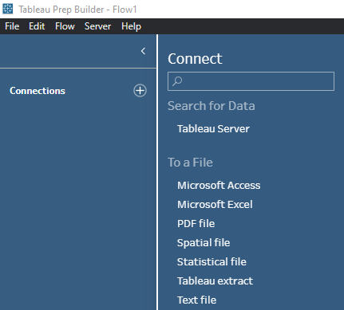

2) Search for Excel file Format, click and select your Global Super store data from your system browser.

3) Clear the checkbox in left to remove any fields that you do not require

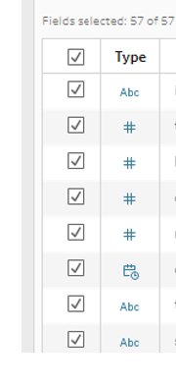

4) You can use recommendations to trim spaces between the text

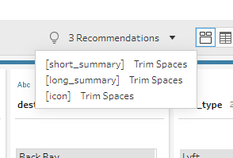

5) From the Top panel you can select ‘Rename Fields’ to name the variables per your understanding

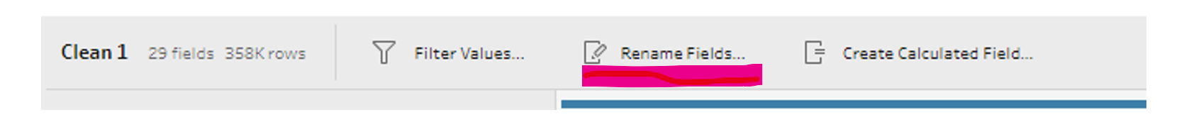

You can also use Data Interpreter in Tableau Desktop, as shown below:

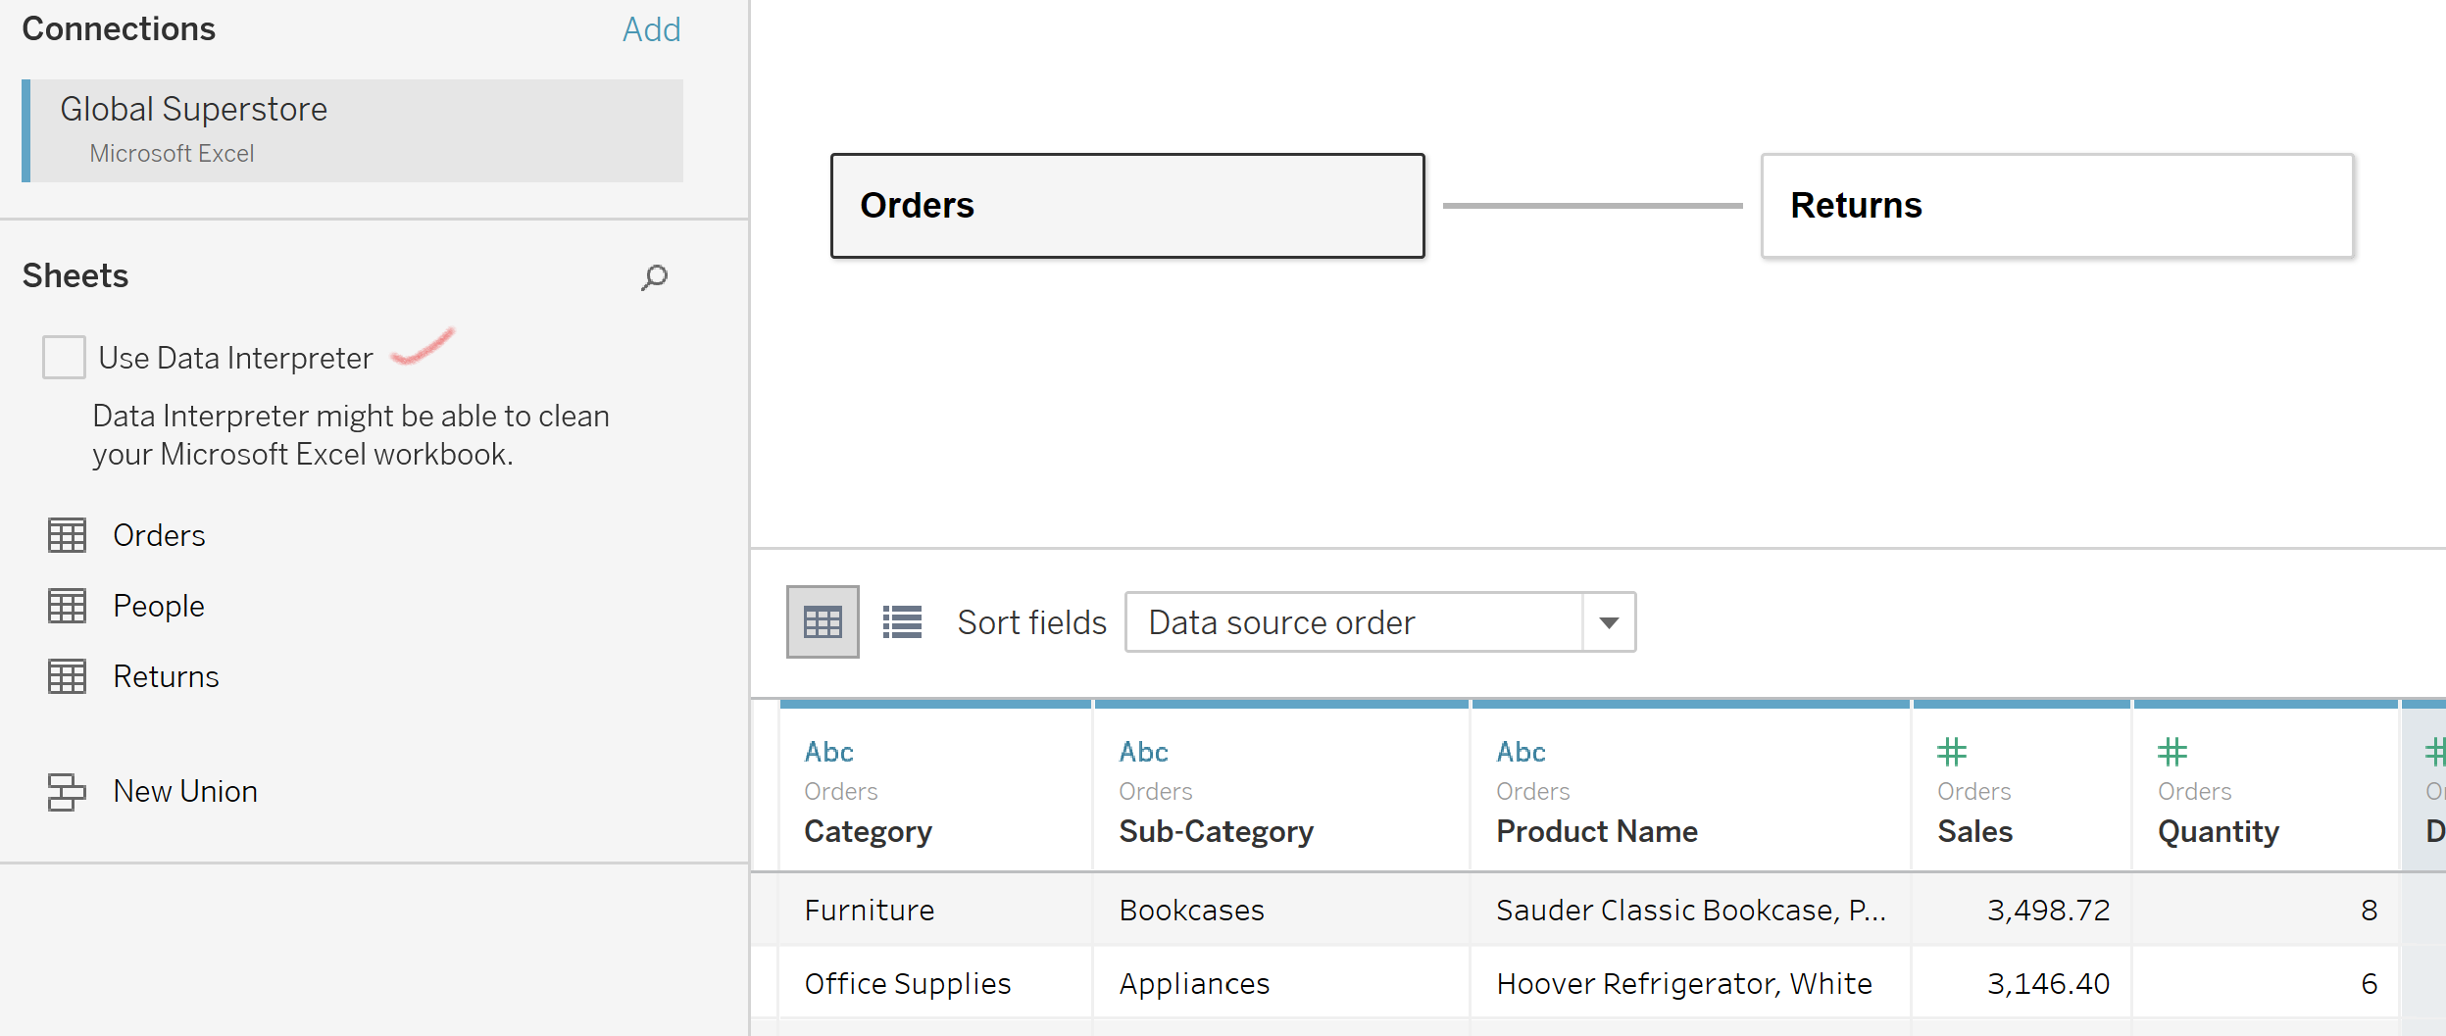

When you click Data Interpreter, you can review the Results highlighted below

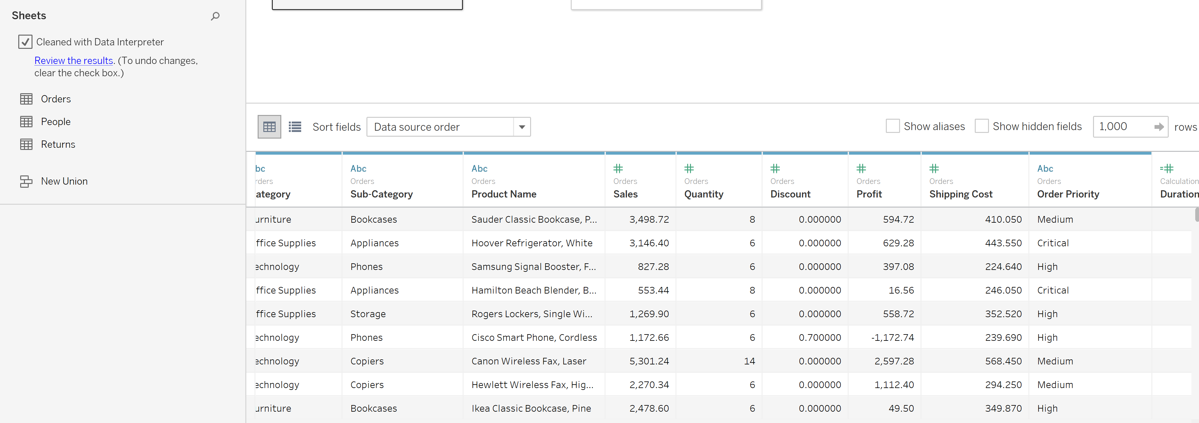

Correct any data type that Tableau reads incorrectly

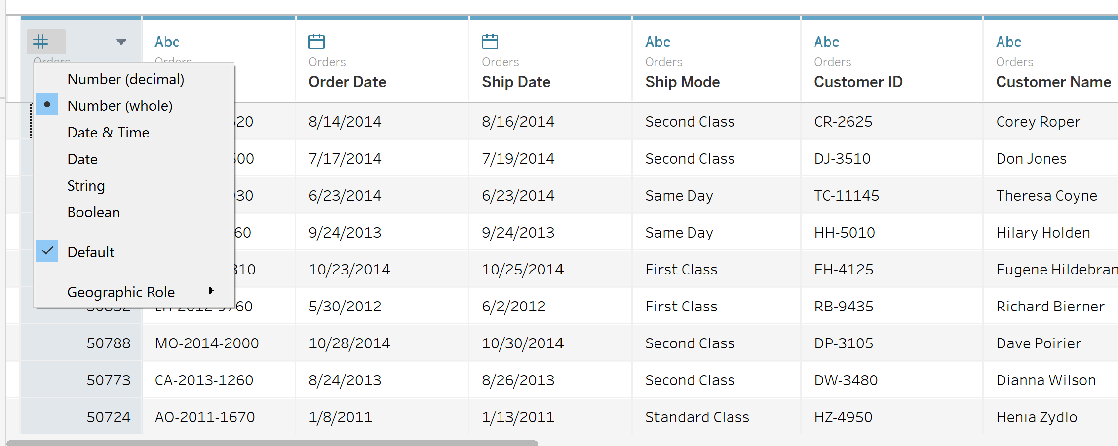

# Dashboard

Please find the link to the dashboard below:

<https://public.tableau.com/app/profile/elamaran4014/viz/Jayabarathy_Elamaran_GSDashboard/GlobalSuperStoreDashboard?publish=yes>

## 1.8.1 Business Scenario

Global Supermarket sells products in 147 countries. Its sales increase steadily year after year, but the company realizes that it is not generating the profits that they had anticipated. Sales, as a key metric in the retail industry, must be visualized in multiple dimensions. The company's desire to increase sales has an impact on profitability. As a result, the company decided to forecast the Sales to Profit ratio, as well as other important measures. The customer journey is not a solitary one. From research to purchase, it's a zigzag across channels. Because customer preferences change daily, it is difficult for the company to promote the product. A product category performs well in one market but does not generate enough profit in the other markets. Marketing Strategists are having difficulty deciding which product to promote in a specific region/market. The company's higher executives are dissatisfied with the company's current marketing strategy of profit-driven product promotion around the world. The only way to understand the customer journey is to examine transaction data. To visualize the popularity of the Products, management decides to track the key Performance indicators globally for each market and the corresponding Business measures.

## 1.8.2 Purpose and Questions

Global Super store has a big problem when it comes to decide a Marketing Strategy to promote a product based on its Sales information. Regional managers can compare Sales and profit figures only in their regions. They don’t have enough information to decide. They need to segment the customers based on their orders, purchase behavior and product preferences. It is possible to accomplish these tasks by analyzing the customer Transaction details. As the Profit of the company is directly involved in these decision-making process, executives and other board members need to track the key metrics on daily basis. They can approve the regional manager’s marketing strategies, only if they can visualize how the company performs globally and make sure that the business strategies are aligned with company’s goal and mission. They must make other policy changes based on the Performance of the company.

Key Performance Indicators are the essential metrics that every retailer should monitor to analyze the health of their business. Numbers don’t lie, and KPI can help the company to see where their business is thriving, where they are falling short and, most importantly, how they can make positive changes to ensure the business continues to grow. There are multiple KPIs that the retail business can monitor, but which carry the most weight as the company plan? Are some KPIs more valuable than others

Tracking KPI’s allows Global Super store to have a high-level view of the performance of retail business—where they can streamline processes and which software solutions, they will likely need to improve sales and customer satisfaction. Now that they know which key performance indicators are essential for retailers to track, they will be better prepared to tackle monthly, quarterly, and annual reporting.

Global Super Store will forecast new demand, reduce the cost structure, reduce corporate costs, and achieve greater customer satisfaction and customer retention based on the diagnostic analytics that they have yet to perform.

Below is the list of questions based on their theory that they need to answer through data visualization:

* What exactly are the Key Performance Indicators (KPIs)? Can they be distinguished by country/region/market?
* Which country makes the most Profit?
* How have Total Sales and Profit Trends Changed in the Past? Is there a straight line between the two?
* Which products generate profit for the company and which products generate a loss for the company?
* Which product sub-category is the most popular in each market?

## 1.8.3 Procedure

**Connect and upload the data set to Tableau**

1. Open Tableau and click on Microsoft Excel under Connect if your data is in excel format

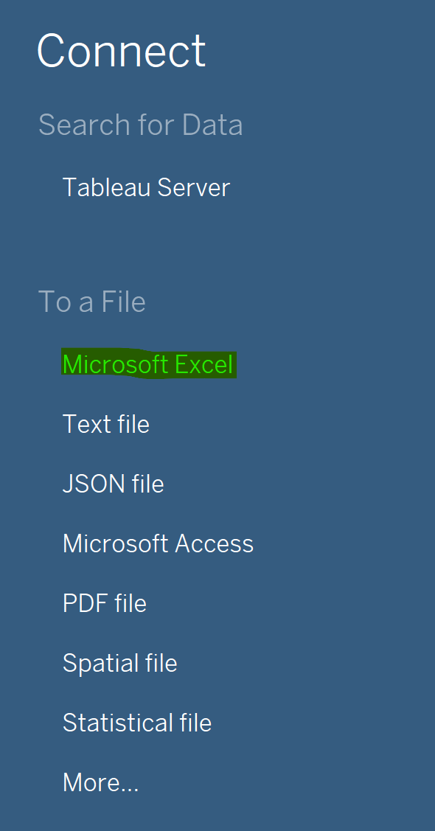

1. Browse for your file in your computer and hit open

Once the Connection is made a new worksheet will automatically open. The data source (GlobalSuperStore.xls) will be indicated and its different tabs will also appear

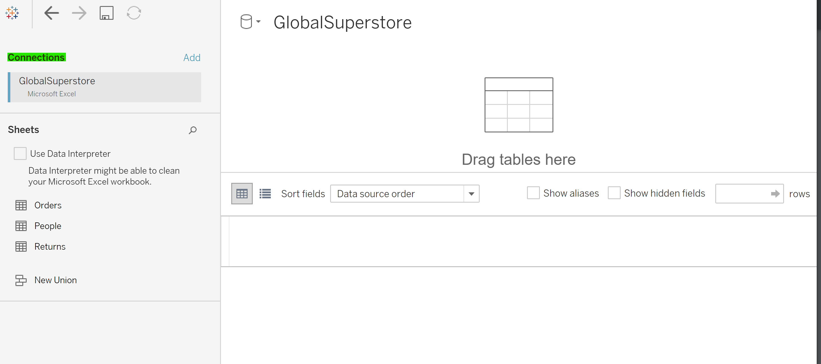

1. Drag and drop the Orders table from the sheet to the main

Below Connections, on the left tab, one can see the three sheets of data from the Global Superstore dataset (Orders, People, and Returns). Drag the Orders sheet on the upper-right pane. You then have the choice to either extract the data or to maintain a live connection with the original dataset. As GlobalSuperstore.xls is not a large file, you may want to choose extract: it gives you the added benefit of portability, as the data will be saved into Tableau (the original file won’t be needed anymore). For heavier files that are too large to import into Tableau, a live connection in which Tableau queries the file as necessary is preferable.

1. Extract the Orders sheet.

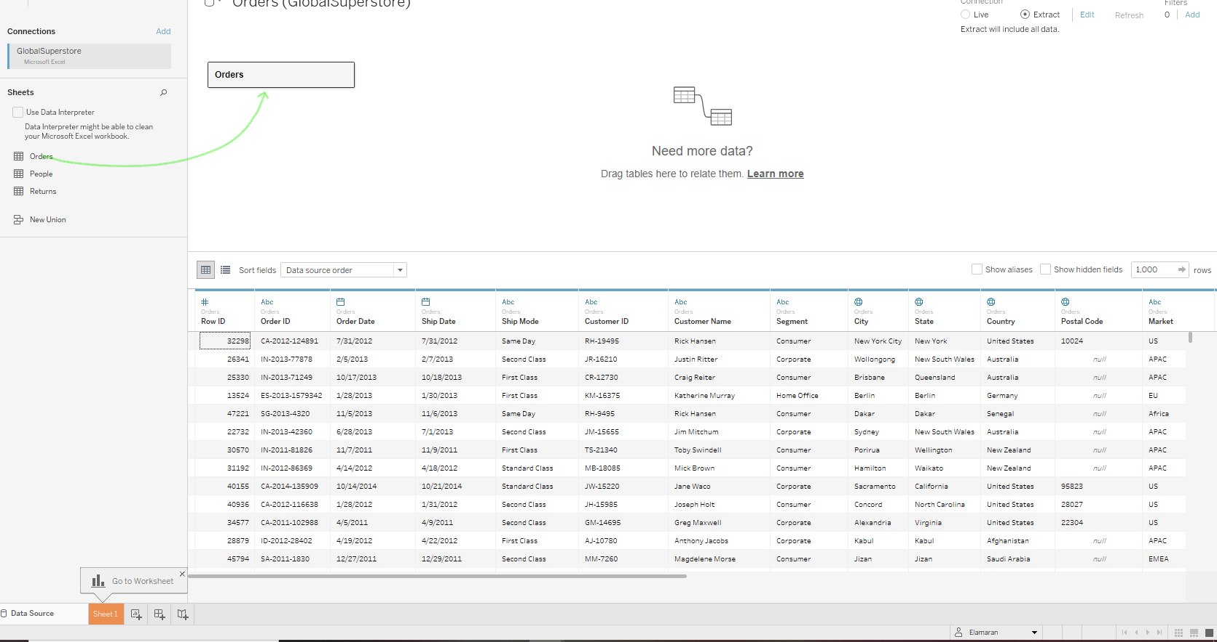

1. Data Preview

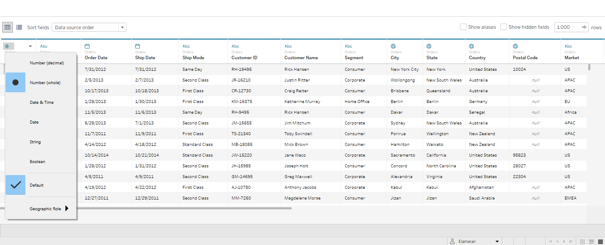

The bottom half of the interface presents a preview of the dataset; each column is labeled with a symbol, representing the type of data (e.g., number, date, string). You can then create your own calculated fields, perform splits, and most importantly, double check that Tableau has correctly identified the type of each column.

6) Extract the Returns sheet

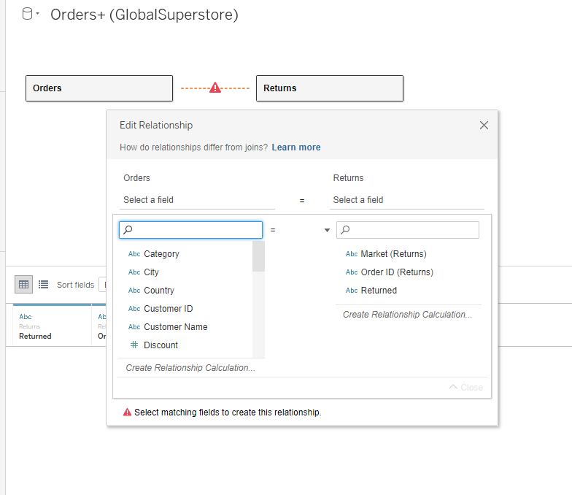

We next discuss one of Tableau’s most important operations: importing a second dataset and joining it to the first. For example, we can do this operation with the Returns sheet. Drag the Returns sheet and place it next to the Orders sheet. Edit the relationship and choose Order ID for both the columns

**A First Look at Visualization**

You can now get started. Click on Sheet 1 at the bottom left of the screen to access Tableau’s main interface. On the left side, you will find Dimensions and Measures, displayed in blue and green respectively. You can think of dimensions as qualitative data, usually containing qualitative and categorical information. The Global Superstore dataset includes several dimensions: some are pure text, such as Categories (Furniture, Technology, etc.), whereas others consist of date values, such as Order Date.

Measures, on the other hand, represent quantitative numerical data and can be aggregated based on a specific dimension. For instance, you could use the Measure called Profit and aggregate it based on the Dimension called Categories. Such an aggregation could be helpful in understanding which category is the most profitable.

Dimensions and Measures.

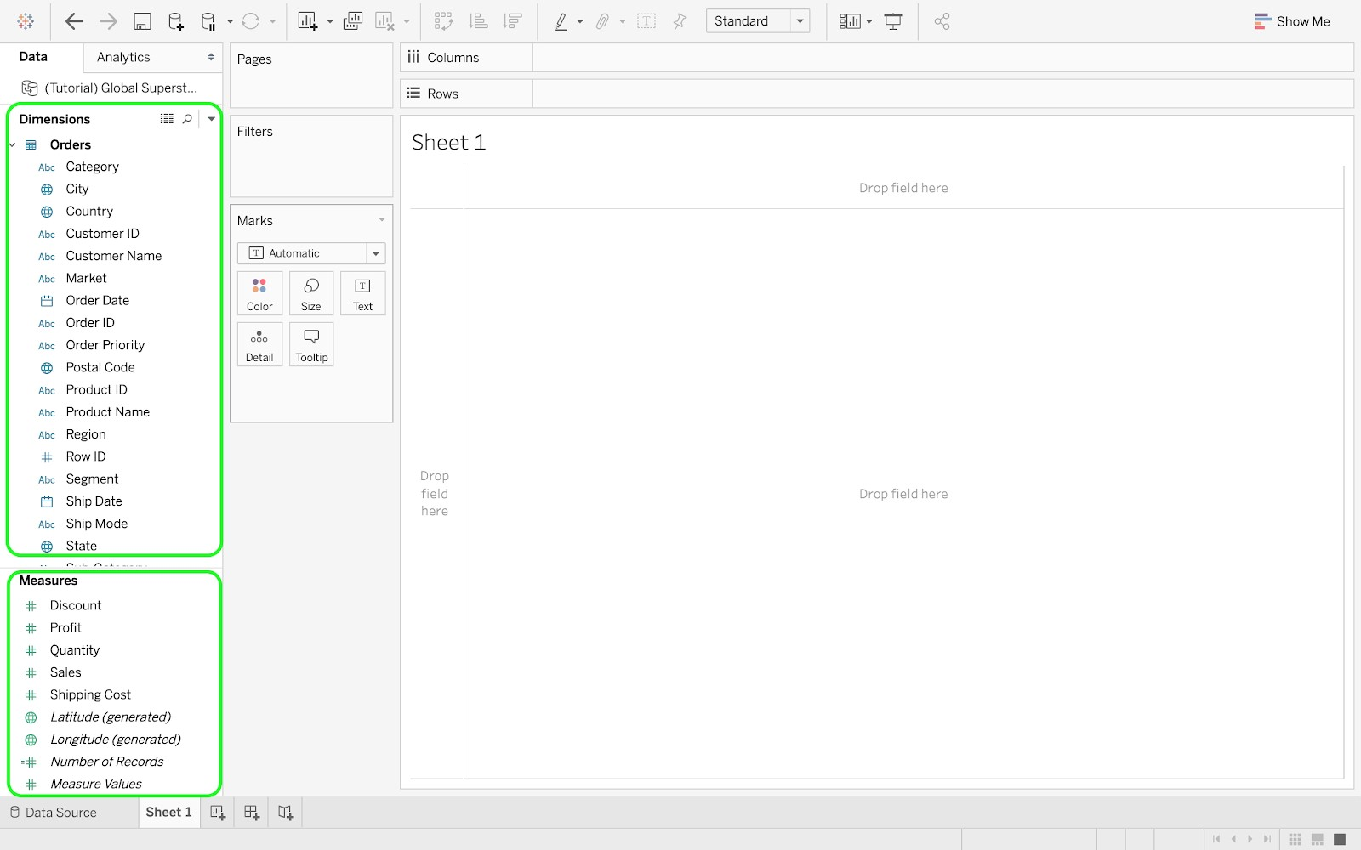

**Visualization 1: Sales Vs Profit**

Step 1: Drag the Sales and Profit measures to the rows

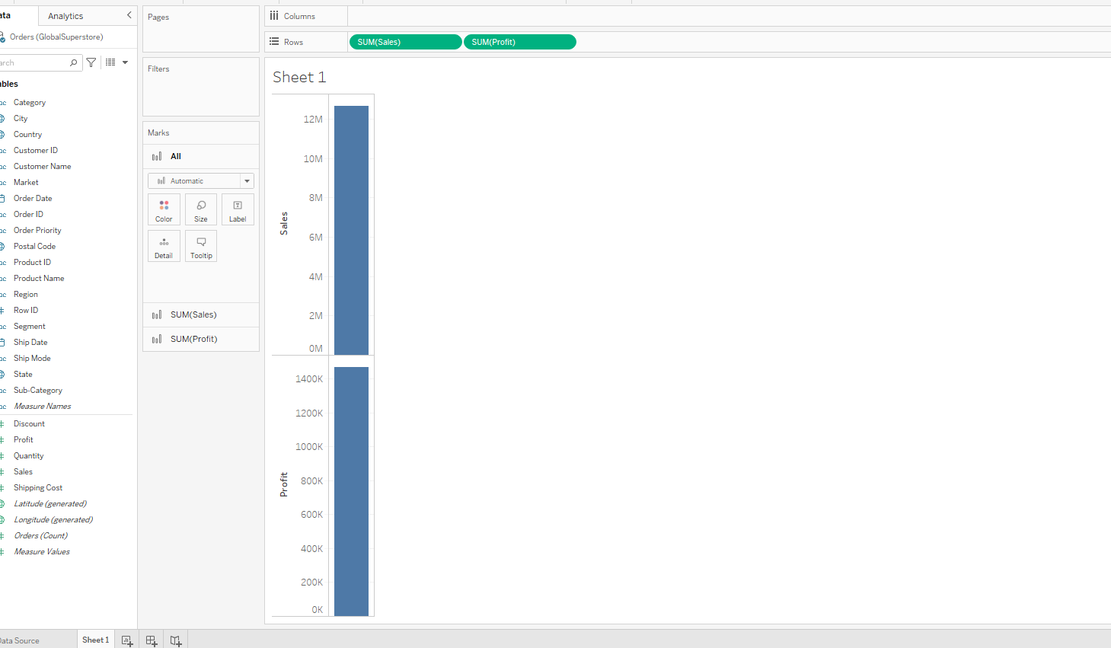

Step 2: Drag the Order date to the column

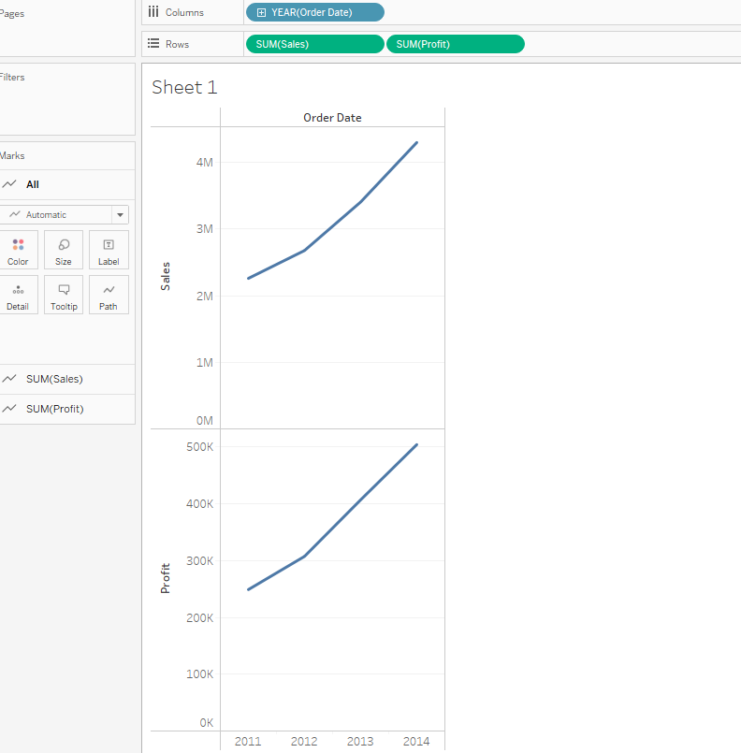

Step 3: Note that Order Date is in blue color which means it is discrete. Right click the order date and change it to continuous and Select Month.

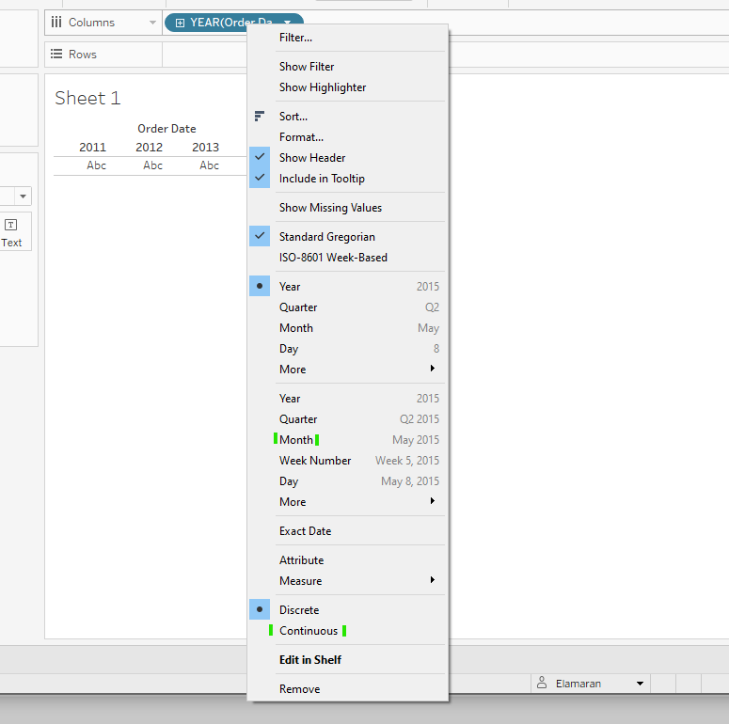

Step 4:Now the visualization should like the following.

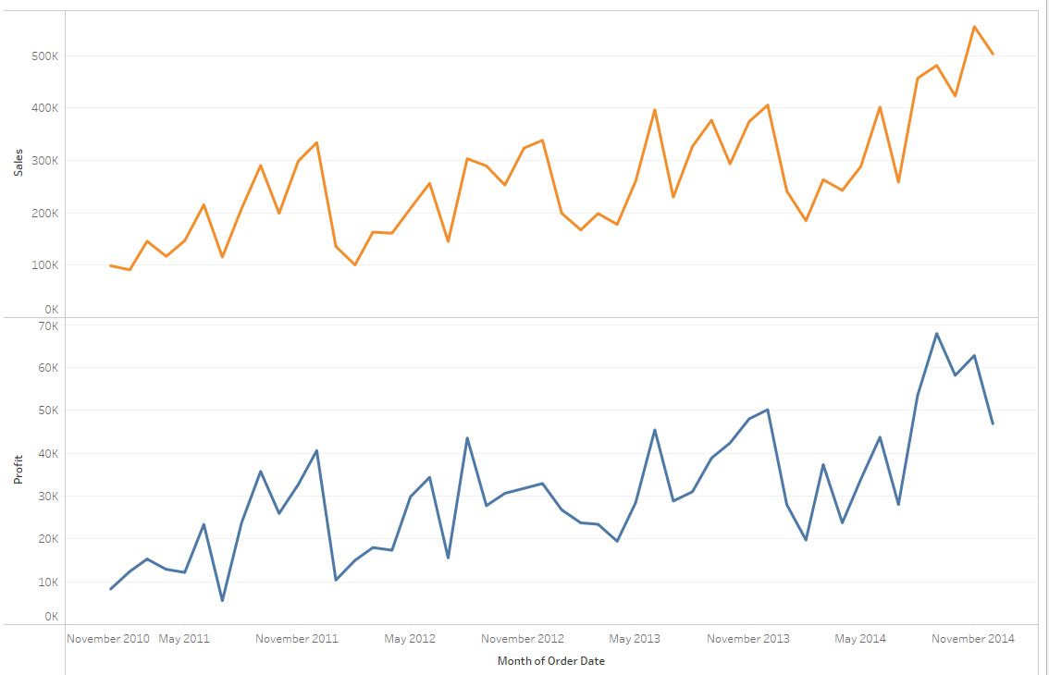

Step 5: Now we are going to create a Dual Axis Chart with Sales and Profit measure. Drag the Profit measure from the column and place it to the right side of the graph where it shows black dotted lines as shown below

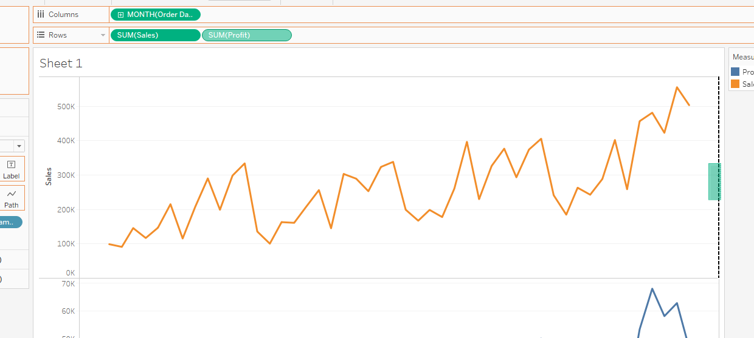

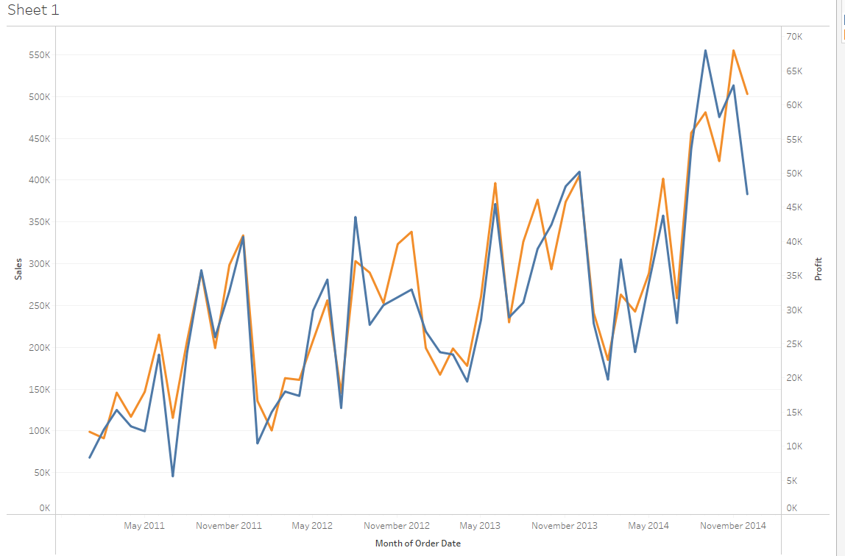

Step 6:Change the color by editing the Color in Mark and reduce the size in mark as following

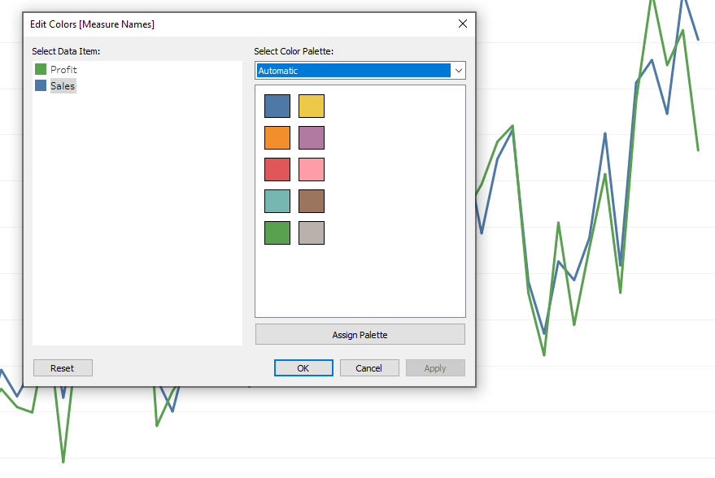

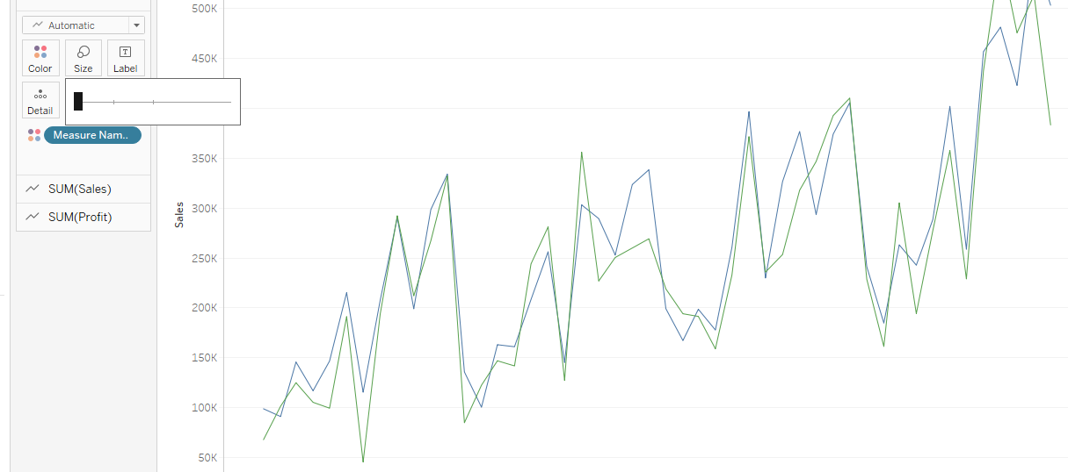

Rename the sheet to Sales Vs Profit.

**Visualization 2: Sales on Monthly basis**

Step 1: On a new sheet , drag the Sales measure to rows pane and Order date to columns pane

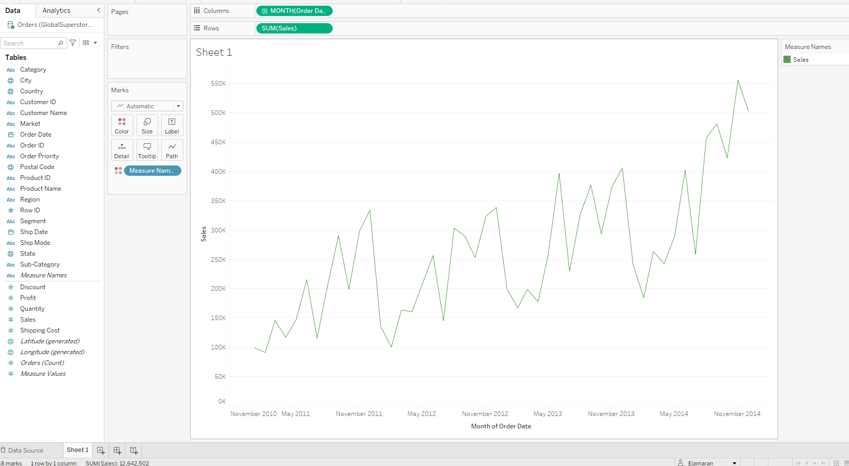

Step 2:Now add category to Rows, change the color in mark shelves. Visualization should look like below

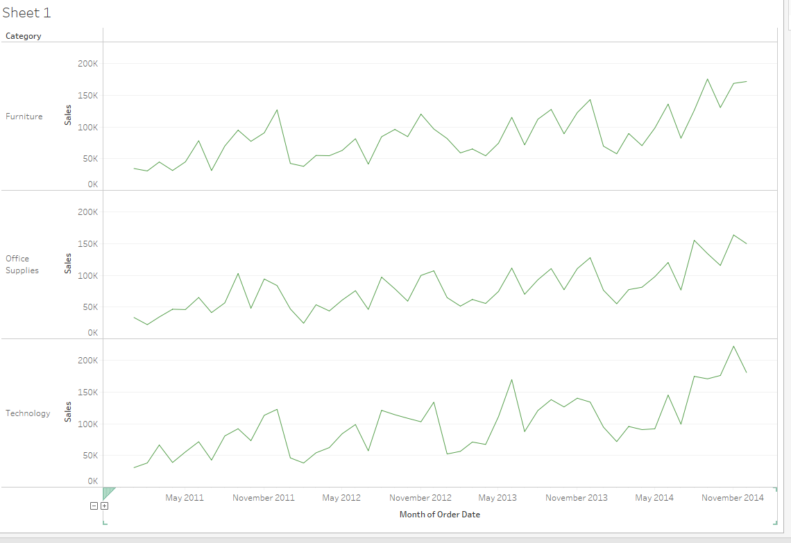

Step 3:Format the Axis change it to Bold and Black .

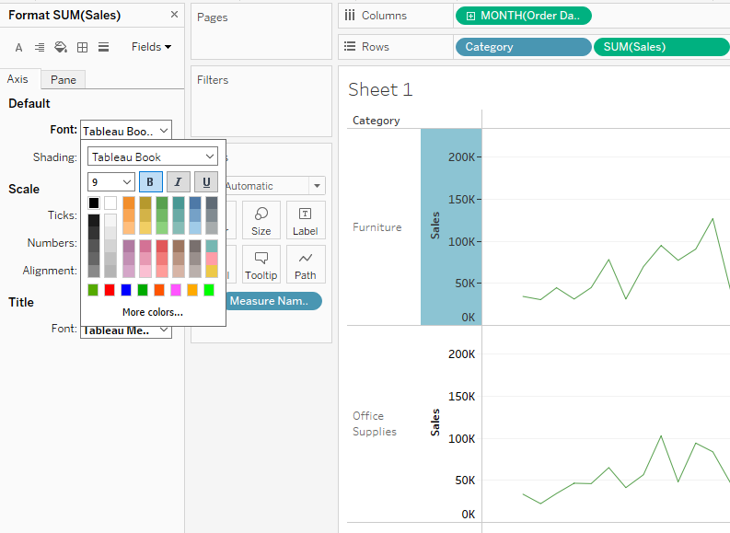

**Visualization 3: Product Popularity based on Profit ratio**

Step 1: First, we must calculate profit ratio using calculated field. Click the Analysis from main menu and choose and calculated Field

**Creating Calculated Field**

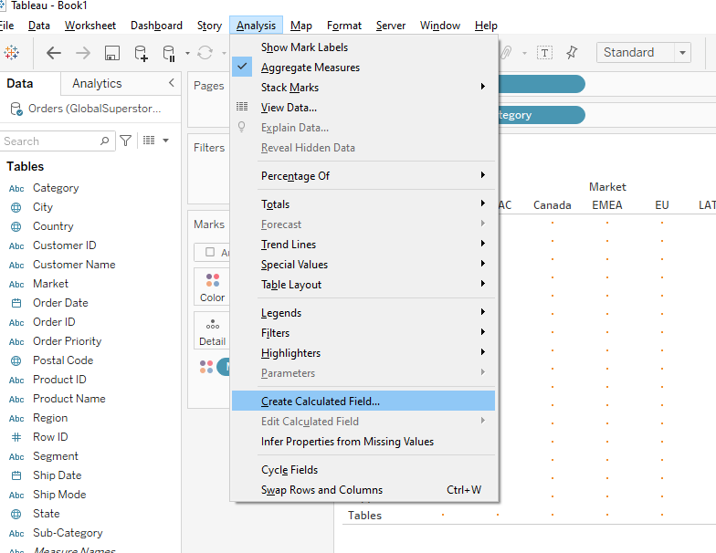

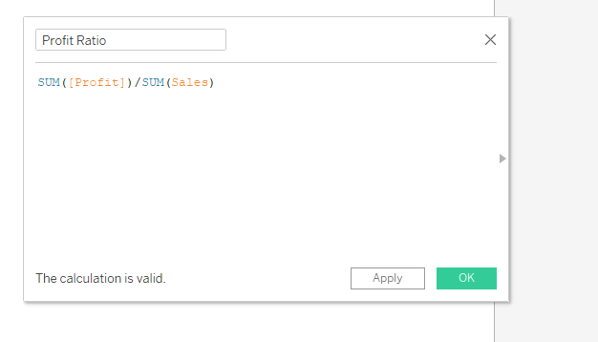

A dialog window will open , rename it to Profit Ratio and enter the formula to calculate Profit ratio. If there is no error , tableau will display “The calculation is valid “ at the bottom. Click Apply and Ok.

Step 2: Now drag the Markets to columns and Sub-Category to Rows.

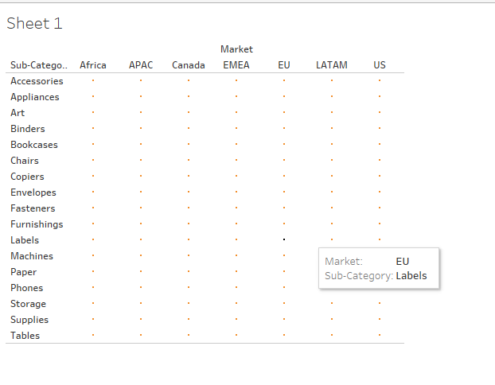

Step 3: The calculate field Profit ratio will look like =# in the beginning in the Measures. Drag Profit ratio to Colors and Labels in the marks shelf.

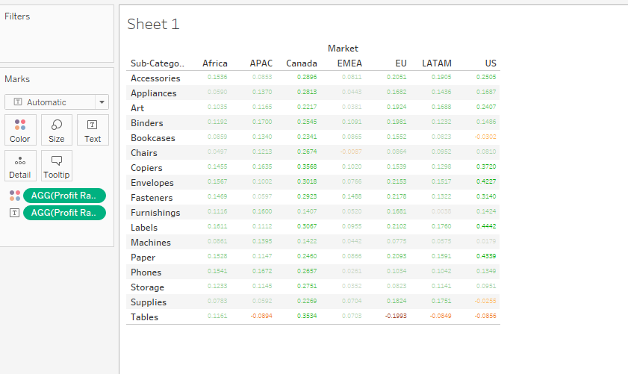

Step 4: Click the Automatic in Marks shelf and change it to Square

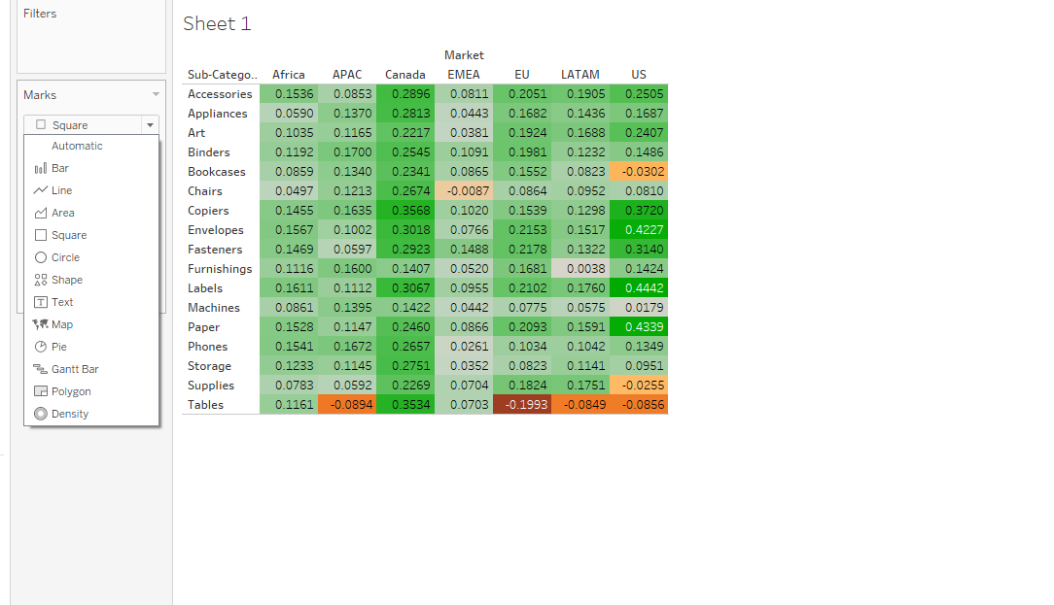

Step 5: Right click the AGG(profit ratio) in the Labels and click format

On the Left side, under the Default Pane , click the Numbers

Change the Numbers, change it to Percentage and reduce the decimal Places to 0:

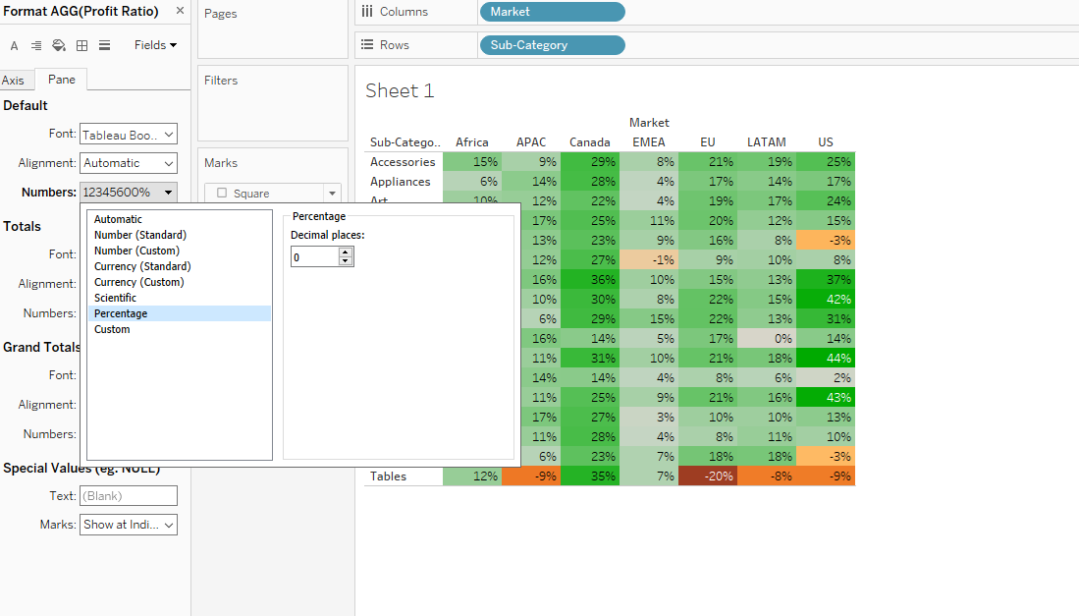

Step 6:Click the Font, Click B for Bold and Choose black color square box. Rename the sheet and save the file.

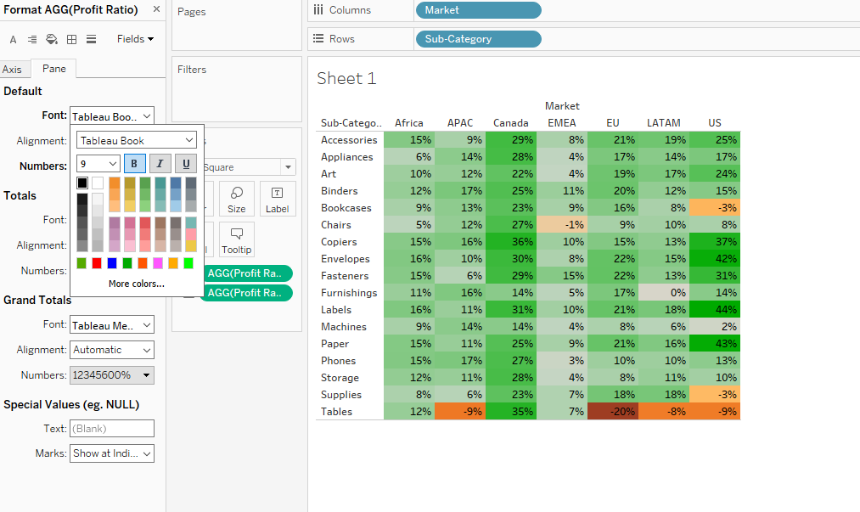

**Visualization 4: Comparing Sales and Profit for each product Name**

Step 1: On the new sheet ,drag the Profit measure to columns and Sales measure to the rows.

Now drag the Category to color in the Marks shelf and change Automatic to Circle.

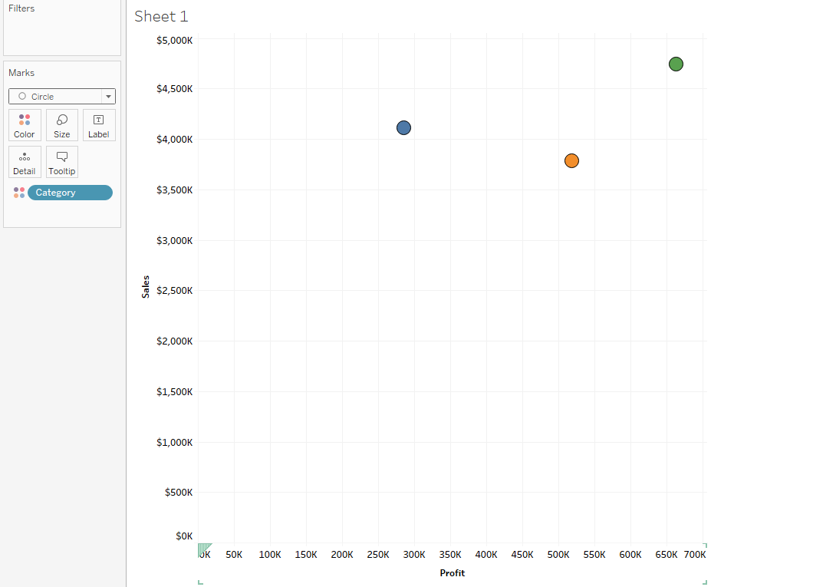

Step 2: Now drag the Order Quantity measure to the Size.

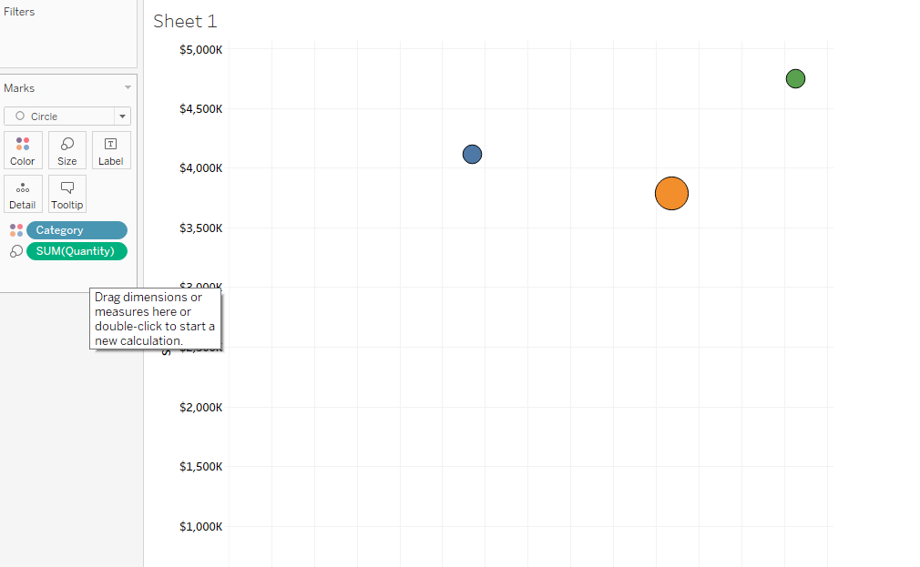

Step 3: Now drag the Product Name to the Detail in the Marks shelf.

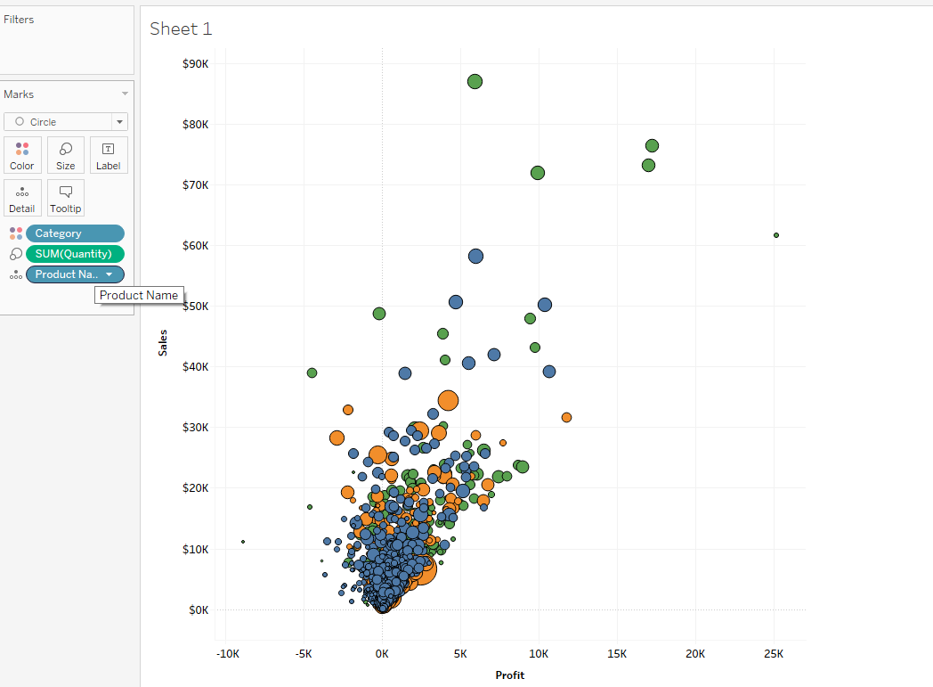

Step 4:For better visualization , click the color 🡪 Effects 🡪Border Choose the Black

Now we can visualize the Profits, Sales and order Quantity for each product name .

**Visualization 5: Profit around the World**

Step 1:On the New Sheet ,double click the Longitude and Latitude

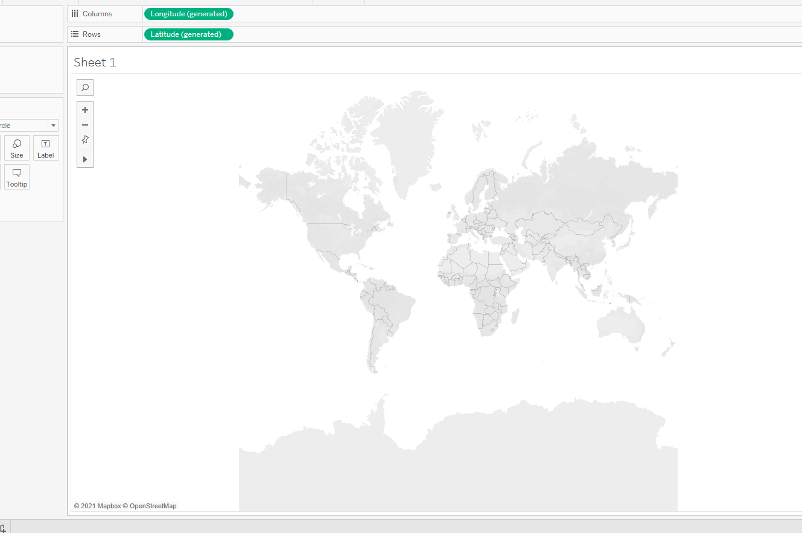

Step 2:Drag the Profit Measure to Color. Drag the Country measure to Detail

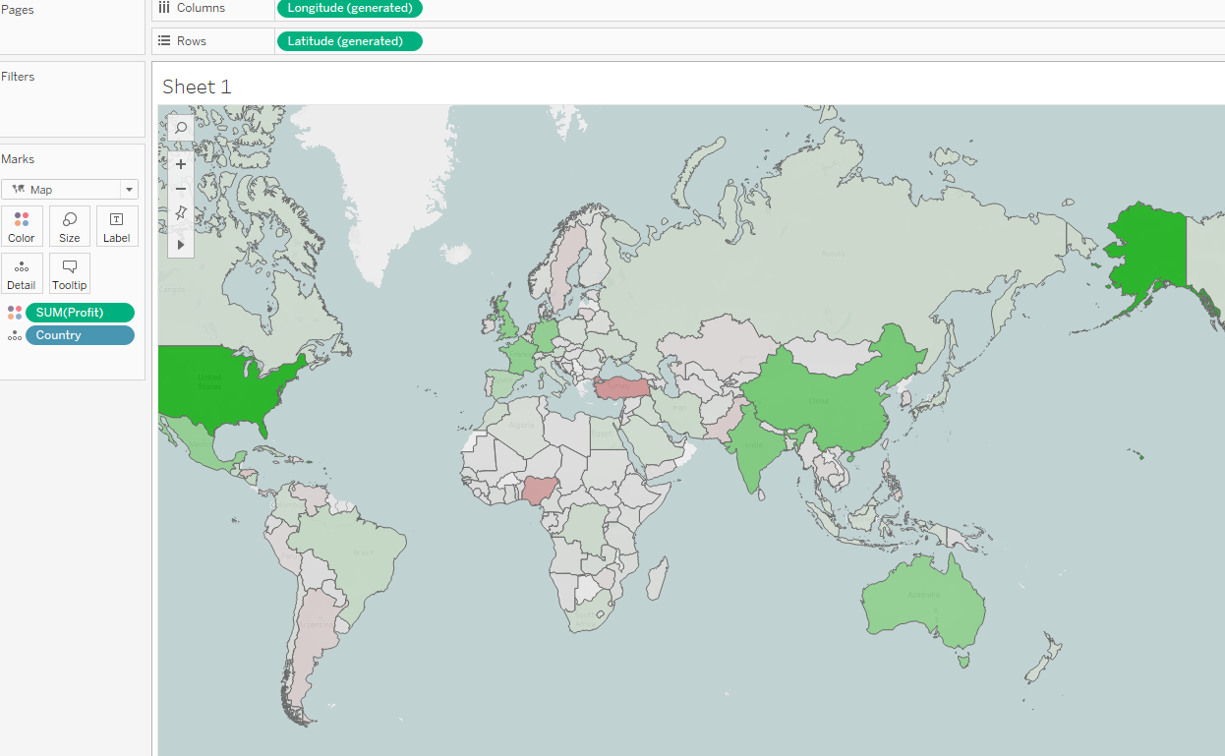

Step 3:Right click the Sum(Profit) measure in color ,click format and change the currency type to custom. Choose display unit as Thousands (K) and reduce decimal values to 0

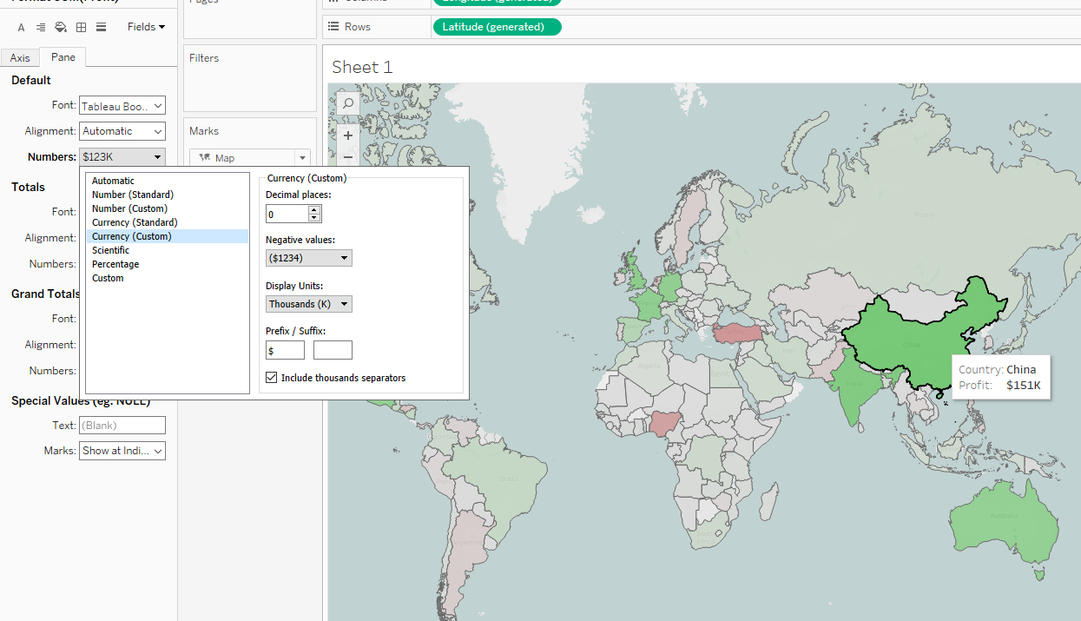

Now we can Visualize the profit for each country across the map

**Visualization 6: Key Performance Indicators**

Step 1: On the New sheet , drag the Sales and profit measures to the Rows.

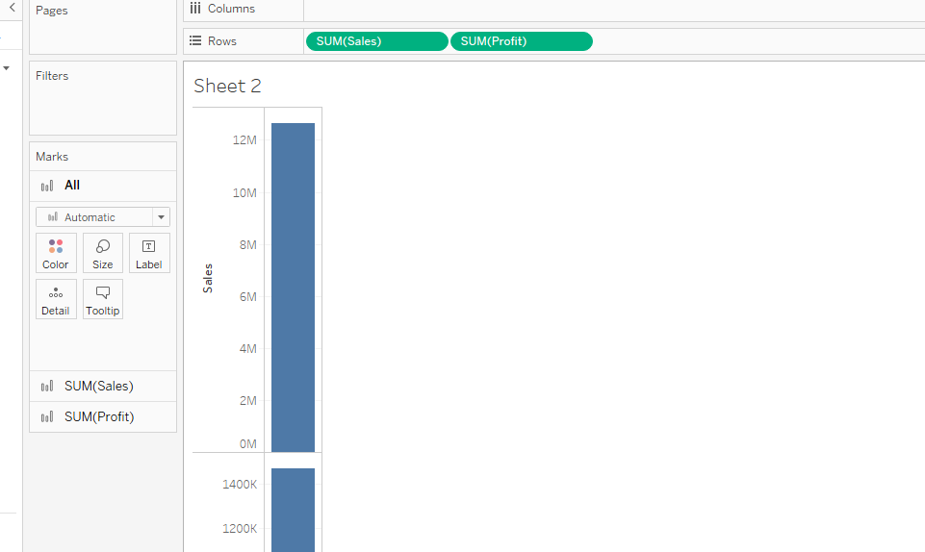

Step 2: Click the Show Me icon on the top right side of the Click text tables

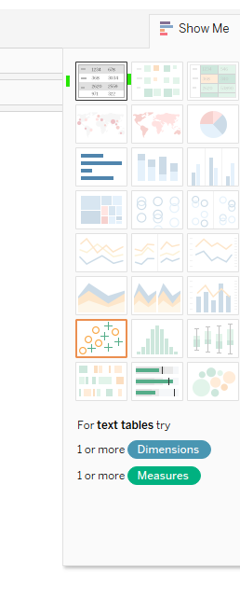

Step 3: Now you can see Tableau Creates Measure Values and Measure Names as following.

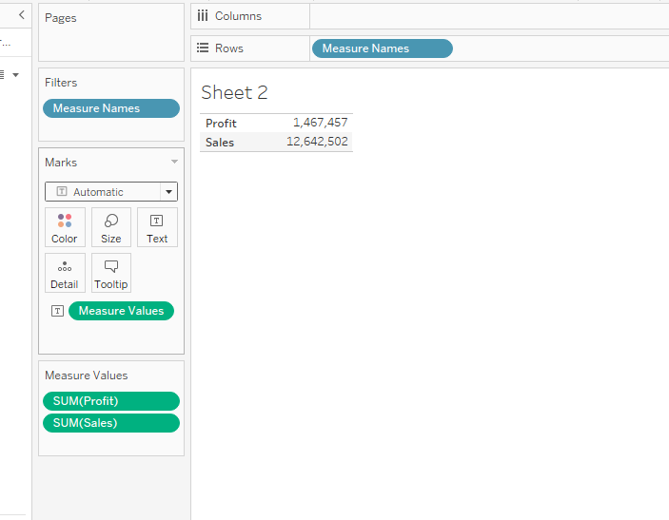

Step 4: Now drag the ordered Quantity and profit ratio to the Measure values as shown below.

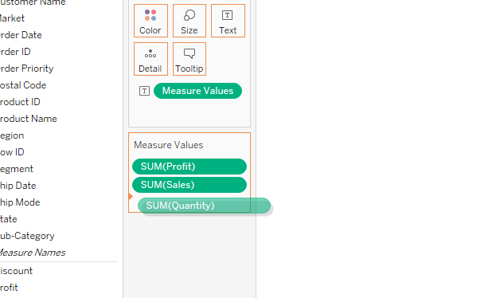

Step 5: Right Click the Quantity and change the Measure Sum to count. Similarly, Right click the Profit ratio ,click format, and change it to Percentage

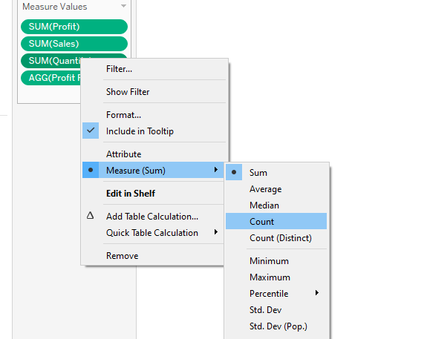

Step 6: Right click the Measure Value , click format, and then click shading and choose the worksheet fill color to green as shown below

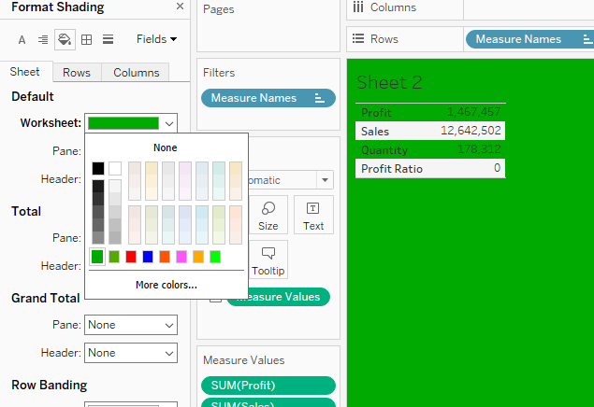

Step 7: Format the Values and Labels to Bold and black color ,the final visualization should look as following:

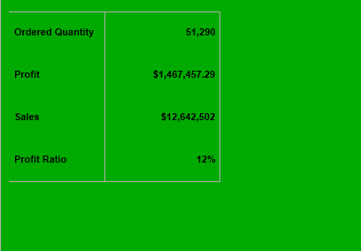

**Creating Dashboard:**

Instead of adding a new sheet, you can select the option “add a dashboard” at the bottom tab. This effective way of visualizing data can combine a combination of several sheets. From the Sheets pane on the left side, select the 5 worksheets created so far and drag them to the middle as shown below

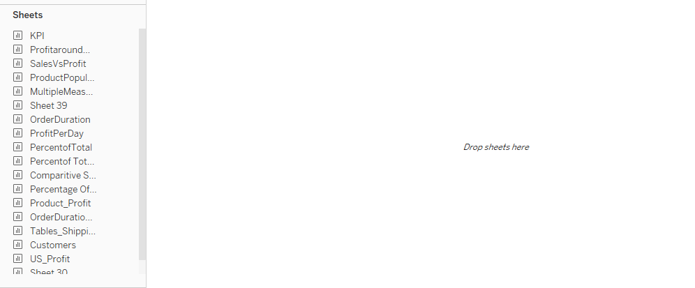

Before dragging the sheets, make sure under the objects Titled is selected . You can choose either titled or floating for the Dashboard layout.

Step 1: Select and drag the KPI sheet to the top as shown below

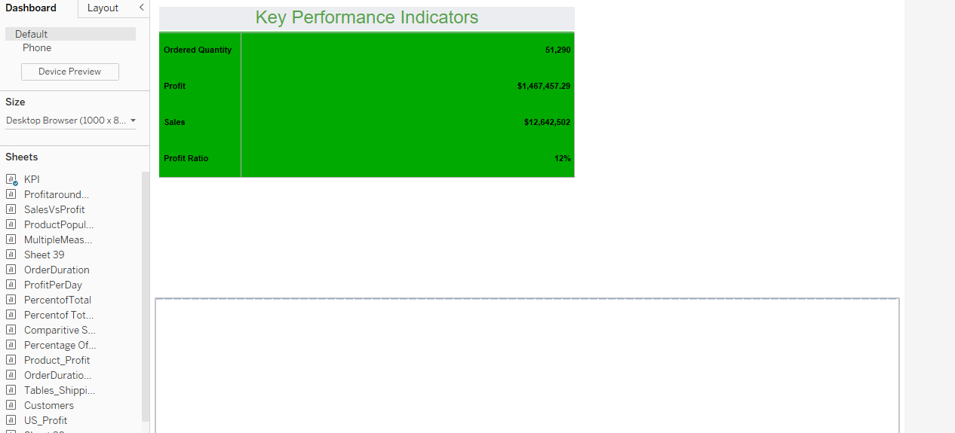

Step 2: Select and drag the Profit Around the World sheet next to the KPI sheet as shown below. Remove the Profit legend by right clicking it.

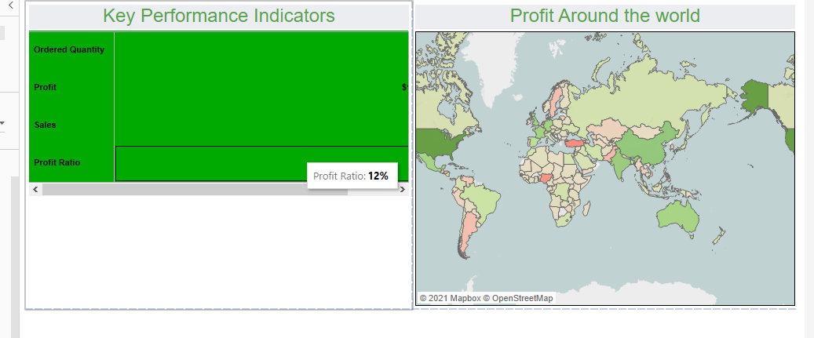

Step 3: Select and drag the Sales Vs Profit trends sheet below the KPI as shown below. Right click the measures Name legend and remove it.

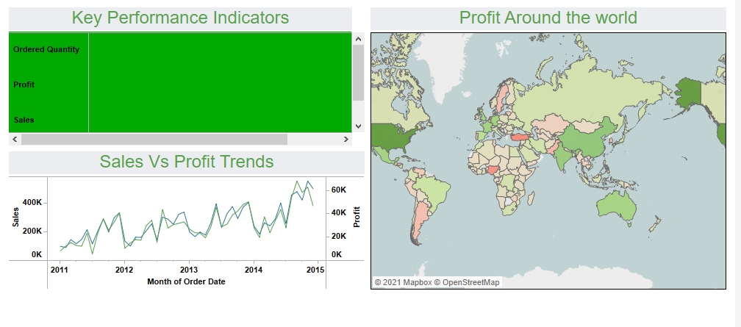

Step 4: Select and drag the Sales on Monthly basis sheet below Sales Vs Profit Trend sheet as shown below.

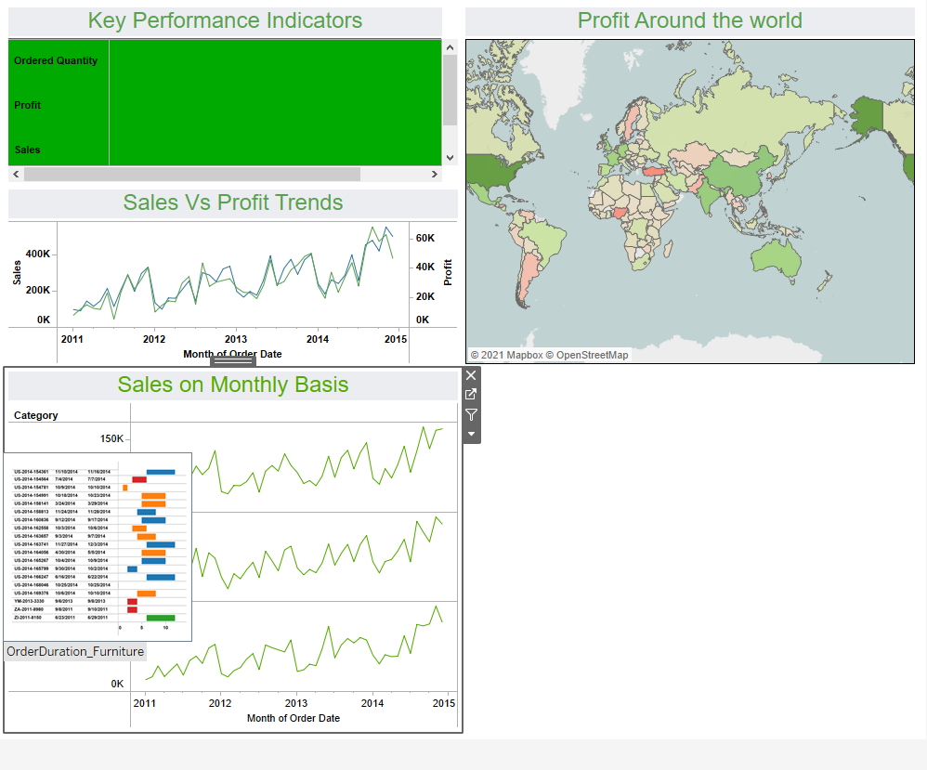

Step 5: Select and drag the Product popularity sheet next to the Sales on Monthly sheet as shown below. Right click and remove the profit ratio legend

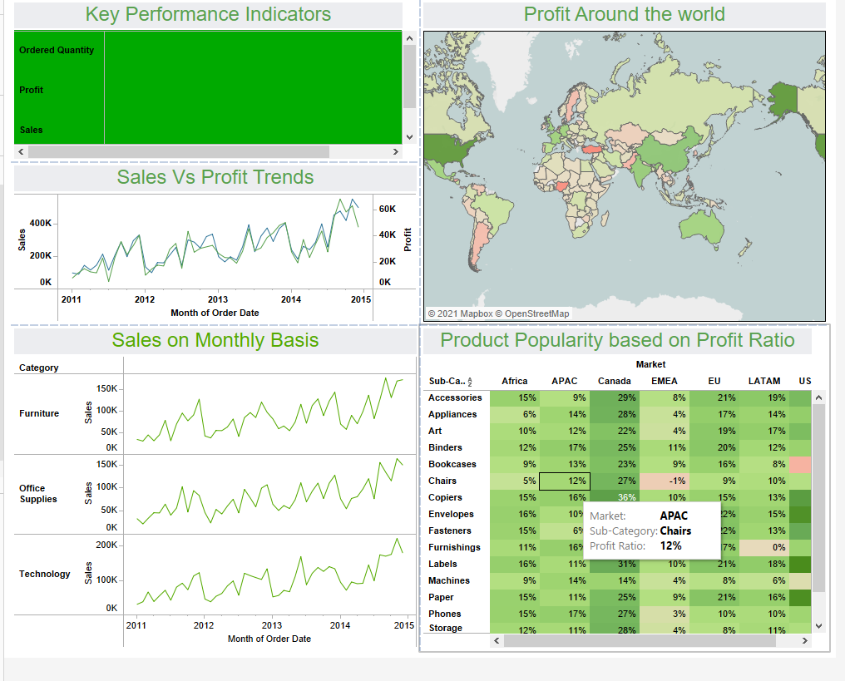

Step 6: .Select and drag the Comparing Sales and Profit measures sheet to the right of Product popularity sheet. Remove the Quantity and Category Legends. Drag and adjust all the sheets for better Visibility.

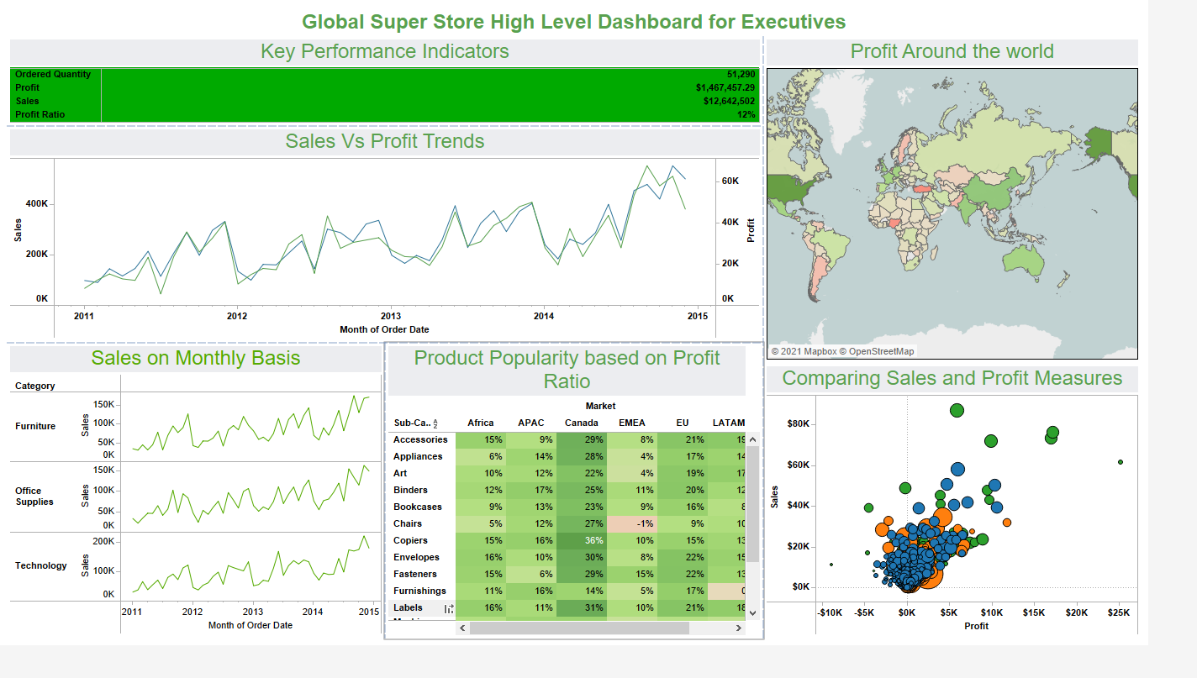

Next, you can use a great function of Tableau that defines one of the sheets to be a filter for the dashboard. Select the Profit Around Map and click on the Use as Filter button, located at the top right of the sheet.

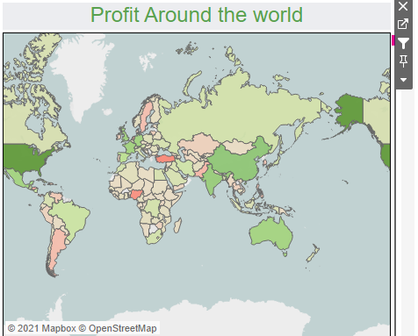

Once this option is selected, you can click on any country. At this time, the chart will evolve as you hop from one country to another. If you go back to the separated sheets, you will see that the data has been filtered, so that it focuses on the country that was selected on your dashboard

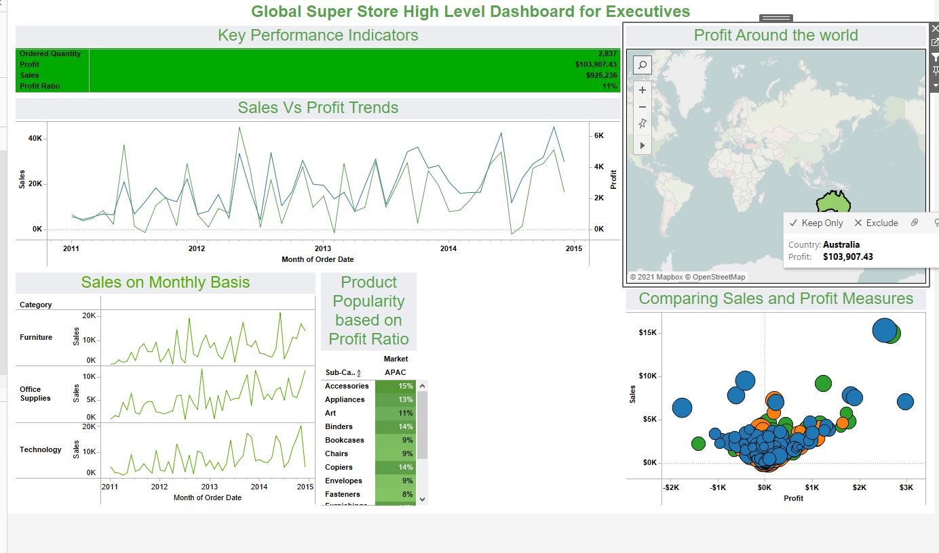

Include a Title for the Dashboard as Global Super Store High Level Dashboard for Executives, format it with the same color and increase the font size larger than other titles as shown in above diagram.

**Story Board**

Please find the link to the dashboard below

[**https://public.tableau.com/app/profile/elamaran4014/viz/Jayabarathy_Elamaran_GSStory/GS_Story?publish=yes**](https://public.tableau.com/app/profile/elamaran4014/viz/Jayabarathy_Elamaran_GSStory/GS_Story?publish=yes)

## 1.8.4 Business Scenario

Analytics are incredibly useful in every part of ecommerce business. The data we collect helps us understand visitor behavior and which day of the week is your biggest revenue generator. We have seen the overall metrics and performance of the company from the dashboard. Now ,it’s time to focus on Product Performance Analytics. Product performance analytics is the collection and strategic analysis of data points (metrics) related to the purchasing funnel like how many times visitors view a product page, how many times a product is left abandoned in a cart, how many times a particular product gets to checkout, unique purchases, and more. These metrics that are gathered on a per product basis can tell you a larger story about your entire product portfolio. Many companies neglect this level of analysis because they aren't sure why or how they should do it.Where many ecommerce stores focus on general metrics like purchases, revenue, and visitors, Global Super Store realizes there is a lot to be learned when adding in product-level insights. Product performance analytics are a critical part of optimizing ecommerce operations, from web store management to sales and marketing. They give deeper insight into what works. CEO of Global Super Store asks the Analytics team to investigate on Product Performance.

## 1.8.5 Purpose

There’s one major reason that product performance analytics are important for ecommerce brands: they help you increase sales and improve overall operations.

Understand the Product funnel: Product performance analytics, at their core, help to understand how well a product moves through the buying funnel. So, from first impression to final purchase. No products are created equal, so it is important to see which categories of products are more or less likely to be abandoned or returned after purchase. Armed with this information, you can identify which products might be generally poor performers or are being snatched up by competitors in comparison shopping.

Avoid stock outs: Inventory tracking is an important part of product performance analytics. Seeing in the moment how many items are being sold can help you forecast stock needs and work more efficiently with suppliers. This kind of performance data becomes more valuable when you couple it with regional or seasonal sales data. Many bigger brands and retailers also share this kind of point-of-sale data so that they have a more global view of who needs what and when. Being out of stock, if not a strategic choice, is frustrating for everyone.

Sales vs Returns: Tracking which specific products come back to you is critical. The return rate will help you understand if your product listing is poorly designed (maybe the sizes or colors are off) or there is a deeper defect in the product. When you gather return data, also make sure to pick up on the qualitative data (what your customers say) so that the returns can be analyzed, and the problems fixed.

Identify Opportunities to boost revenue: The end goal of running an ecommerce store is to generate revenue. Product analytics make it easier to identify opportunities to do just that. If we are tracking first time purchases versus recurring purchases, for example, we might discover products that may work well on a subscription basis like laundry detergent or coffee capsules. If you track category impressions and store search, you could find out that your customers aren't finding a particular product they want, and you could stock. Then of course, all the other tests can run with pricing, merchandising, and promotions are enough to help optimize overall Global Super store profit

Below is the list of questions based on their theory that they need to answer through data visualization:

* Which product categories are performing well, and which are underperforming?
* How can the profit of each sub-category be compared?
* How quickly are the orders processed? Is there a significant lag in the processing of orders?
* How many items are returned? What is the percentage of return?
* What is the average shipping cost for the underperforming product?

## 1.8.6 Procedure

**Visualization 1:Creating a Scatter plot to visualize Profit and Sales based on Category**

Step 1:Drag the Sales measure to Columns and Profit Measures to Rows

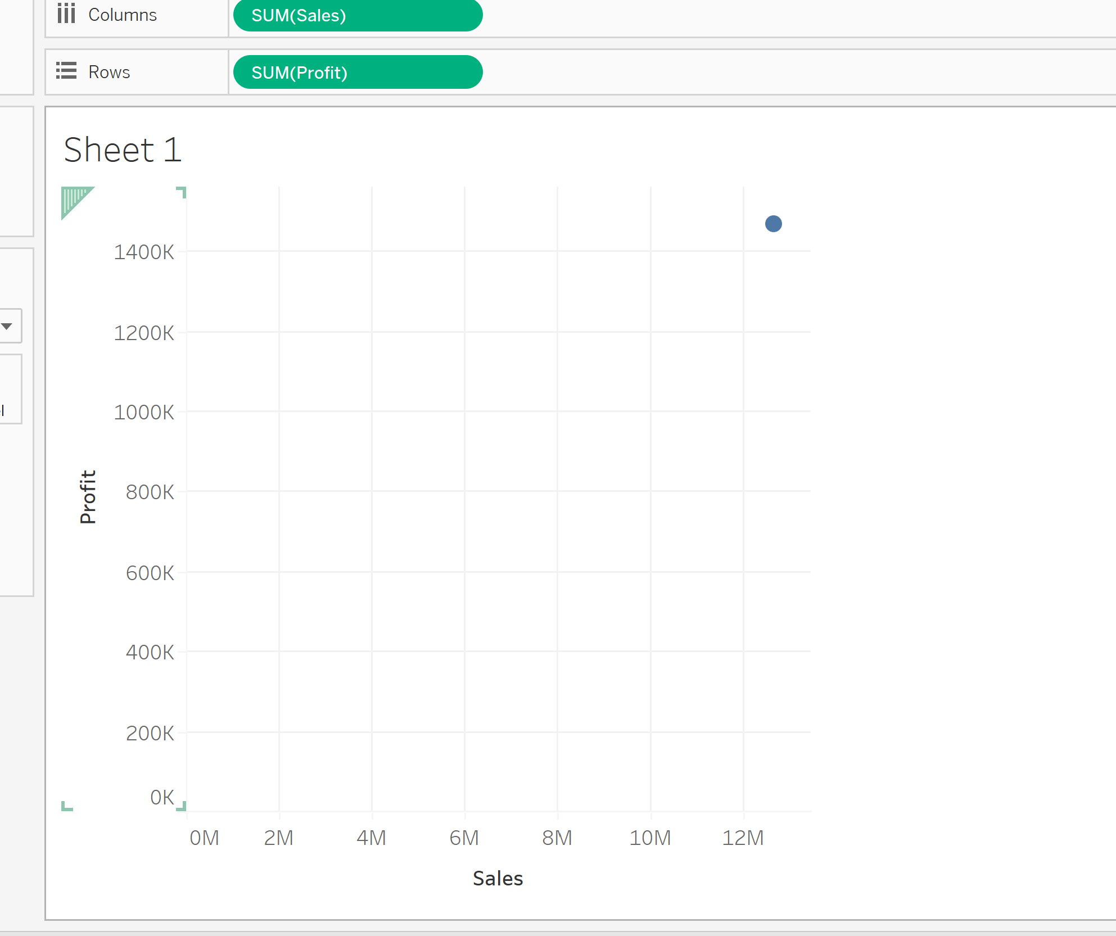

Step2:Drag the Category to color marks and Sub-Category to Size Marks

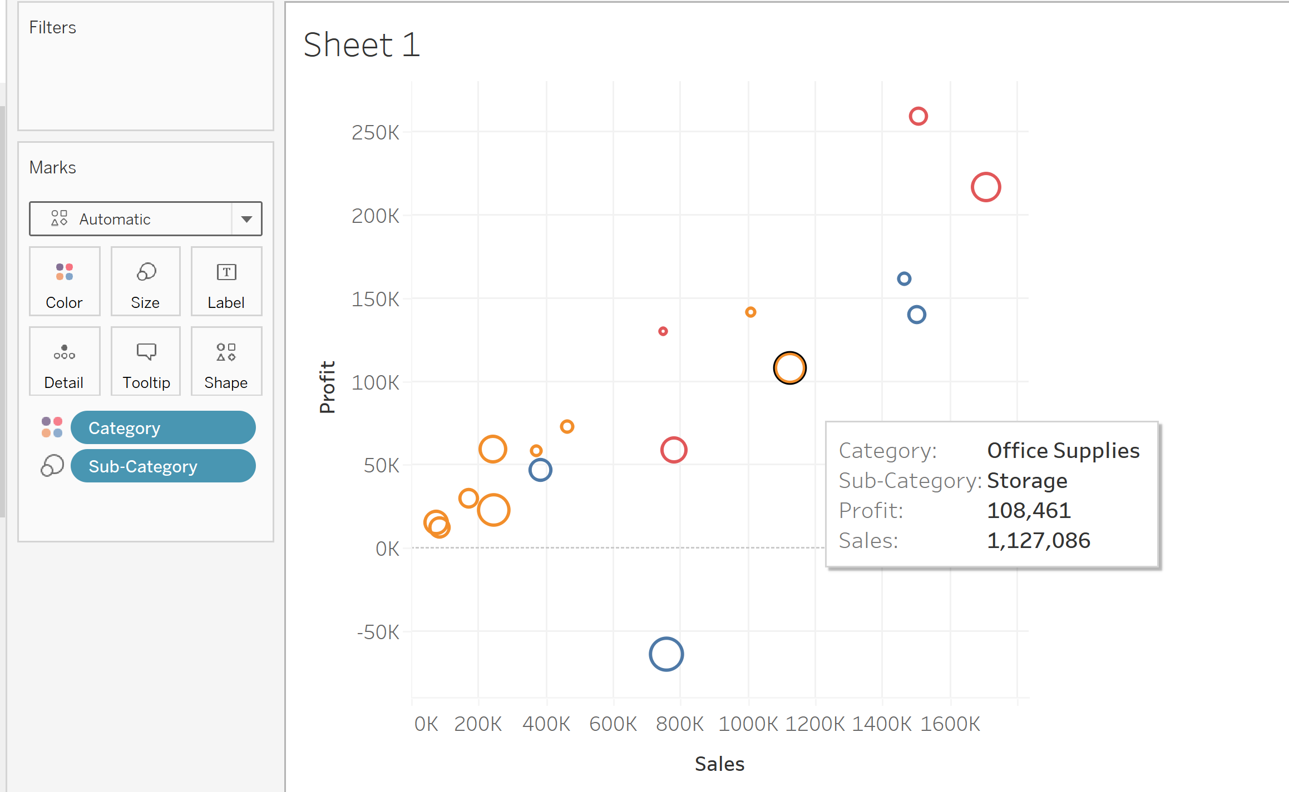

Step 3:Change the Automatic in Marks to Circle.

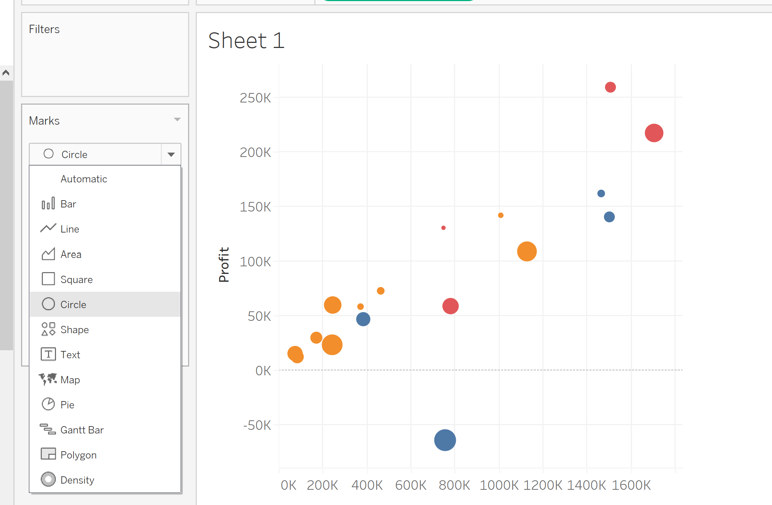

Step 4: Format the axis ,change the font to black color and Bold .Change the Numbers to Custom🡪Display Units: Thousands (K) and reduce the Decimal values to 0.

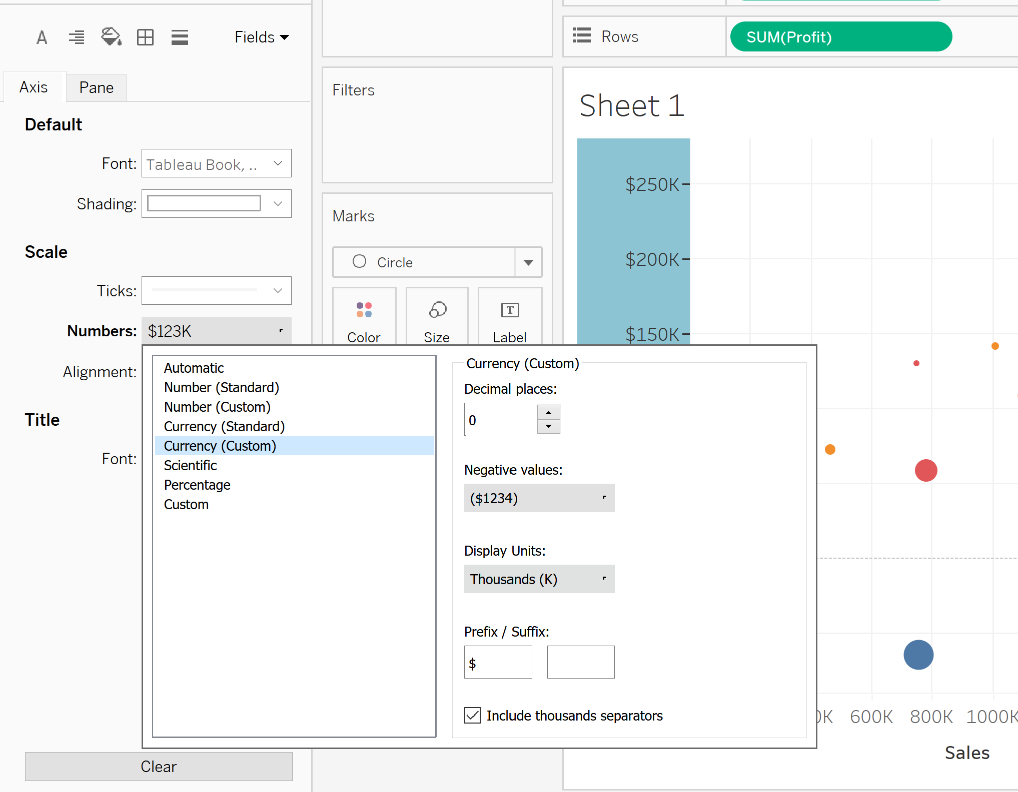

Step 5: Rename the sheet to Product Profit and save the file. Now you can visualize the profit and Sales for each category and Sub-category as shown below

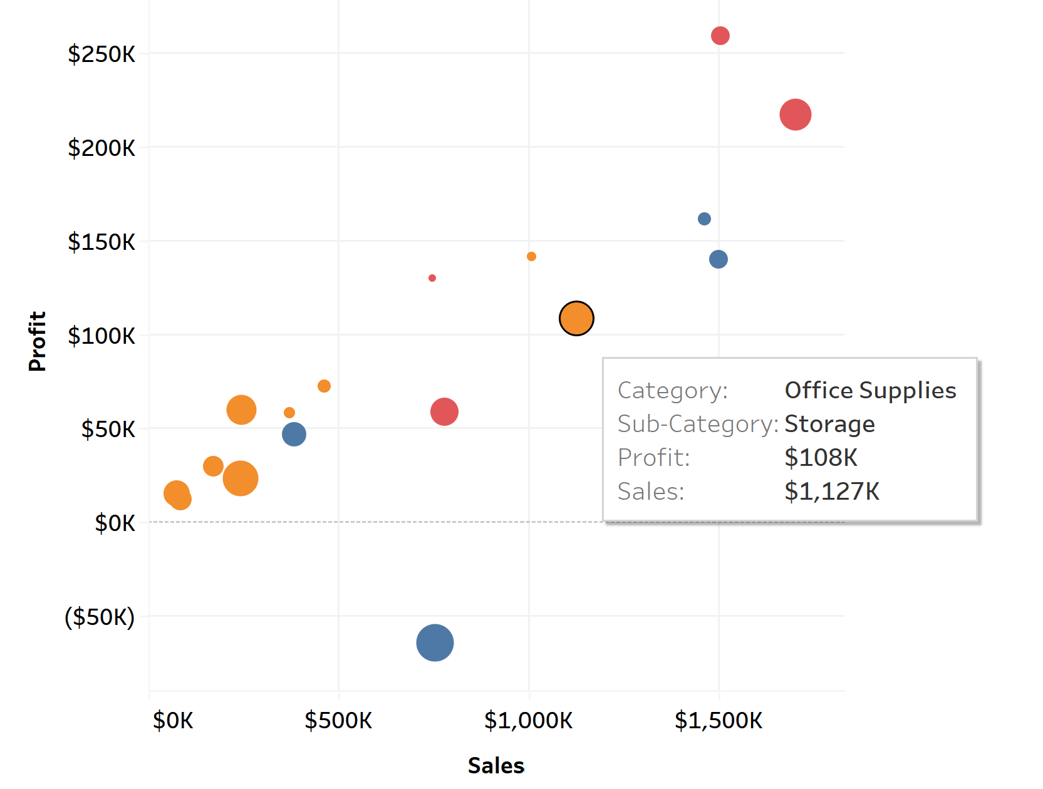

**Visualization 2: Creating a pie Chart for Comparing the Profit Percentage contributed by each Sub-Category**

Step 1: On a new Sheet ,Drag the Profit measure into Rows

Step 2: Click and drag the Subcategory into colors of mark shelf

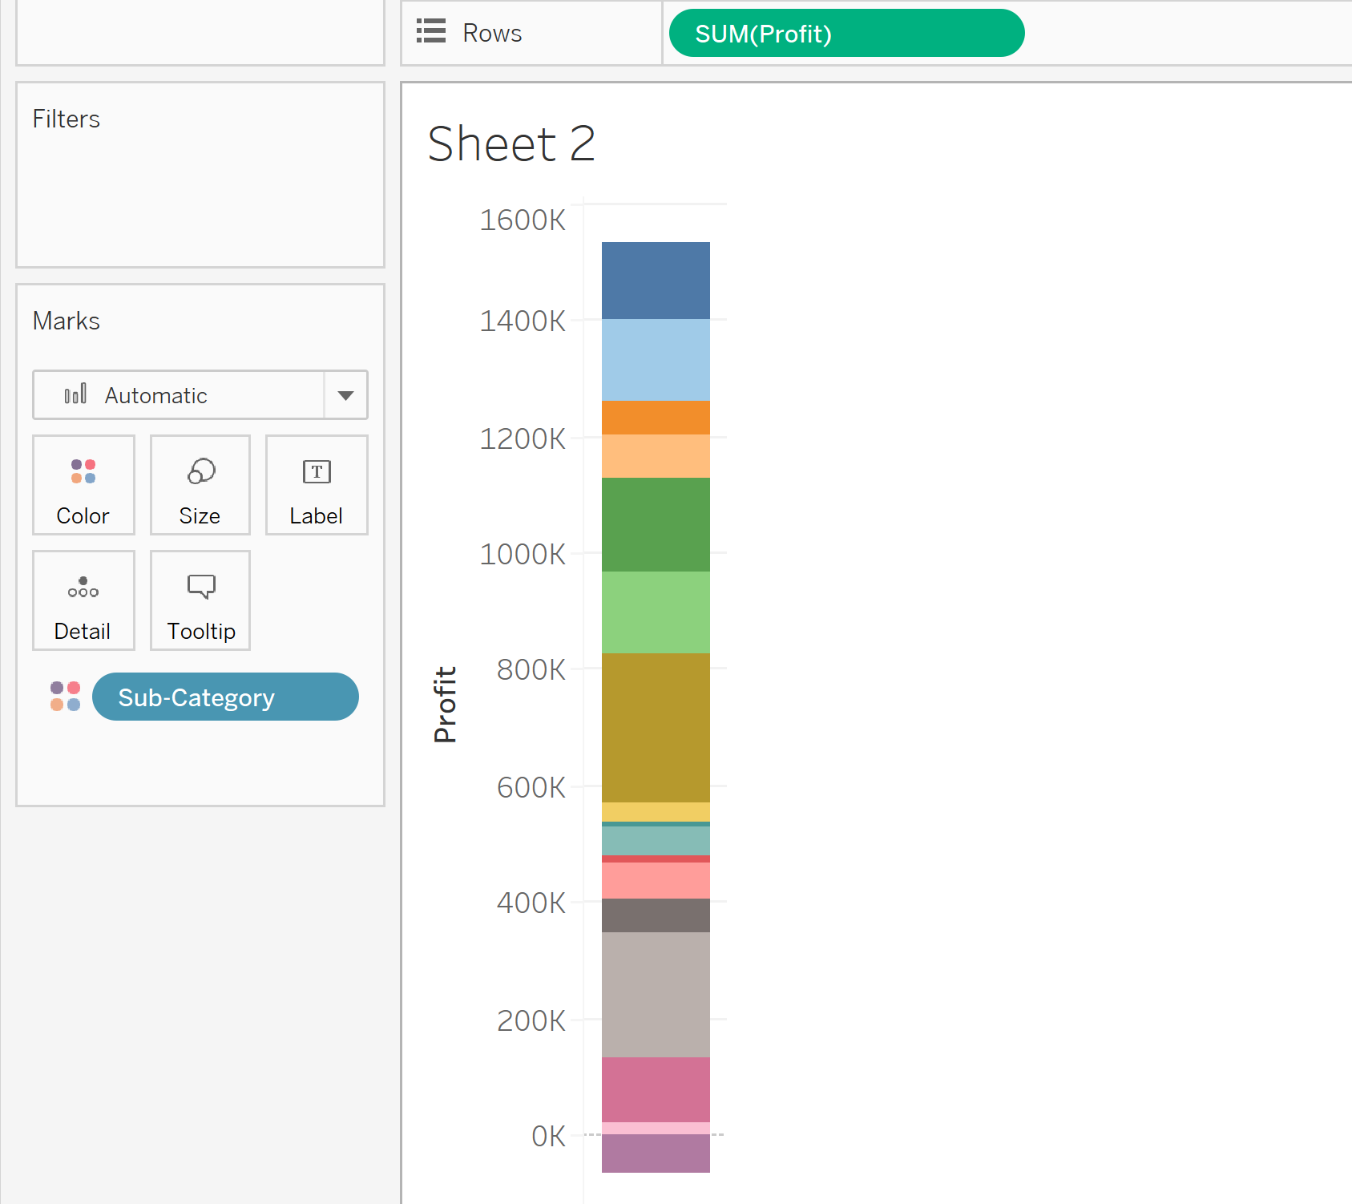

Step 3:On the Top side in the show me window , click pie chart

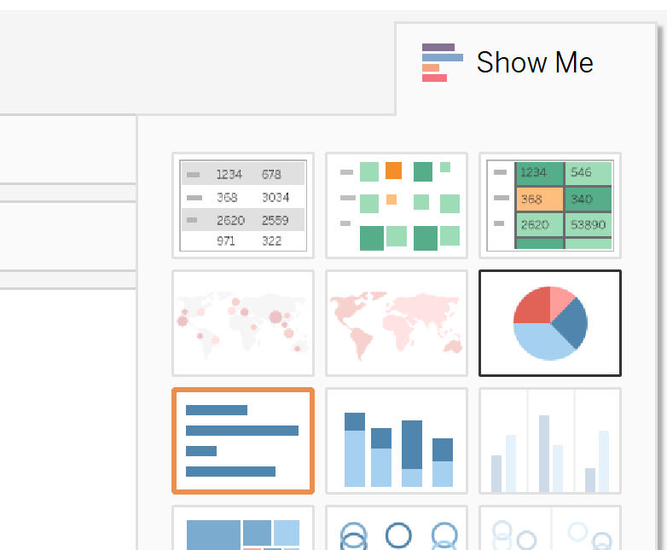

Step 4: Drag the Profit measure into Labels in the Marks. Then right click the SUM(Profit) from the Marks , Select Quick Table Calculation and then click Percent of Total as shown below

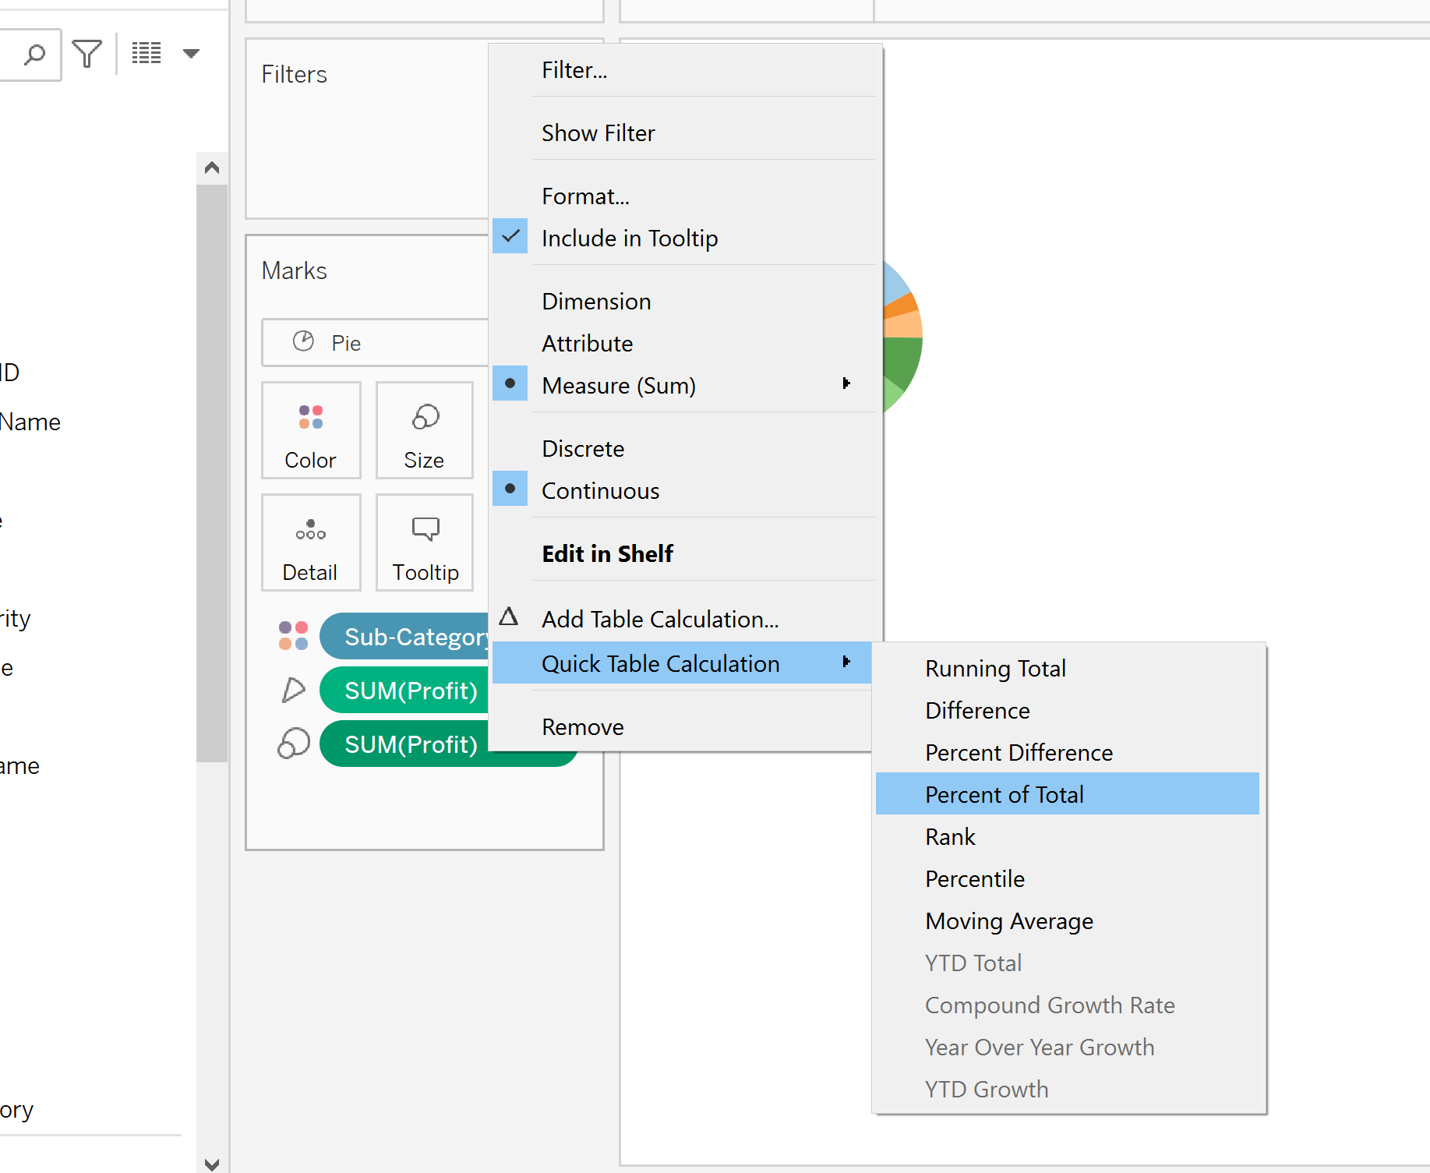

Step 5:Right click the SUM(Profit) , select Format and change the font to black color and Click Bold. Now we can visualize the Profit percentage for each sub-category as shown below

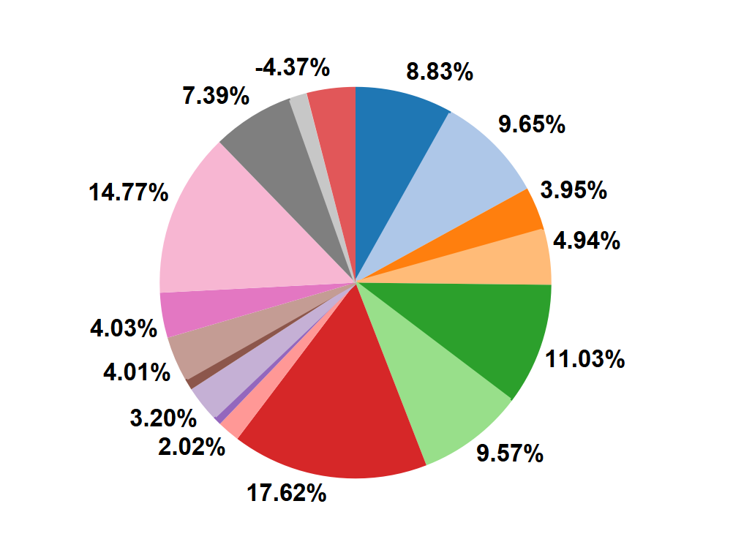

**Visualization 3: Creating a line chart for Visualizing Monthly Sales and Profit Trend**

Step 1: On a new sheet, drag Subcategory to Filter and select Tables and Click Ok.

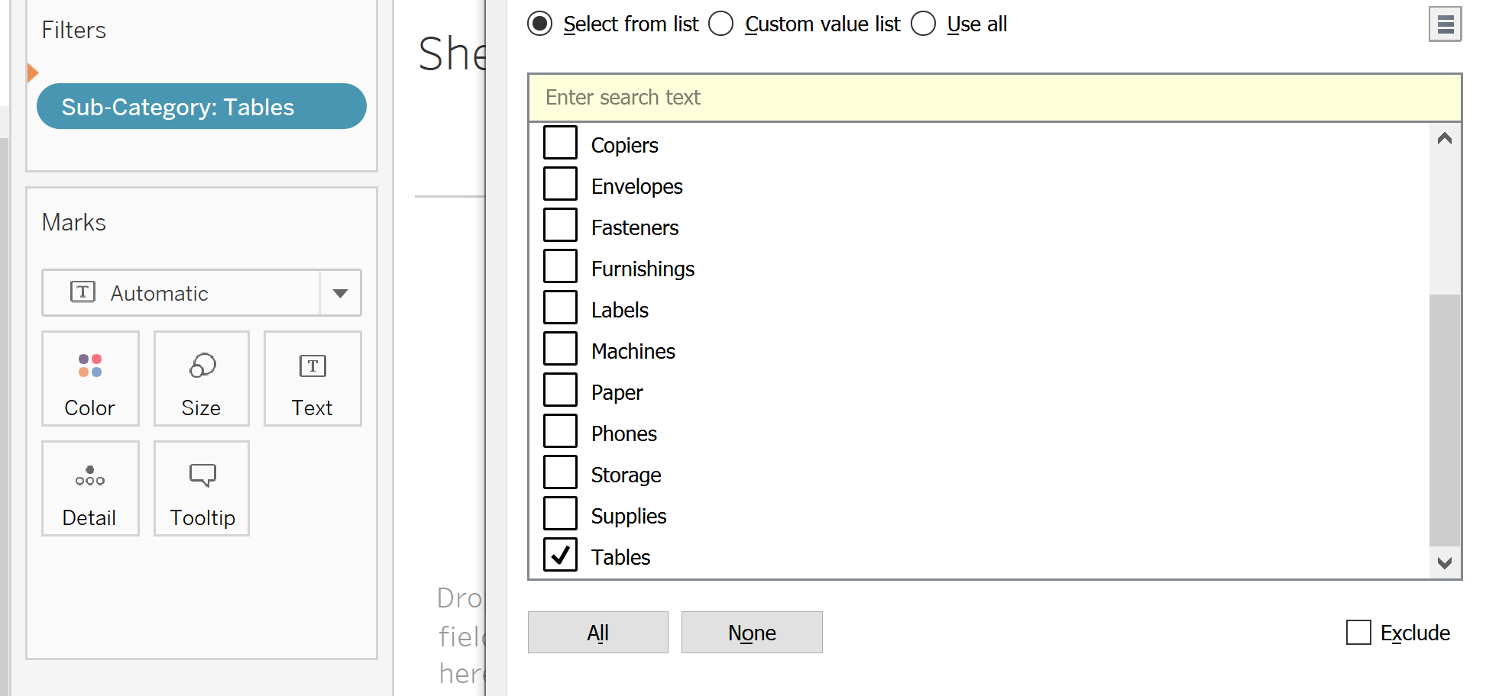

Step 2: Drag the Order date to Columns , Sales and Profit Measures to rows. Select Month of the Order date and change it continuous

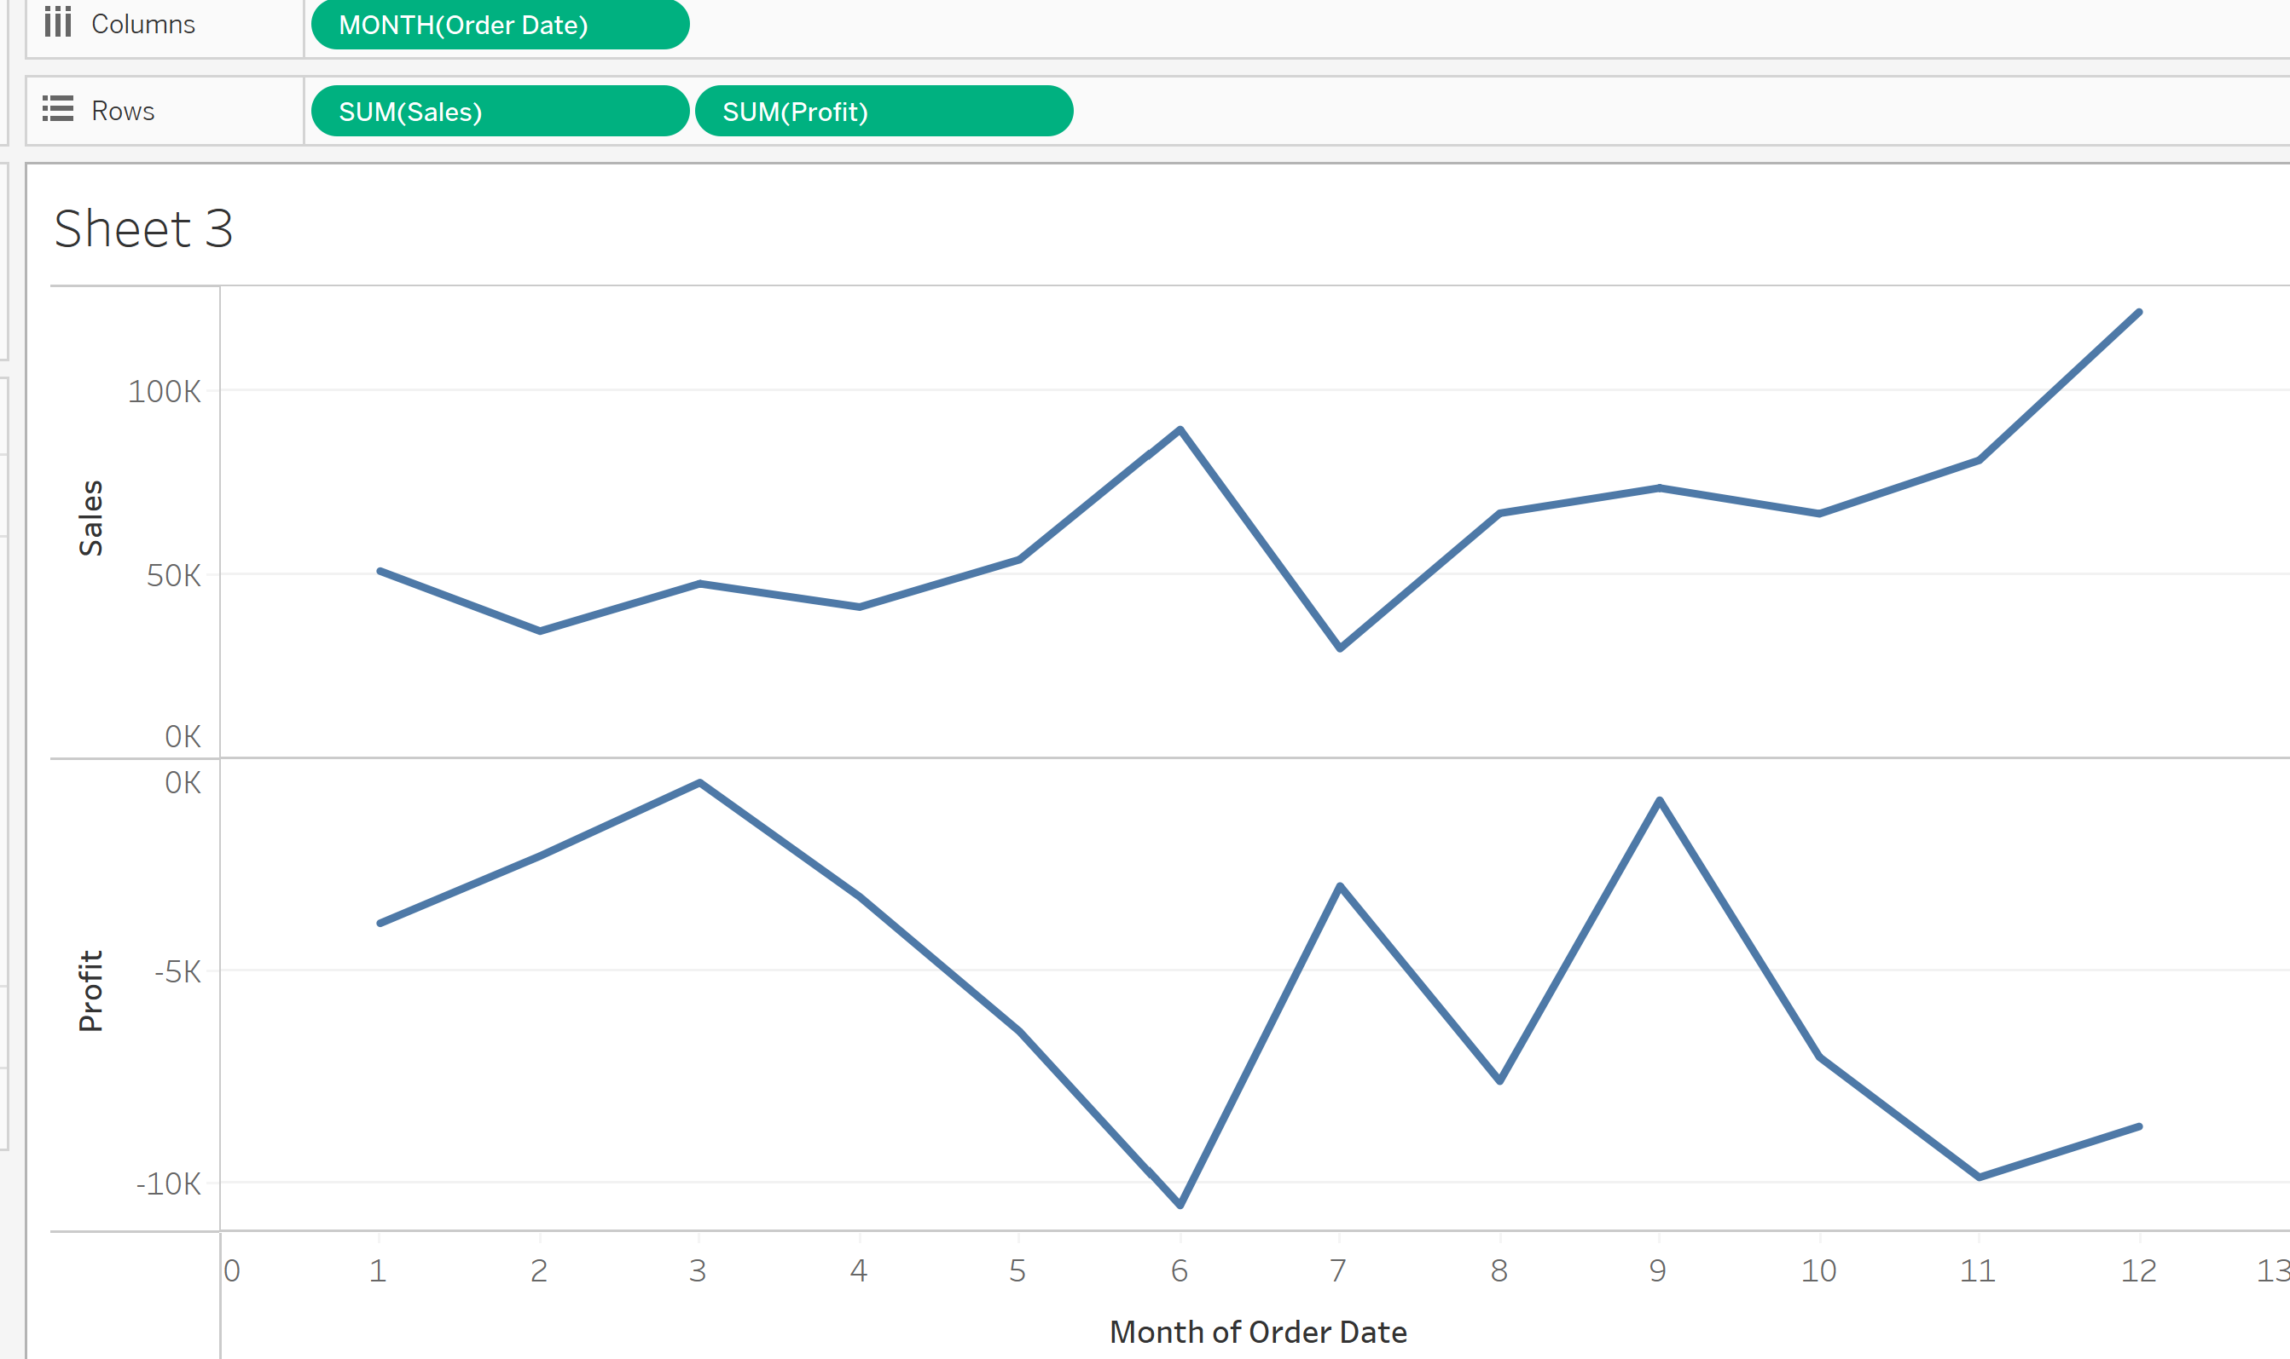

Step 3:To create a dual axis , drag the SUM(Profit) to right side of the axis , when you see the black dotted lines, release the pill.

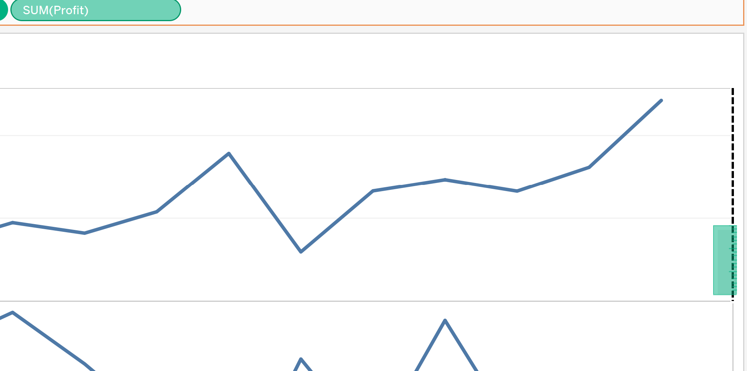

Step 4:Right the Profit axis and select Synchronize Axis.

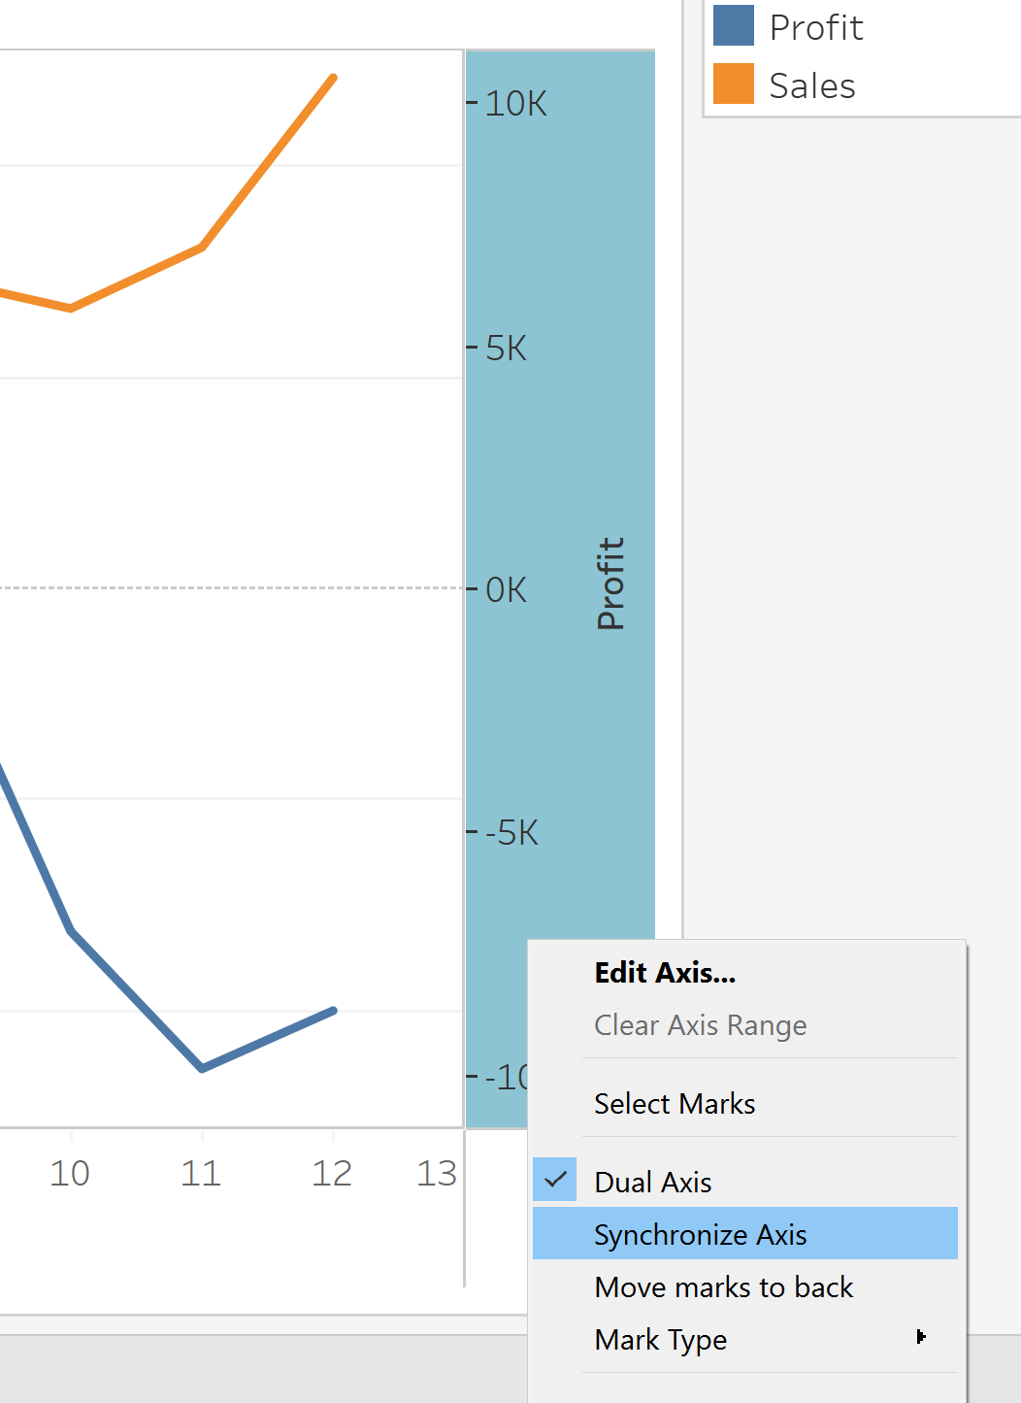

Step 5: Format the axis ,change the font to black color and Bold .Change the Numbers to Custom🡪Display Units: Thousands (K) and reduce the Decimal values to 0. Change the Color of Labels in color Mark to blue and green. The final output should like the below one.

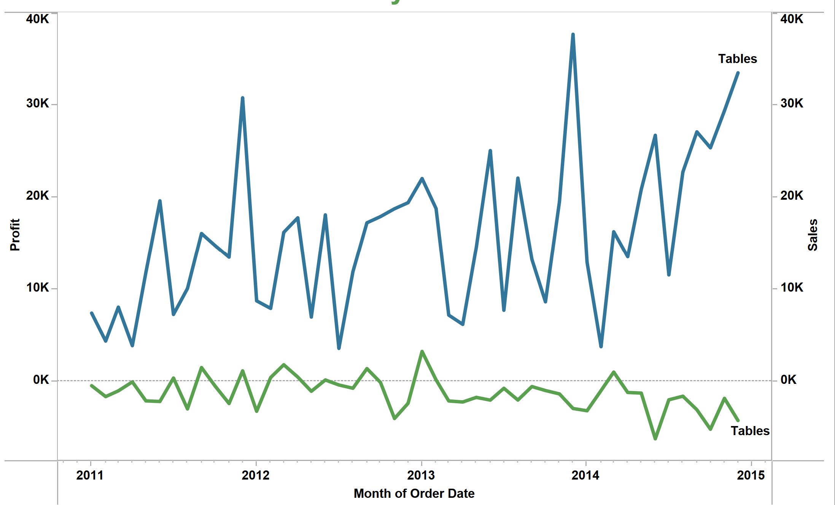

**Visualization 4: Creating a bar chart for comparing Profit within the sub-category**

Step 1: Drag the category into Filter shelf and include only Furniture.

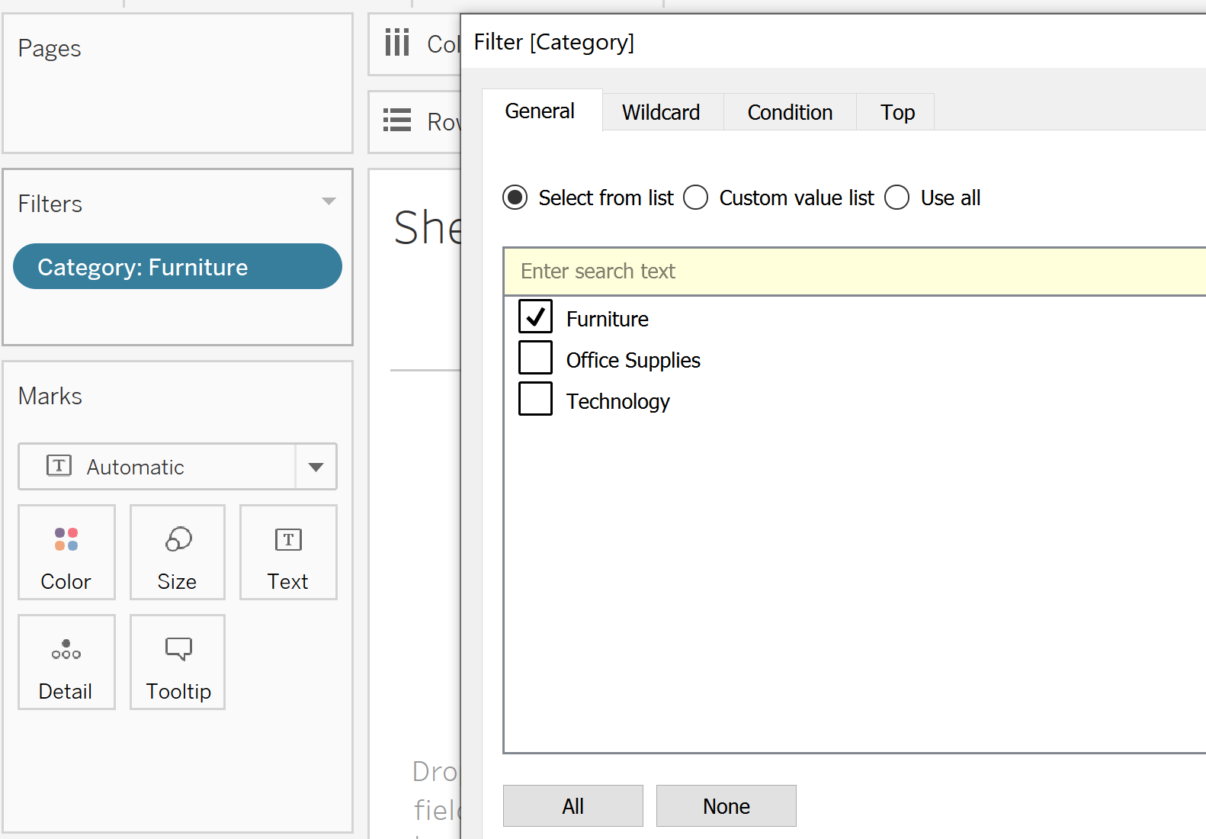

Step 2:Drag the Profit measure into Columns and color in the Labels shelf. Sub-category into Rows and Color Marks

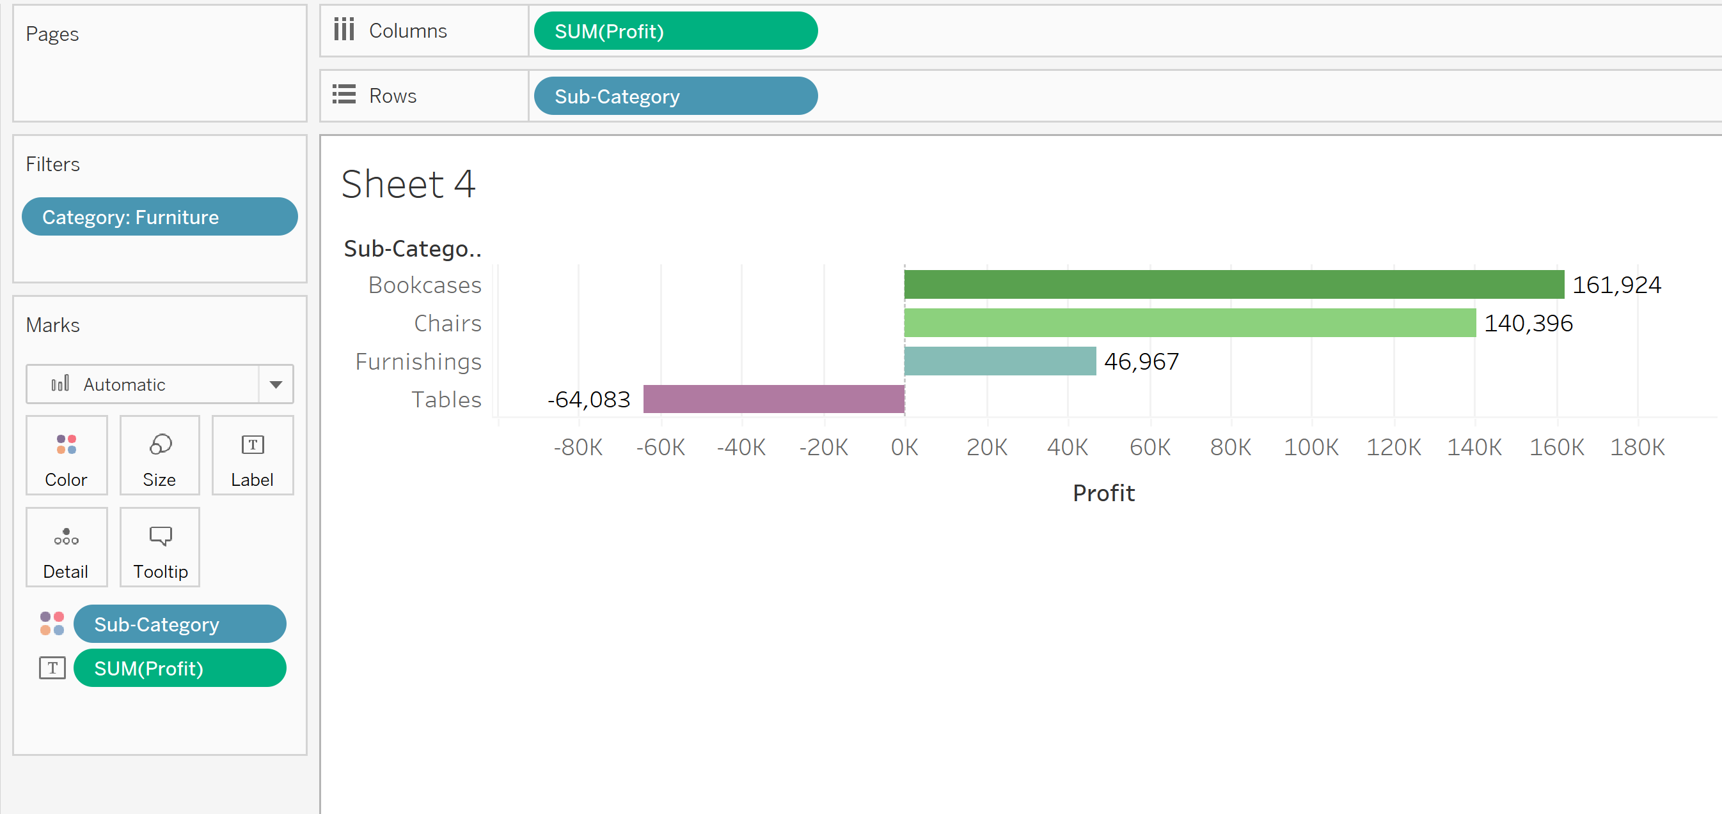

Step 3:Sort the bar chart by clicking sort icon ascending as shown below

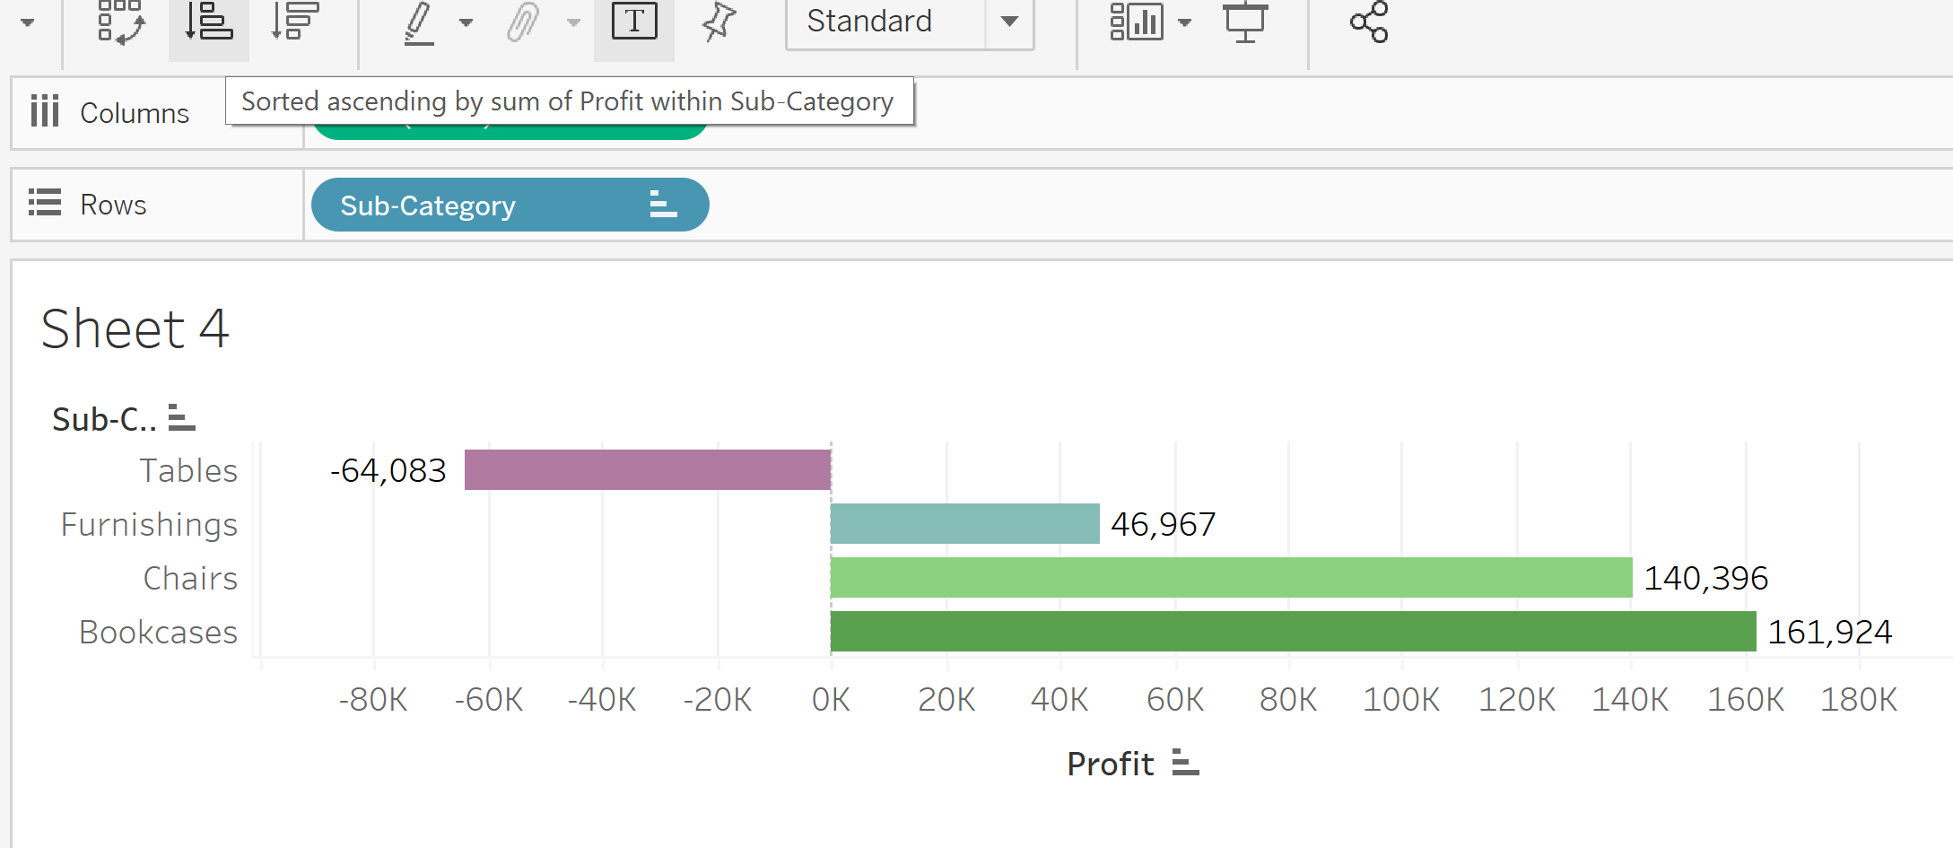

Step 4: Format the axis ,change the font to black color and Bold .Change the Numbers to Custom🡪Display Units: Thousands (K) and reduce the Decimal values to 0.

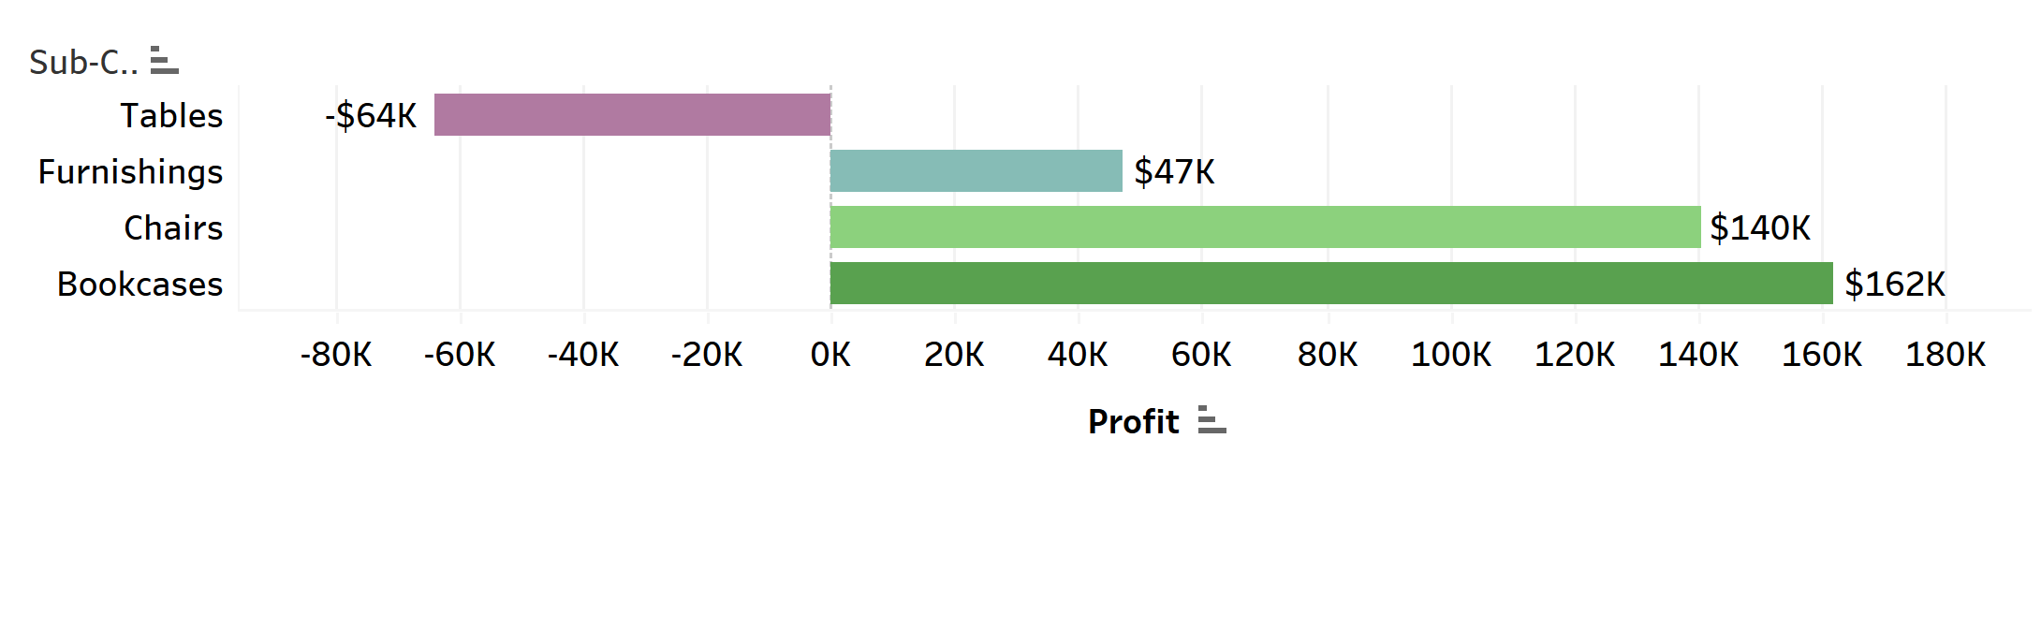

**Visualization 5: Comparing Sales and Profit for each order id placed by customer for Tables**

Step 1: Drag the category into filter and select furniture. Drag the sub-category into filter and select tables.

Step 2: Drag the Sales measure into column and Profit into Rows. Drag the Order ID into Color Marks. Drag the Sub-category into tooltip.

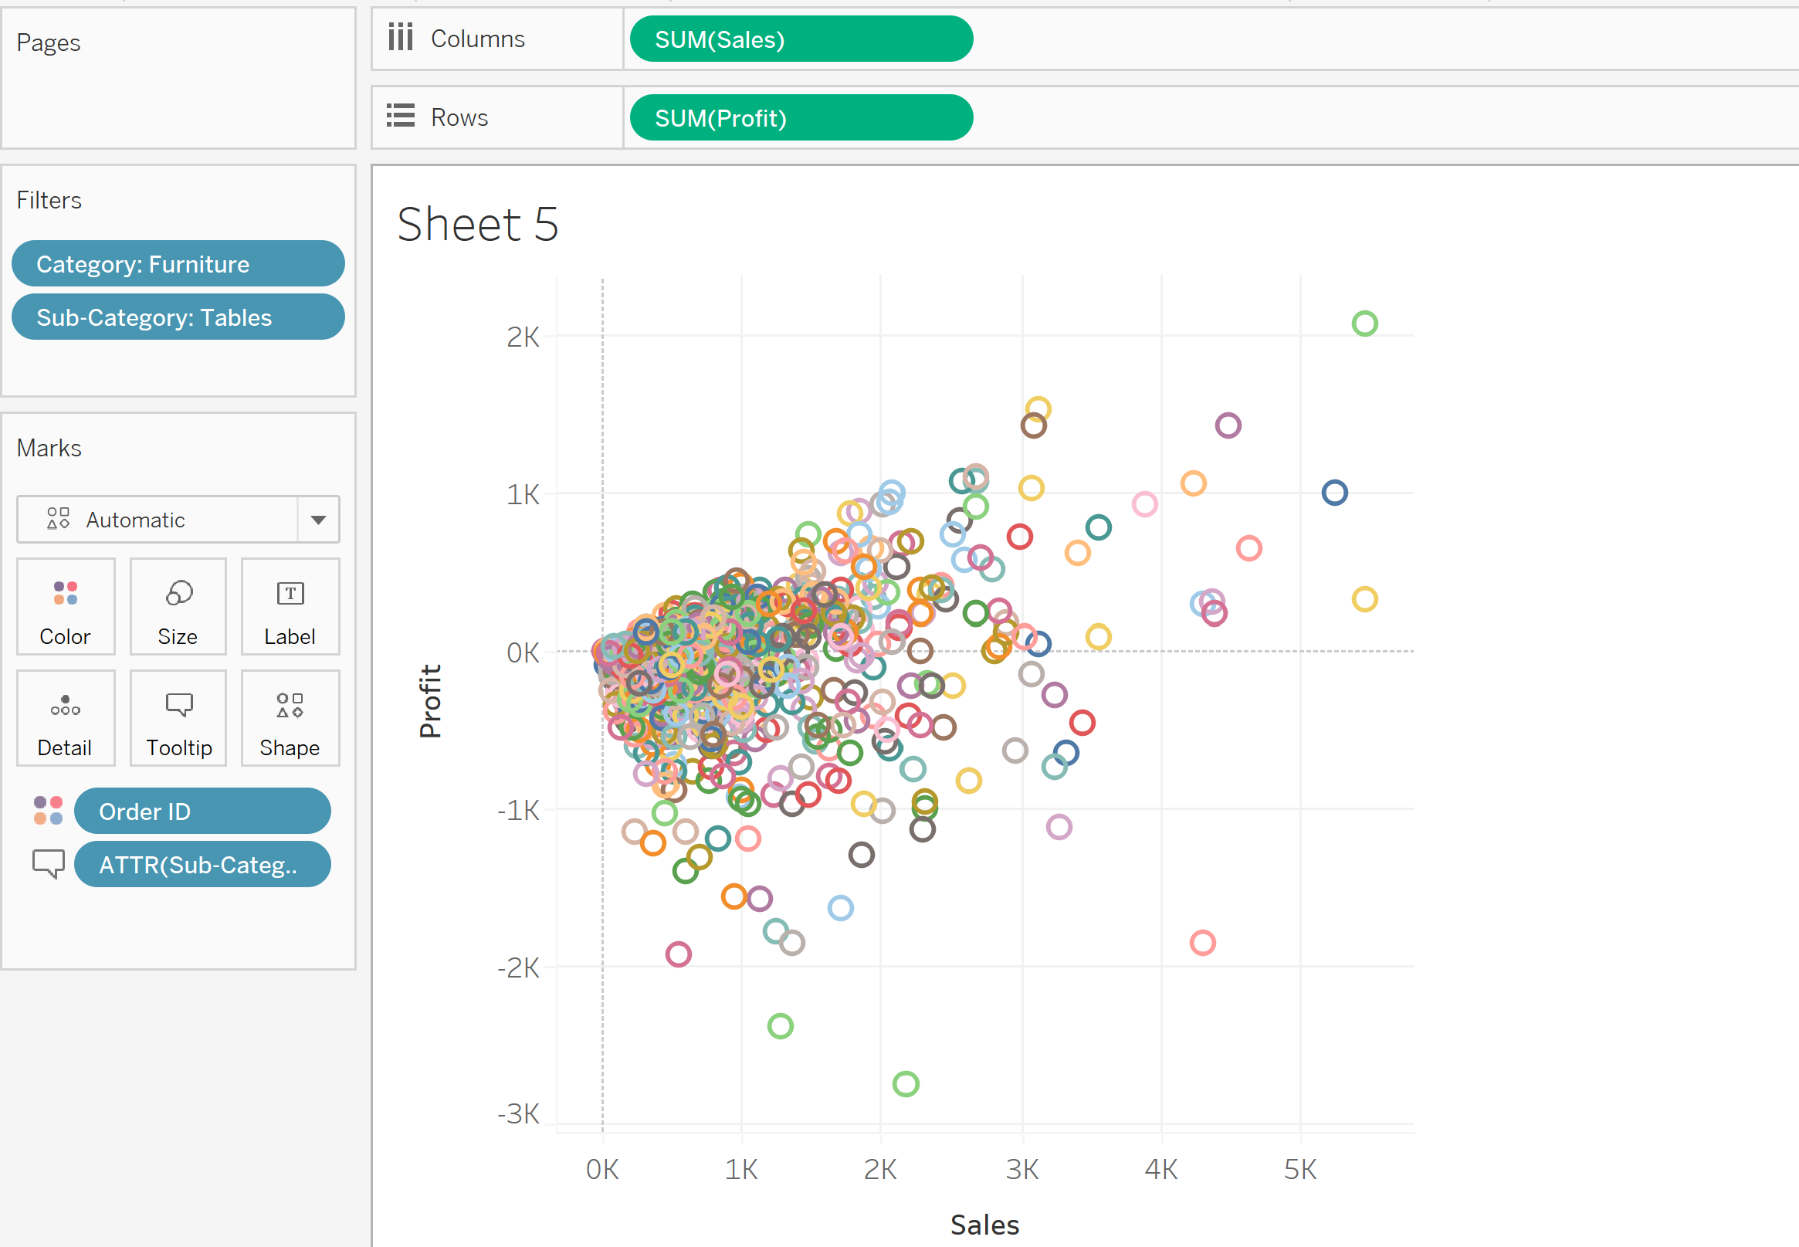

Step 3: In the Marks shelf , change Automatic into Circle

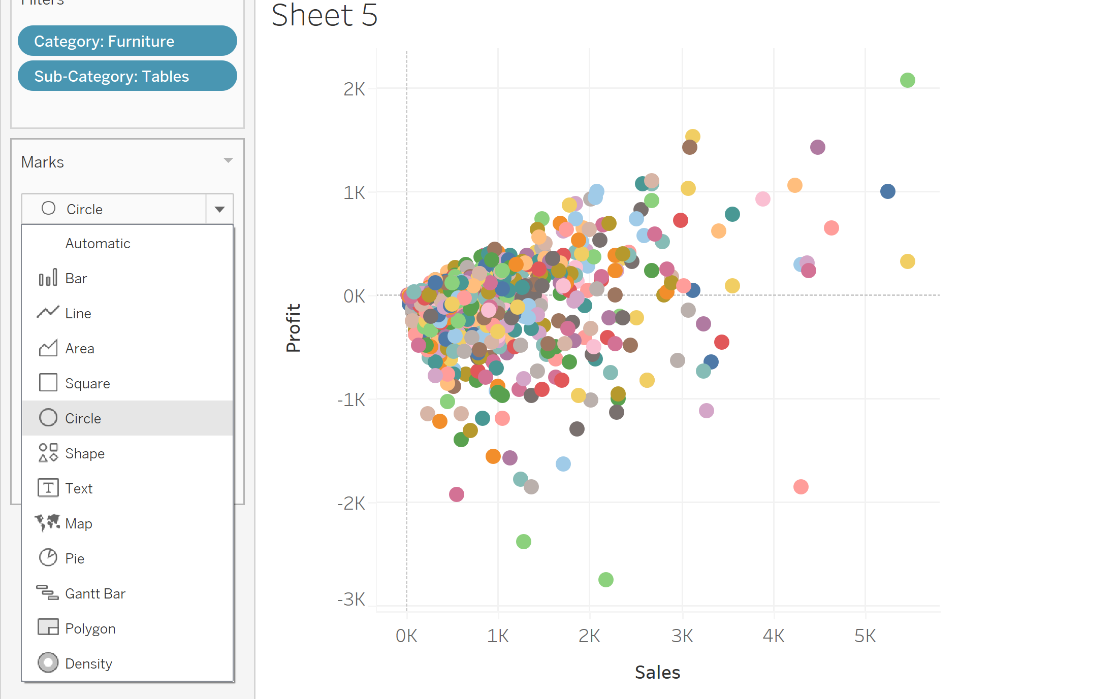

Step 4: Format the axis ,change the font to black color and Bold .Change the Numbers to Custom🡪Display Units: Thousands (K) and reduce the Decimal values to 0.

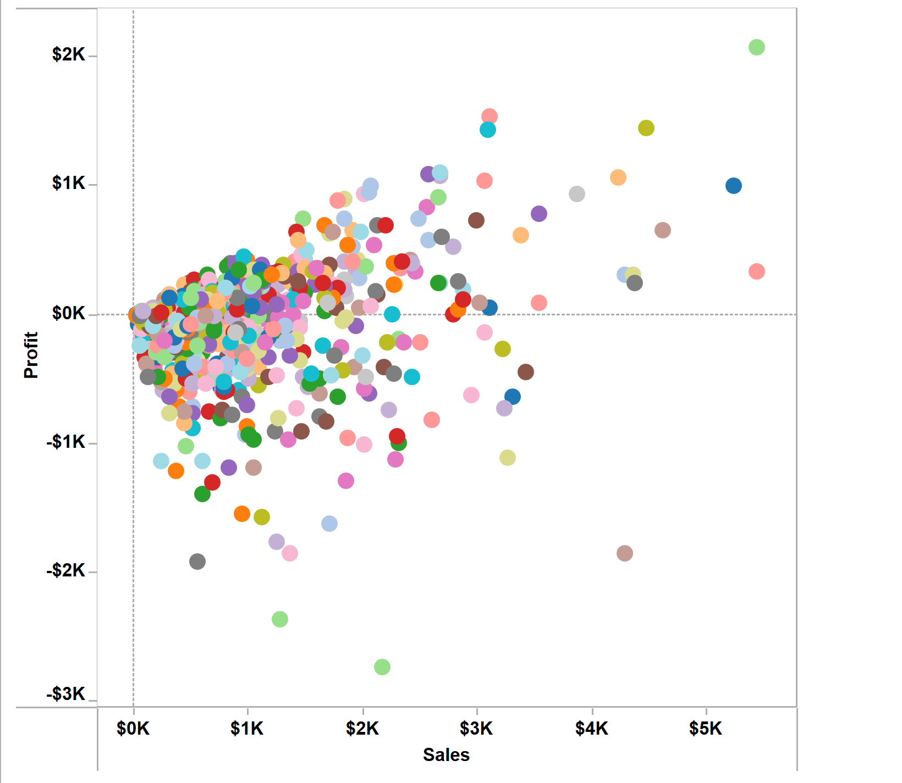

**Visualization 6: Creating Gant chart for visualizing how quick the orders are processed**

Step 1:First let’s calculate order duration using the Calculated Field. Click Analysis , select Create Calculated Field and name it as Duration. Using DATEDIFF function we are calculating the number of days it took for processing the order. Enter the formula DATEDIFF('day',[Order Date],[Ship Date]) and click Ok.

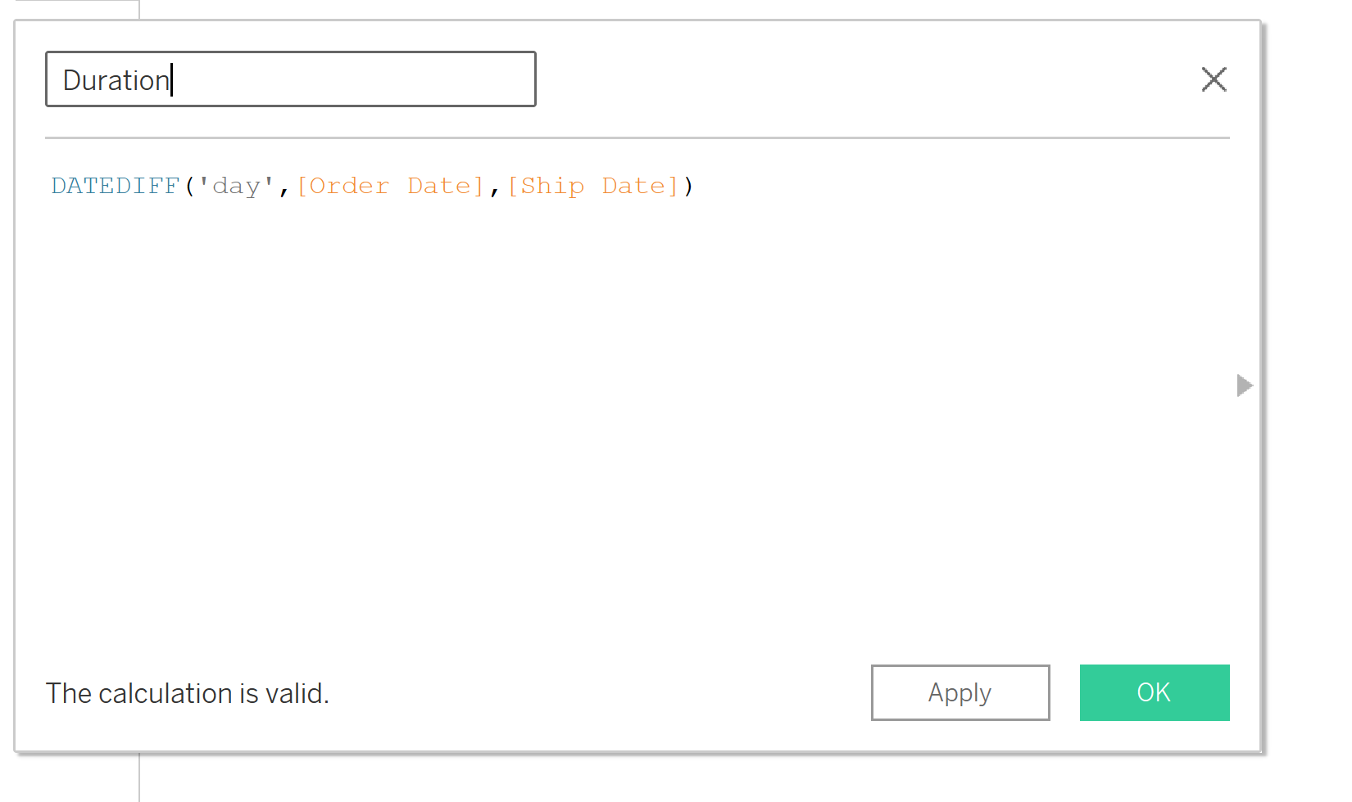

Step 2: Drag the category into filter and select furniture. Drag the sub-category into filter and select tables.

Step 3: Drag the Calculated Field Duration into Columns, Order Id ,Order Date and Ship Date into Rows

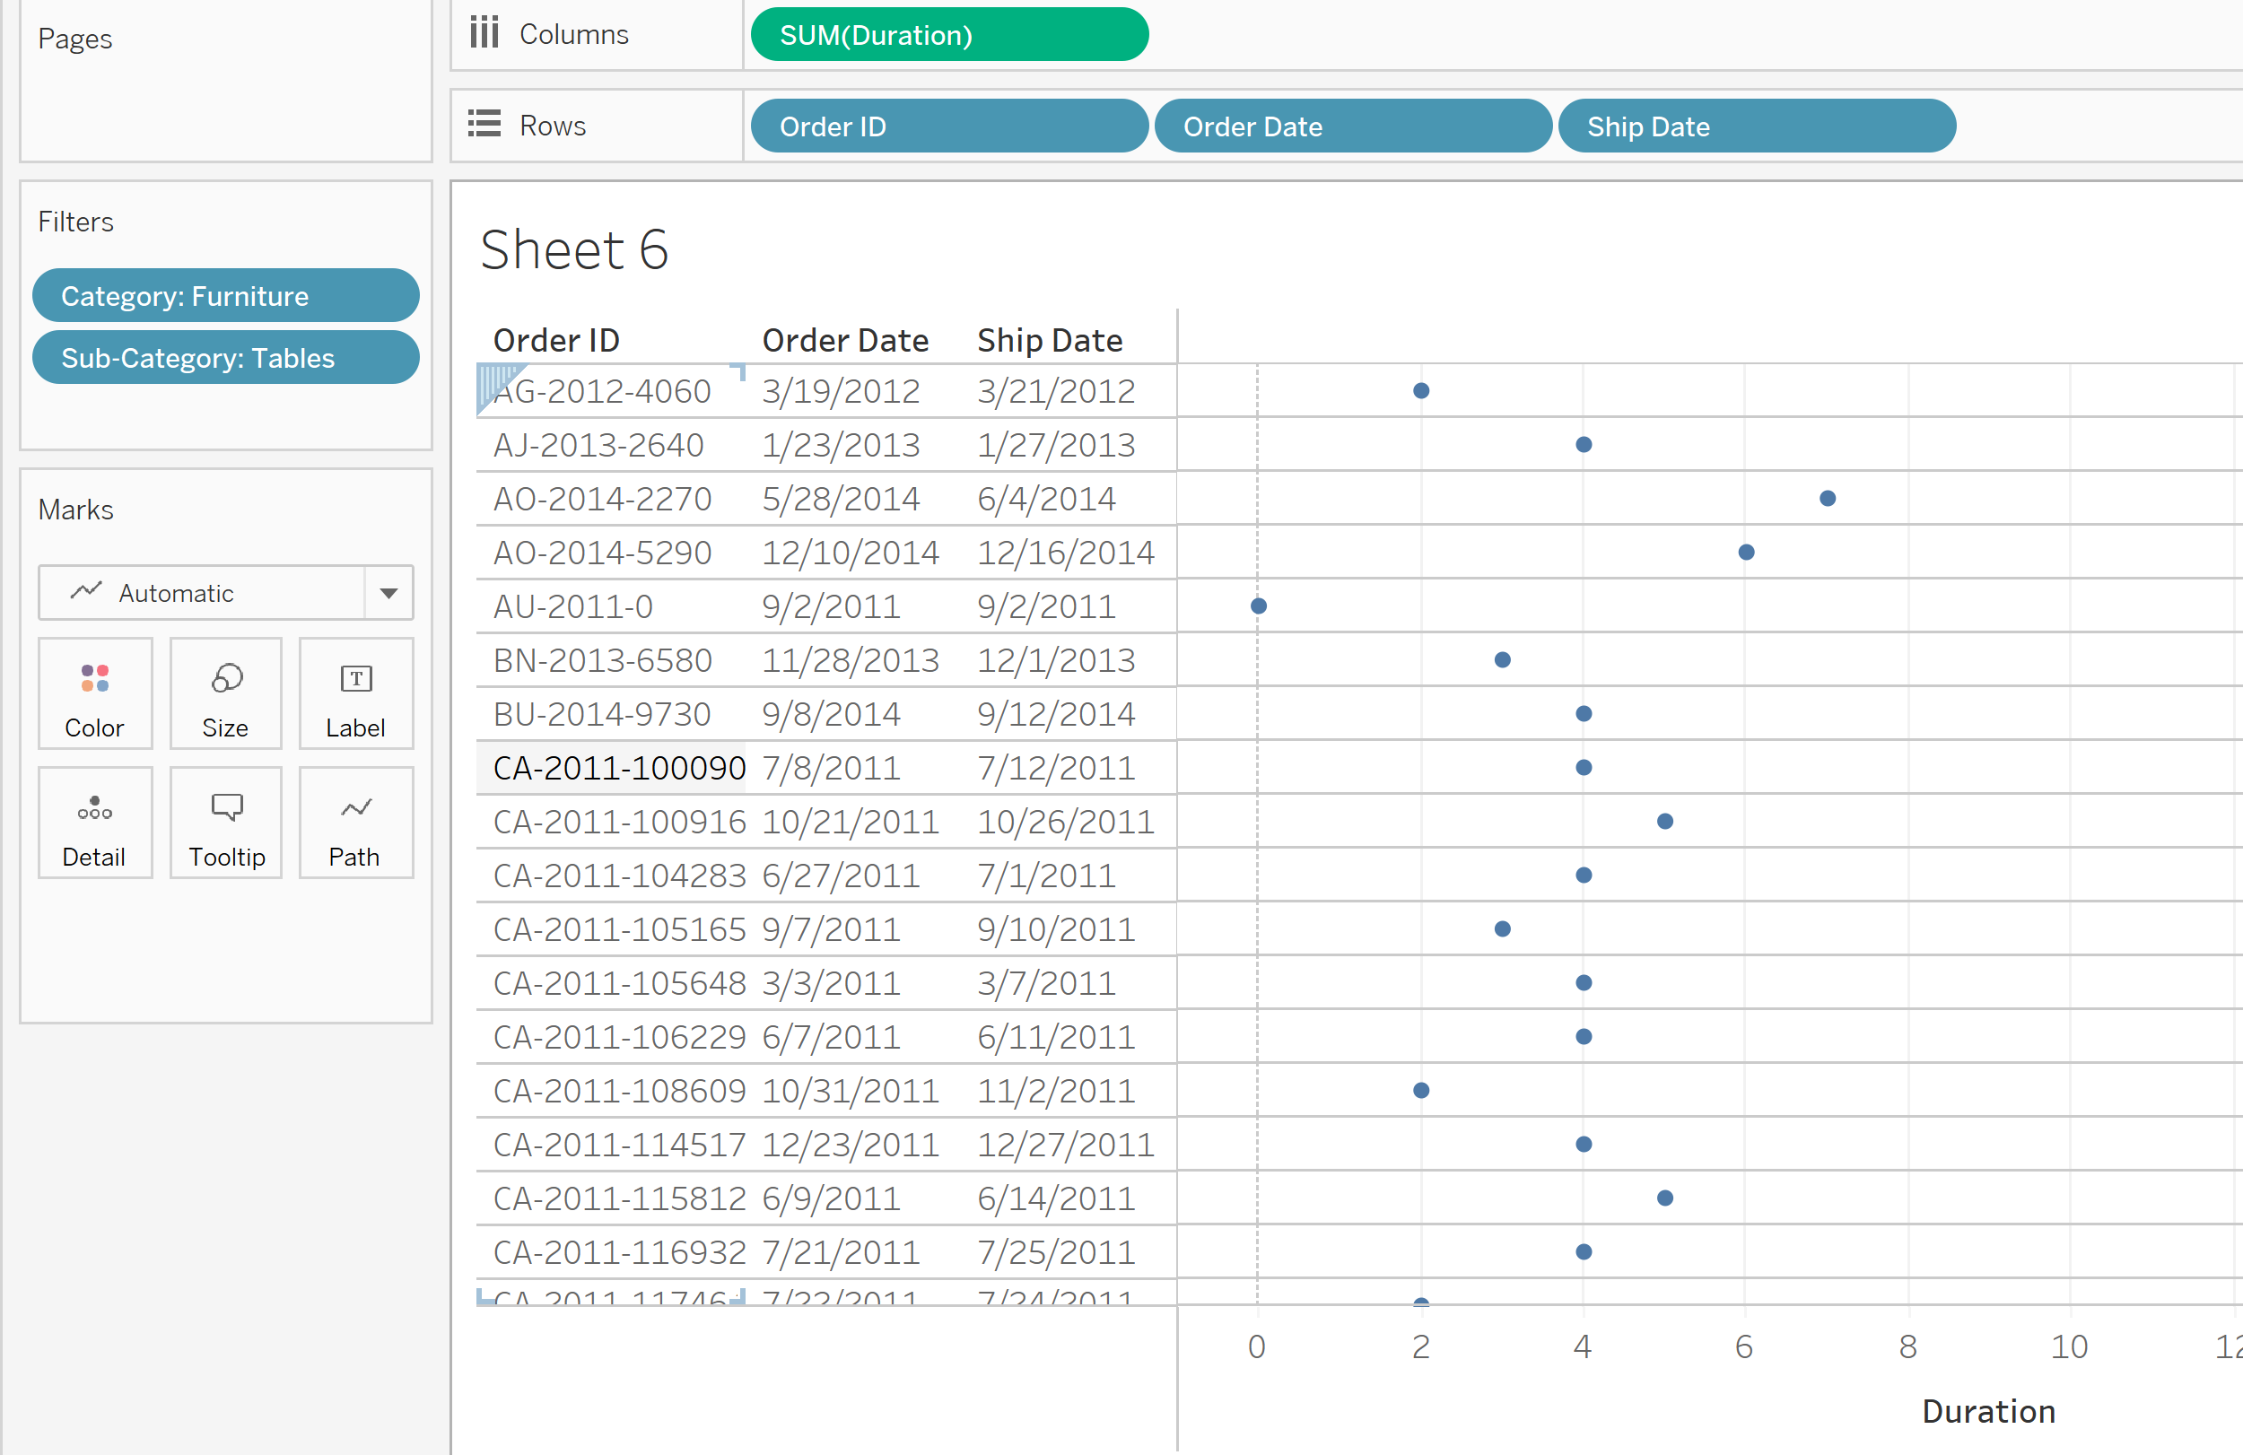

Step 4: In the Marks Pane, click the Automatic and change it to Gant Bar as shown below

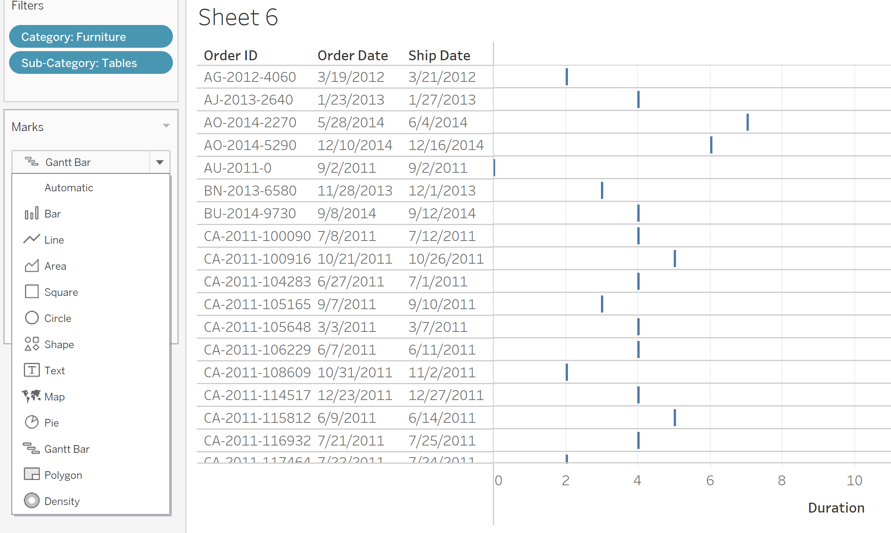

Step 5: Drag the Order Priority dimension into color. Drag the Duration into size

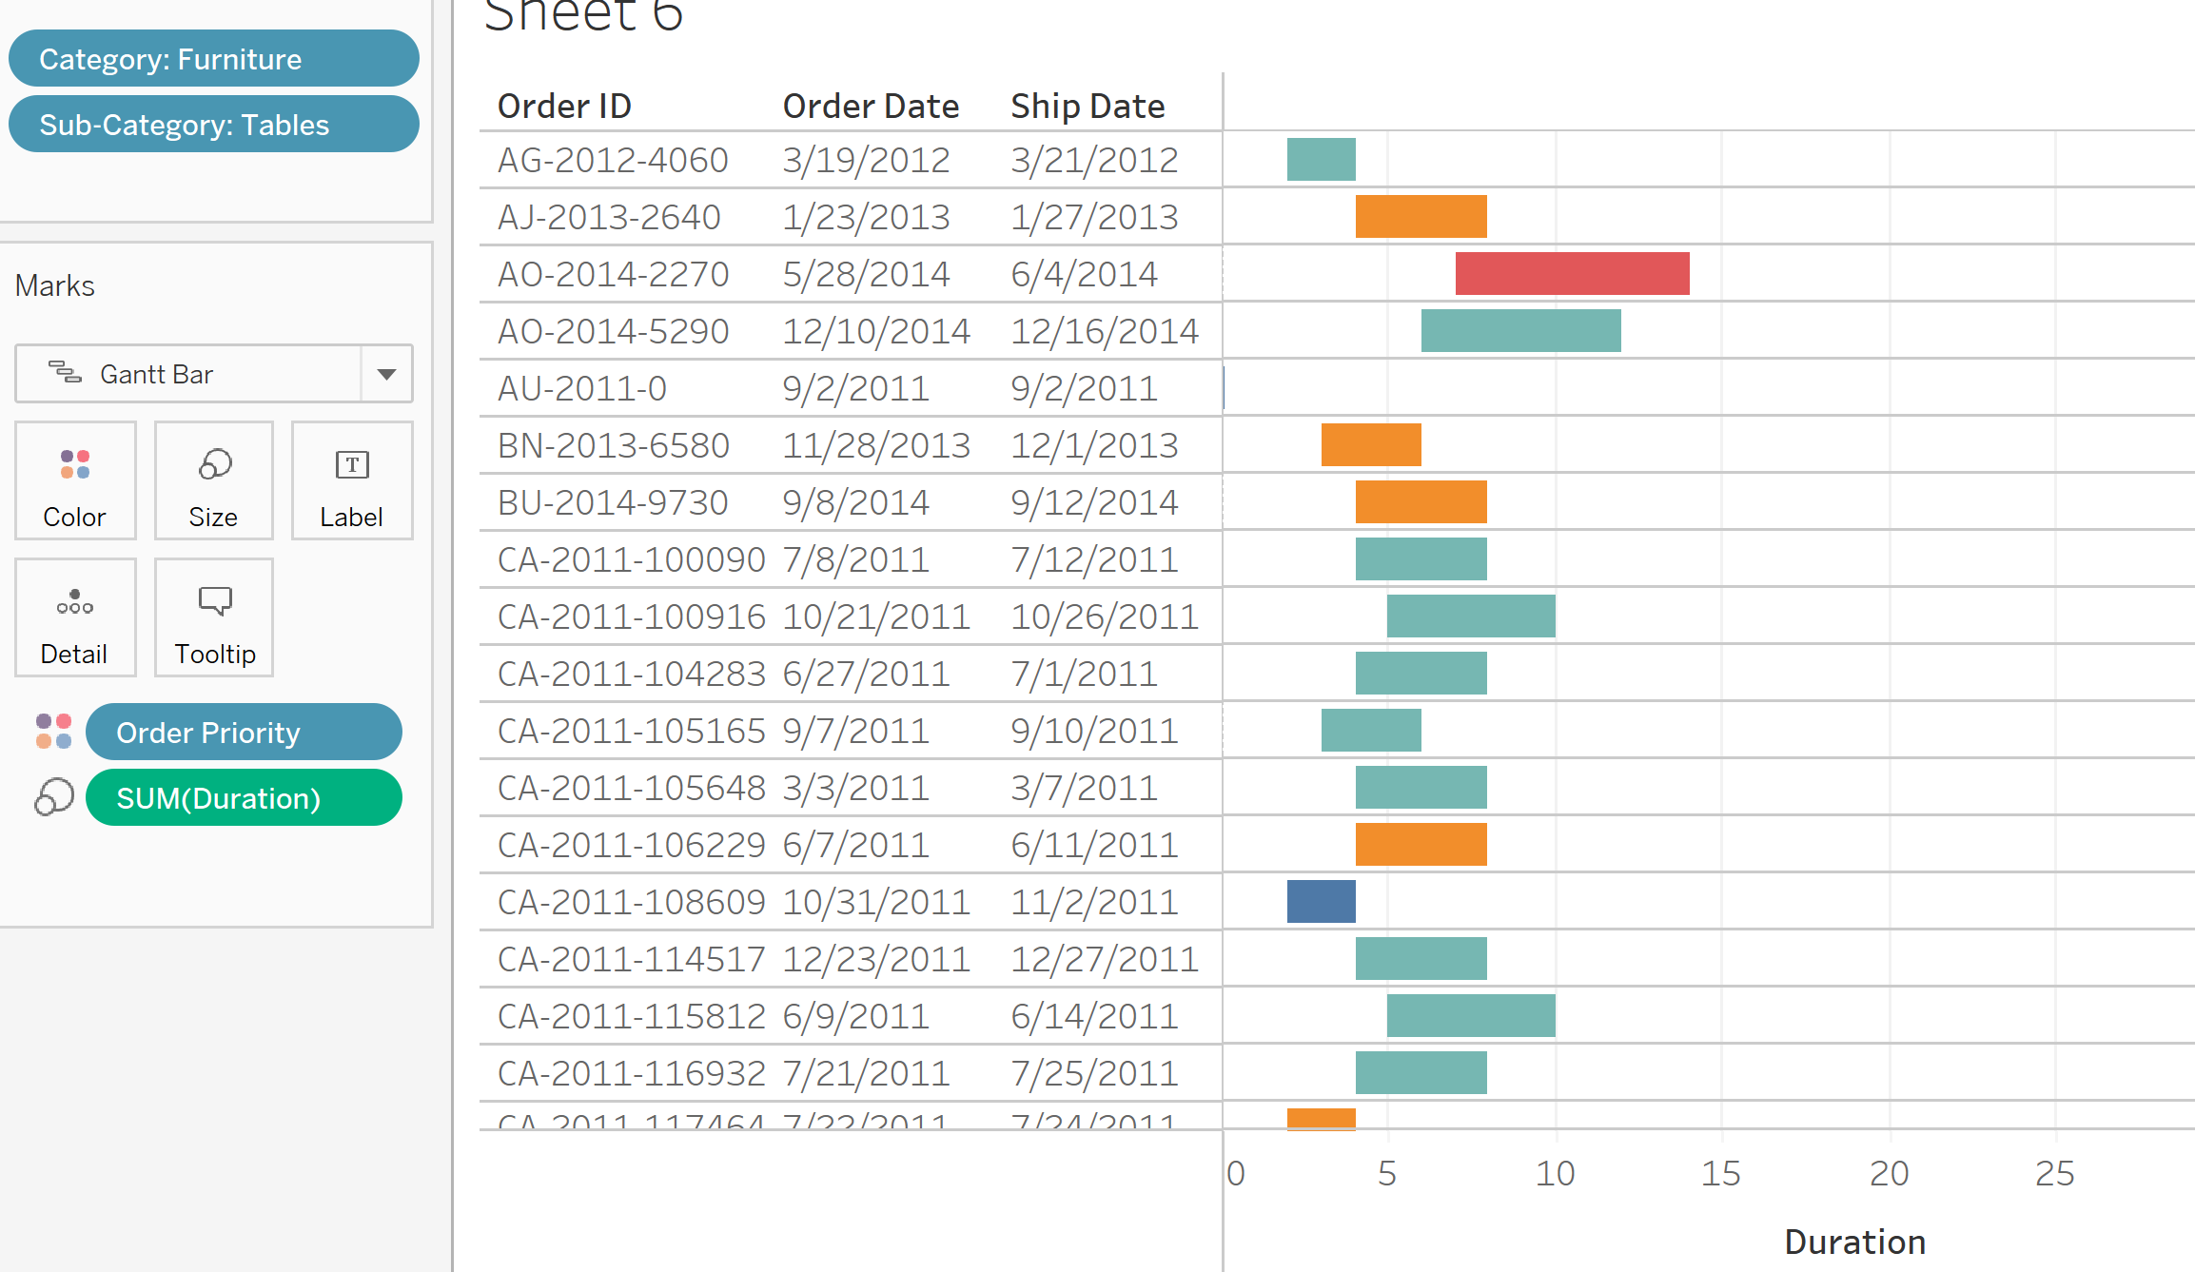

Step 6: Change the color into black and font into Bold . Final graph should look like below

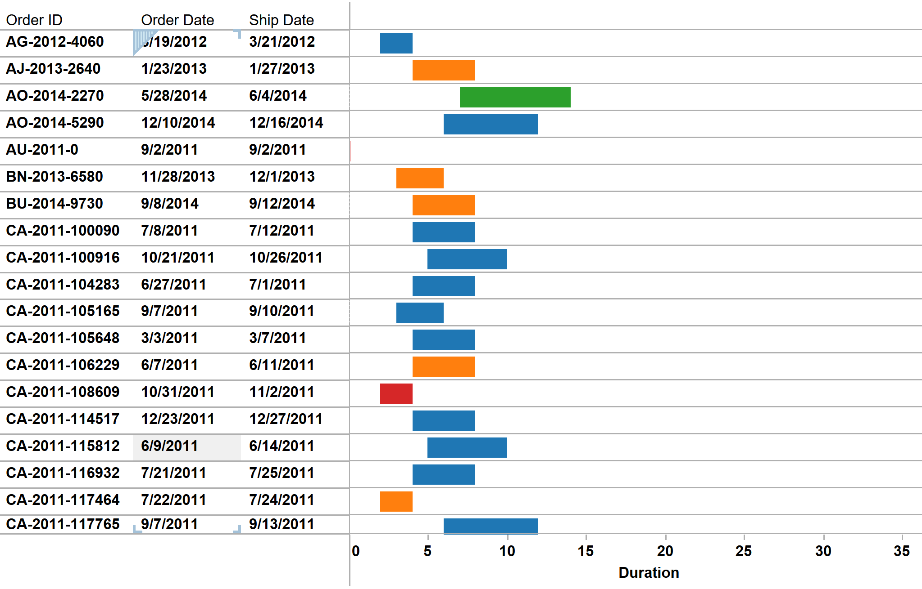

**Visualization 7: Creating a bar chart Visualizing the shipping cost**

Step 1: Drag the category into filter and select furniture. Drag the sub-category into filter and select tables.

Step 2: Drag the Profit, Sales ,Shipping cost into column and Product names into Row

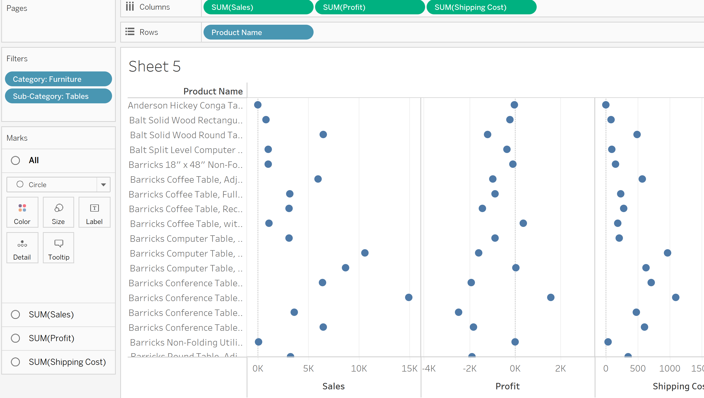

Step 3:Click the Show Me icon and select the horizontal bars

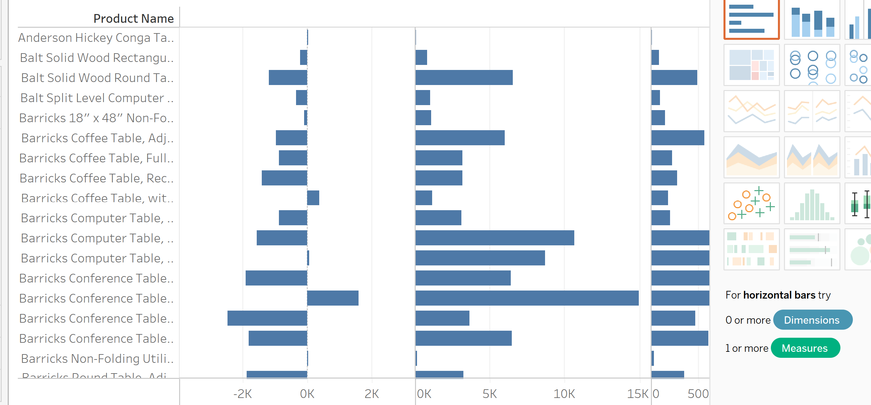

Step 4:click the color in Marks and change the color of Sales ,Profit and Shipping cost to green , red and blue .Format the Labels and Axis color and font.

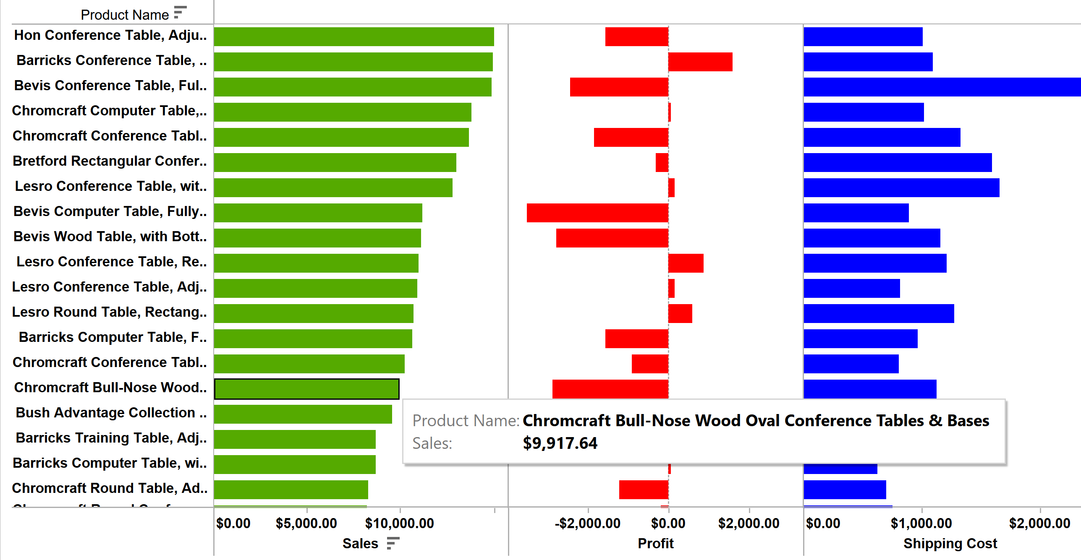

**Visualization 8: Creating a Bar chart to visualize the number of orders returned**

Step 1: Drag the sub-category into filter and select tables. Drag Returned and Sub-category into columns. Orders into rows. Change the Orders into count. Drag the Returns and Sales into Label

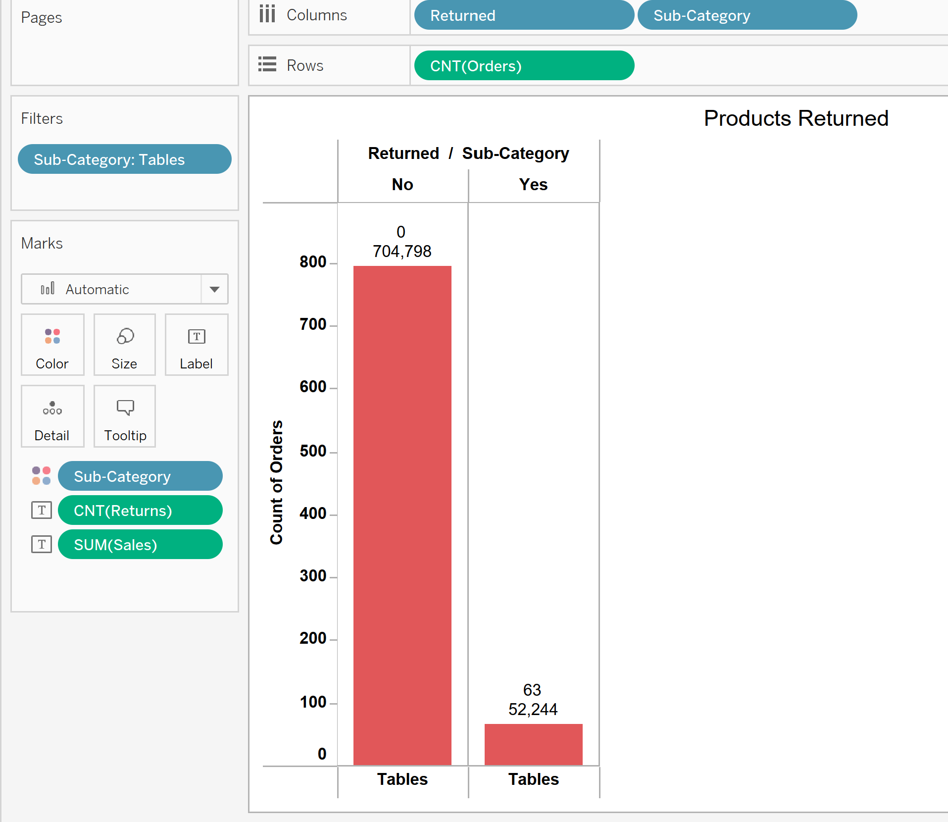

Step 2: In another sheet, drag the Market and Returned into column and Count into rows.

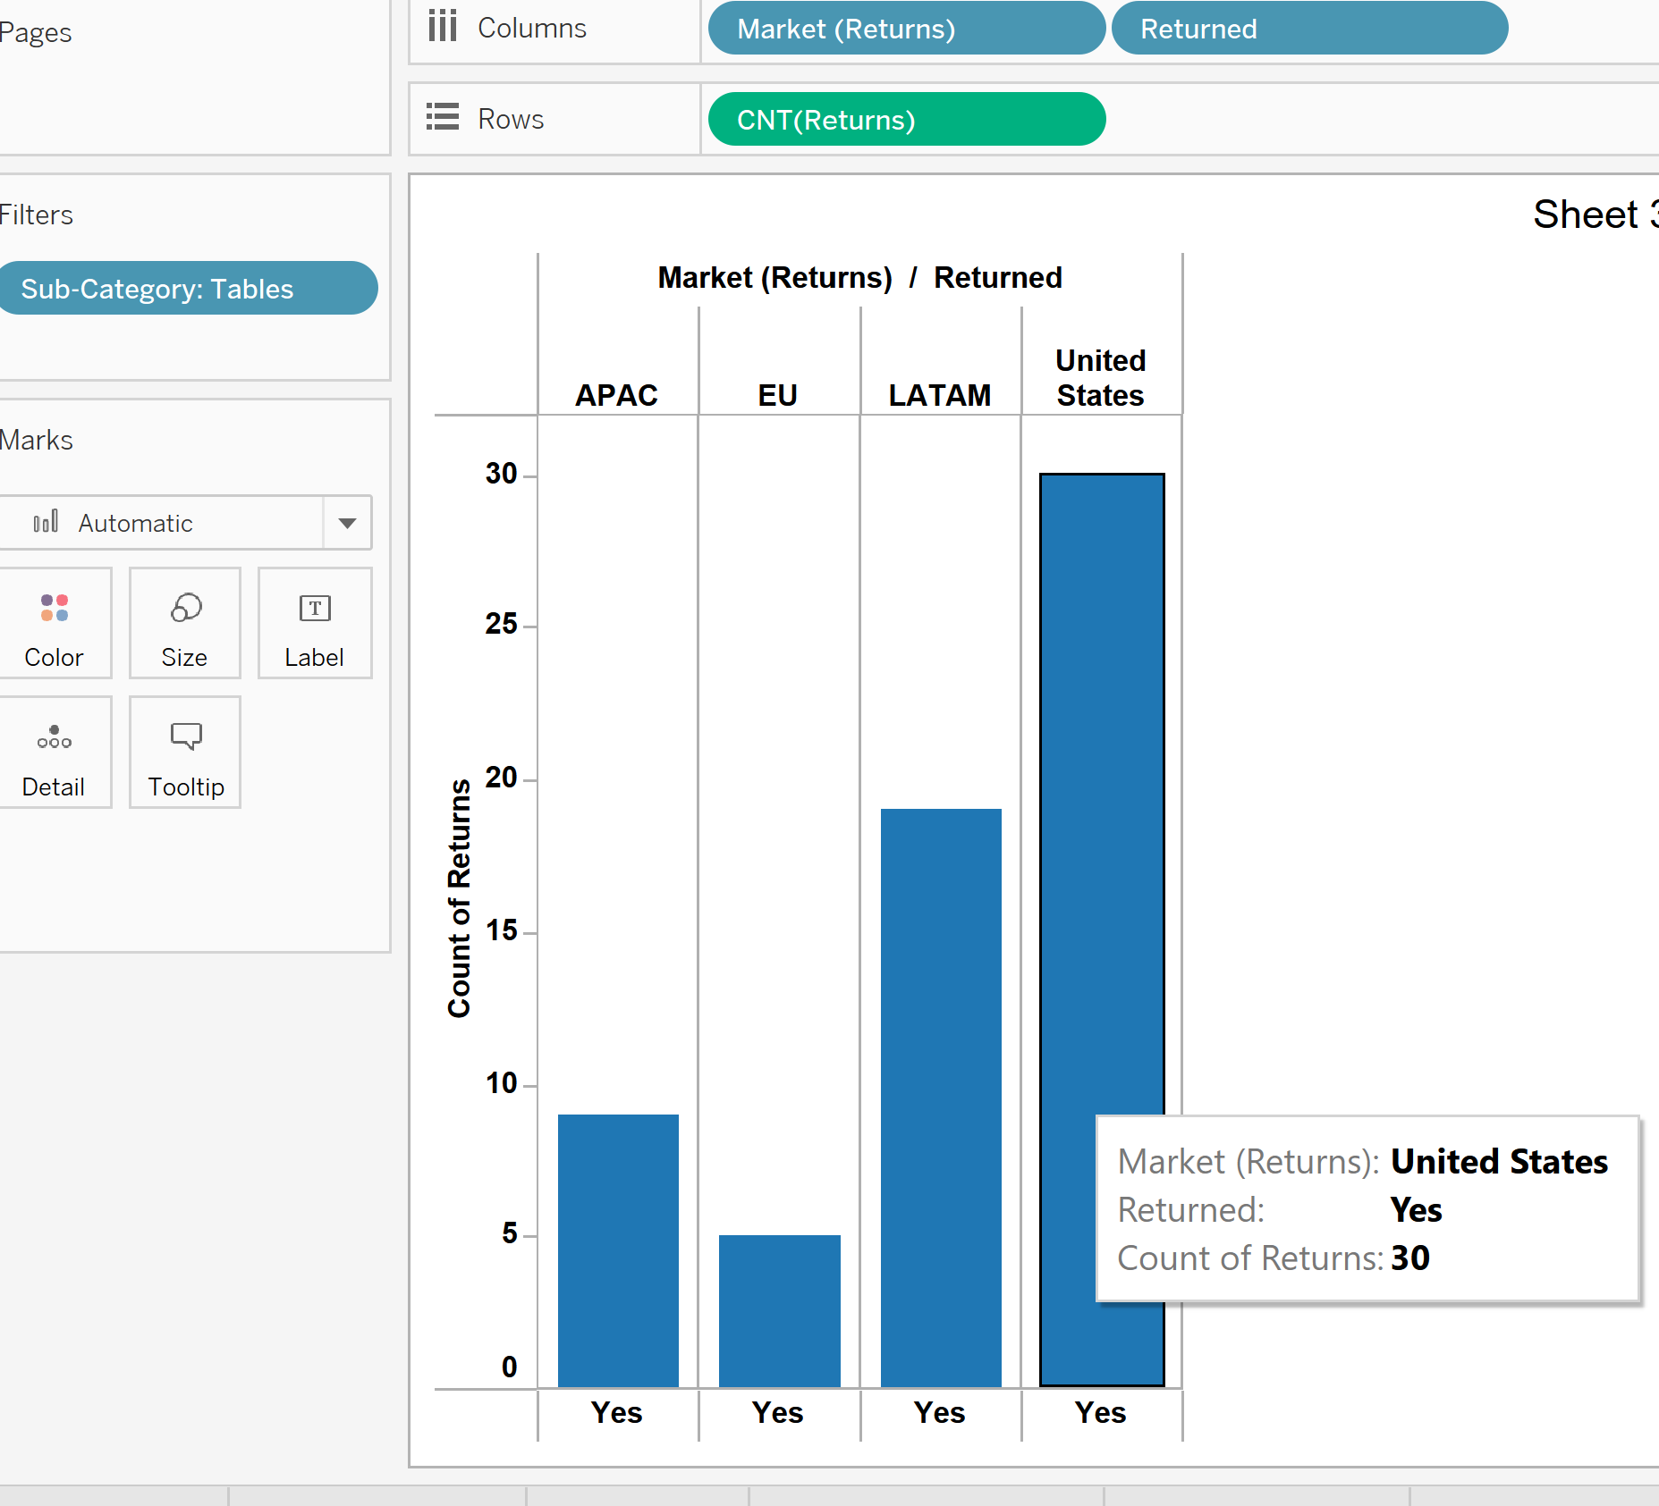

Step 3: In a new worksheet, drag the category into filter and select furniture. Drag the sub-category into filter and select tables. Drag the Person and Region into Columns and Sales into Rows. Drag the Sub-category into color and Profit into Labels.

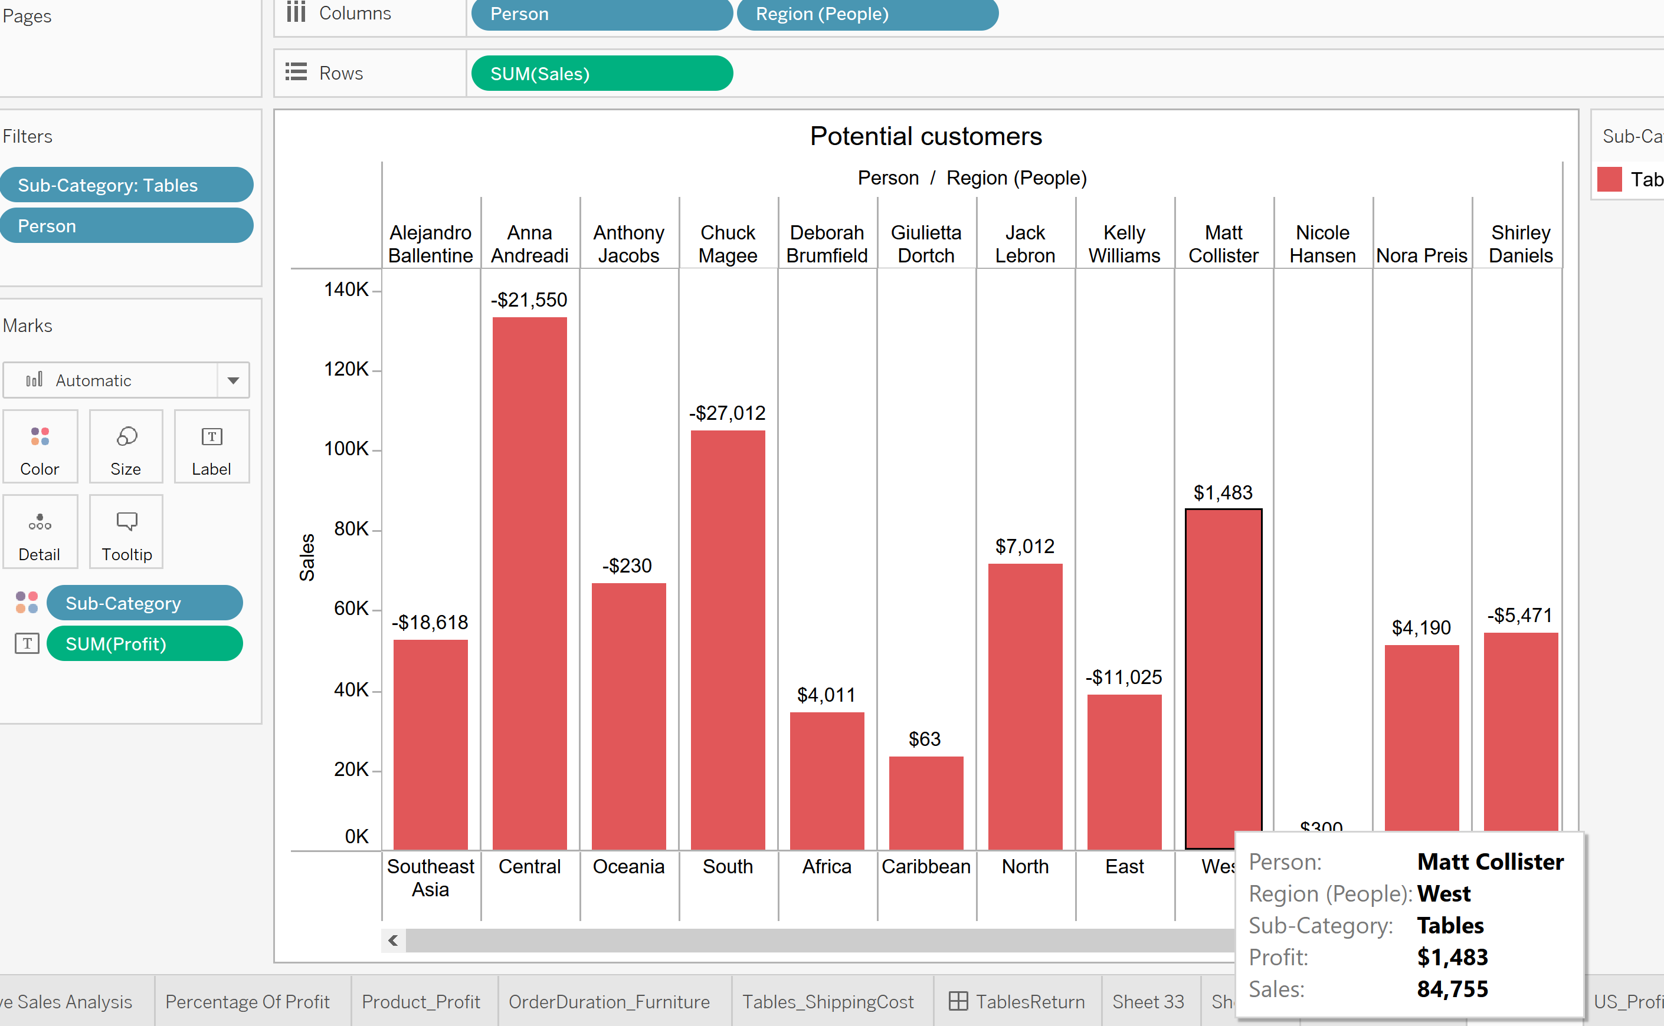

Step 4: Create a Dashboard for the sheets created in Step 1,Step 2 and Step 3 like below

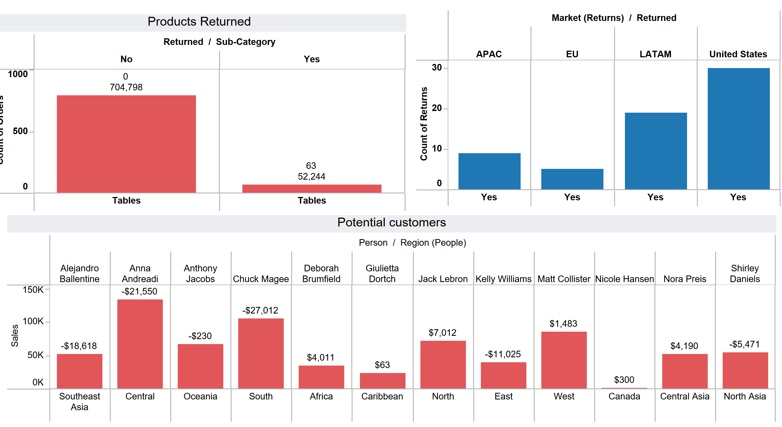

**Story Creation**

In Tableau , story is a sequence of visualizations that work together to convey information. Click the story sheet and click the Blank in the Left side six times to create six story sheets as following.

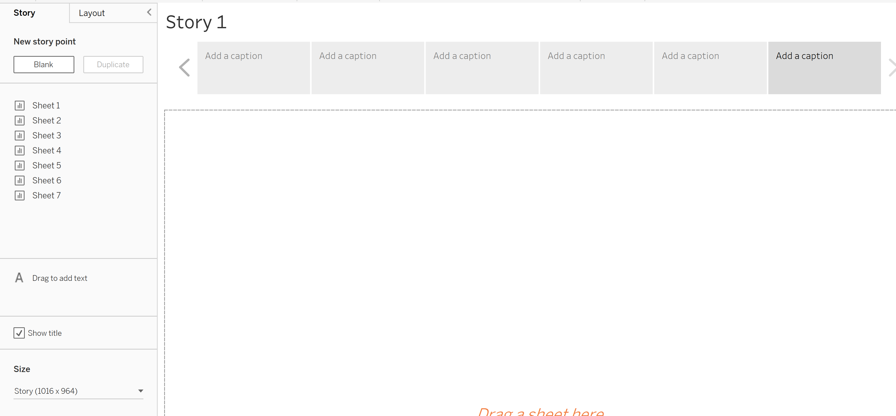

From the Menu , click Format story and change shading to Green Color and title Font to Arial 20 Black bold. Repeat the step for Navigator and text objects

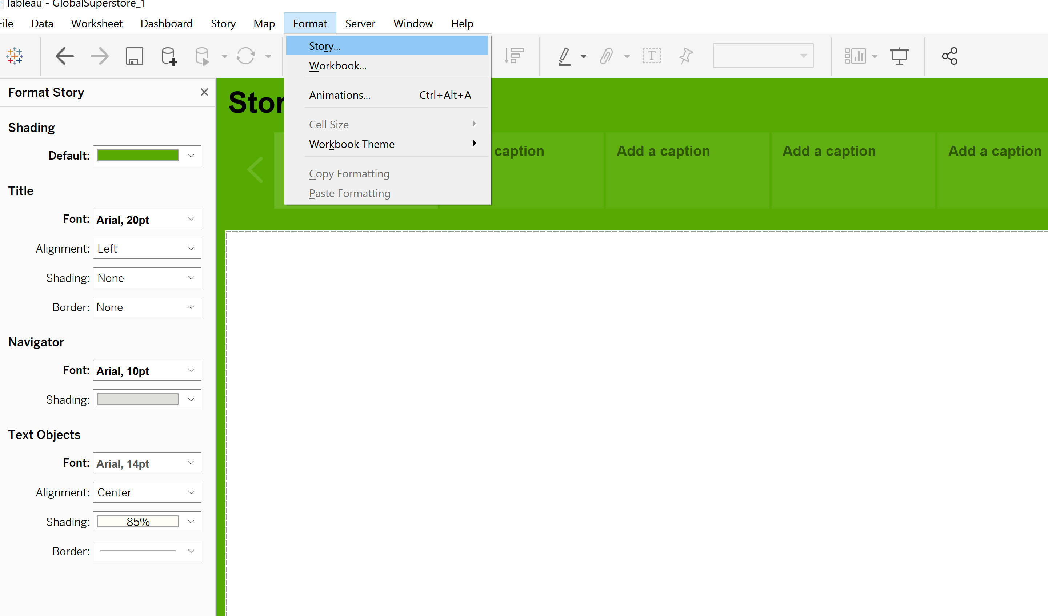

Tableau story creation is done step by step as following

Step1:Profit Around the world

This Work sheet we already created in dashboard , select the sheet and drop into story. In Add Caption edit and write as Profit Around the World

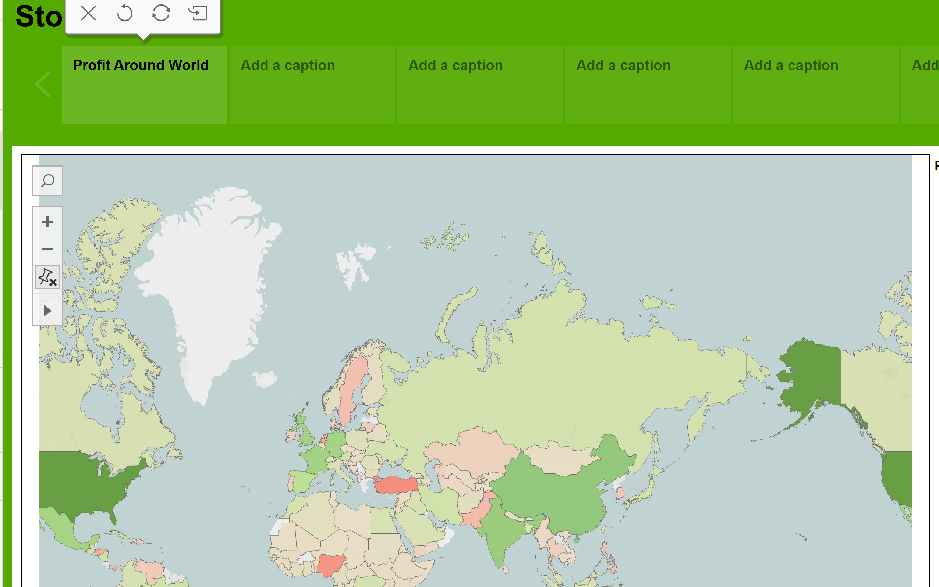

Step2: Which product categories are not profitable?

Drag the Product Profit sheet to the Story now and edit the Add a caption as Which product categories are not profitable?

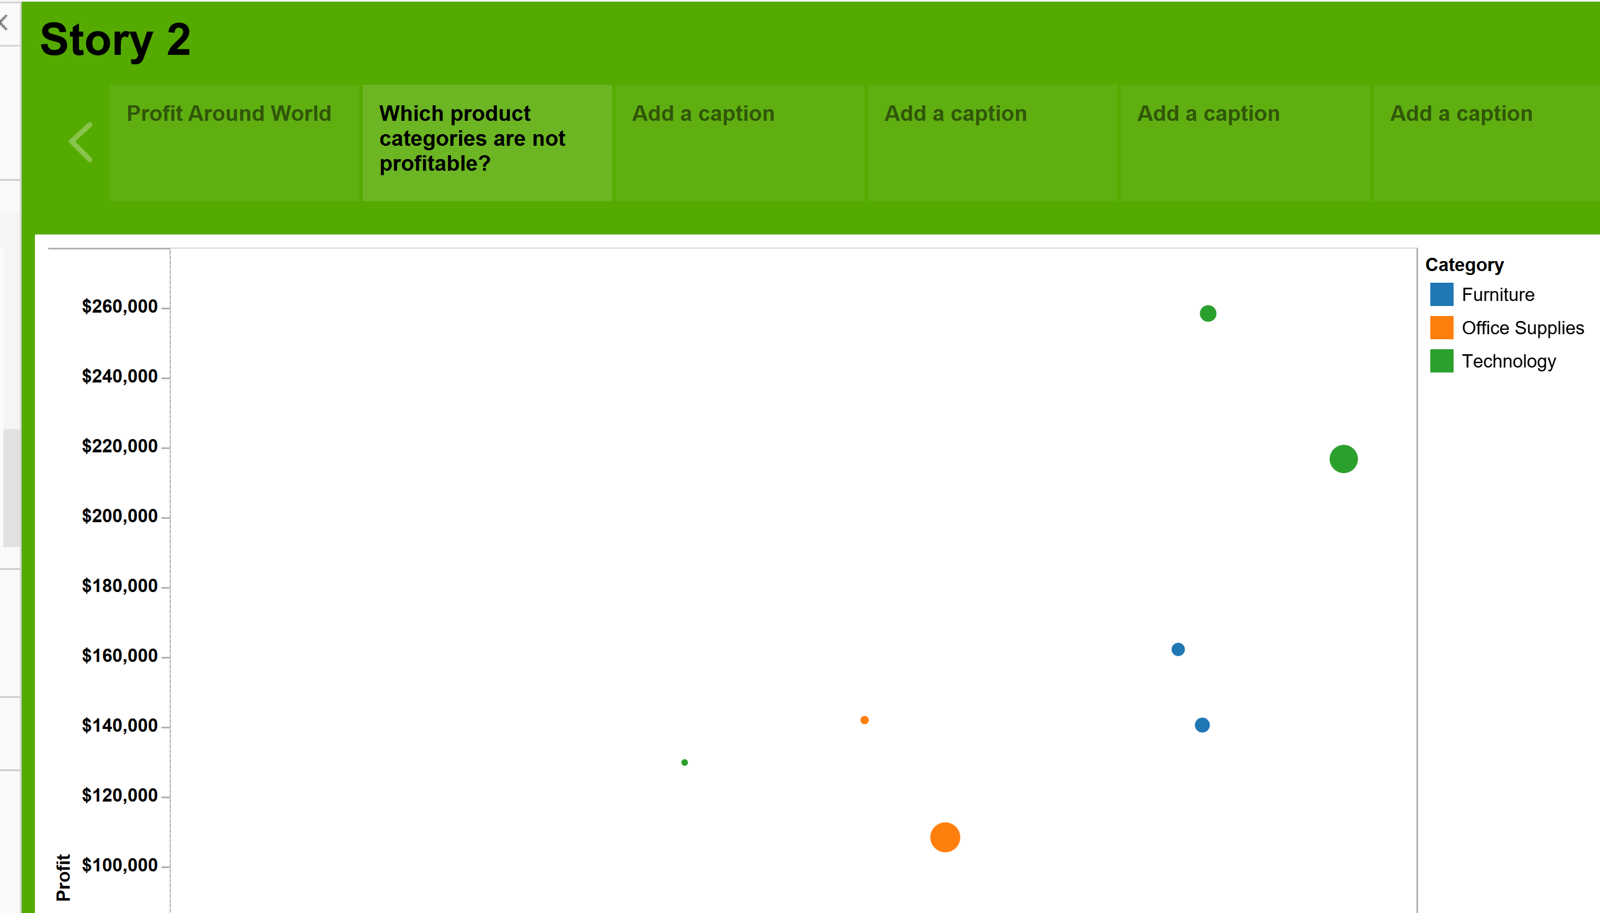

Step3:What is wrong with furniture category?

Drag the table Story Dashboard which we created into the story and edit the title as What is wrong with furniture category?

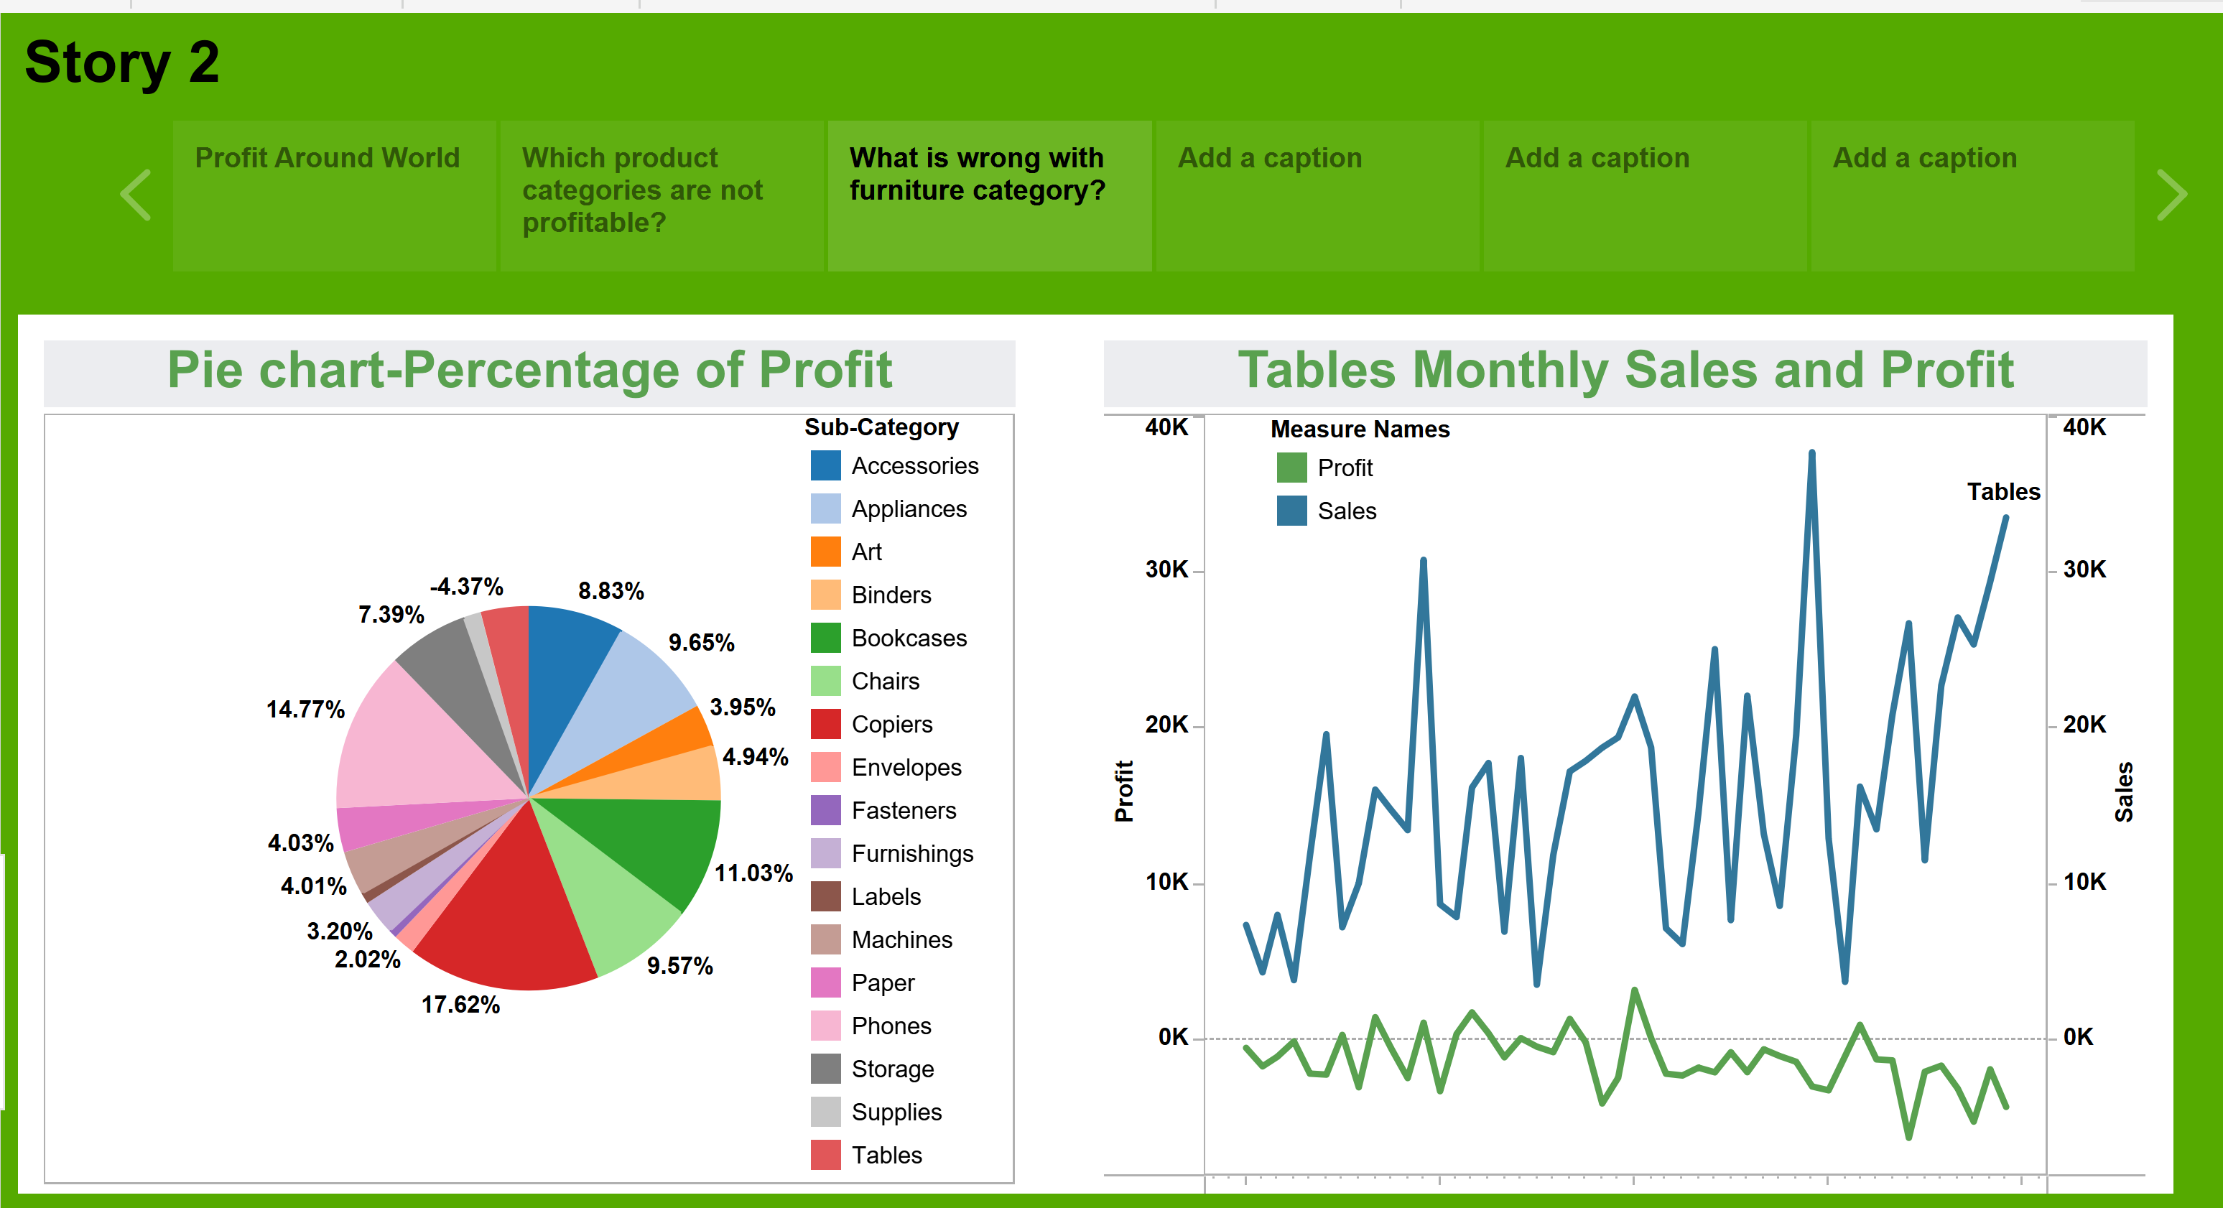

Step4: How quickly are Table orders processed?

Drag the Order Duration sheet into the story and add the title as How quickly are Table orders processed?

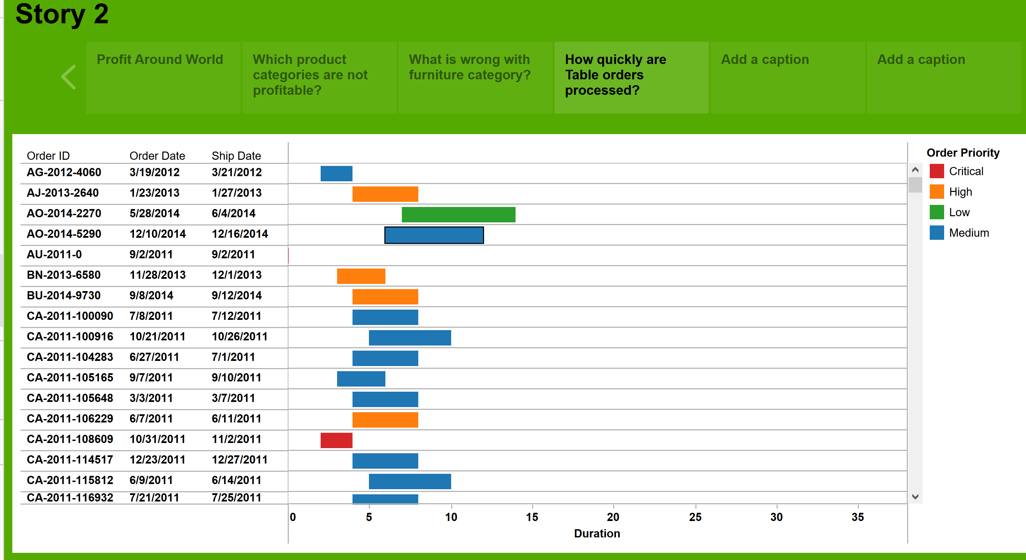

Step5: How much does it cost to ship Furniture tables ? Is shipping cost a factor in profit?

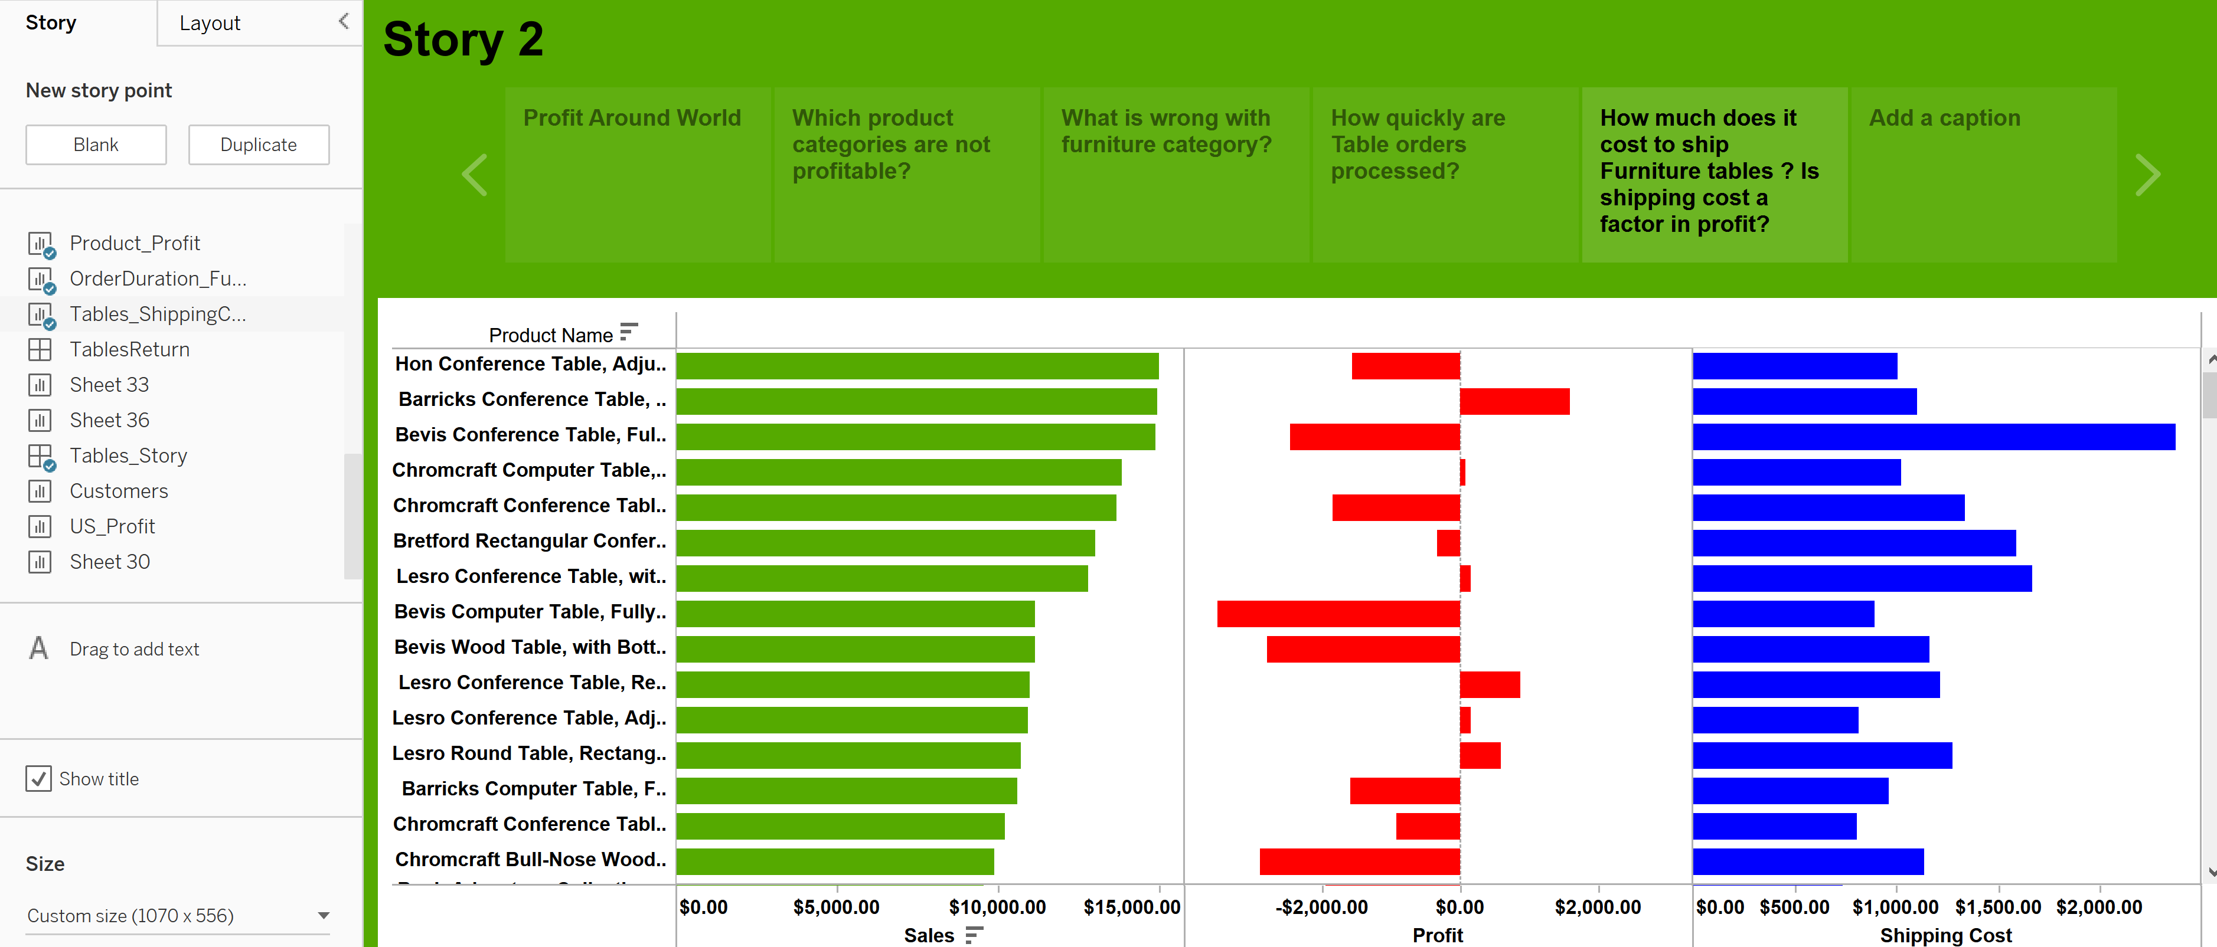

Step 6: How many of these tables did the customer return?

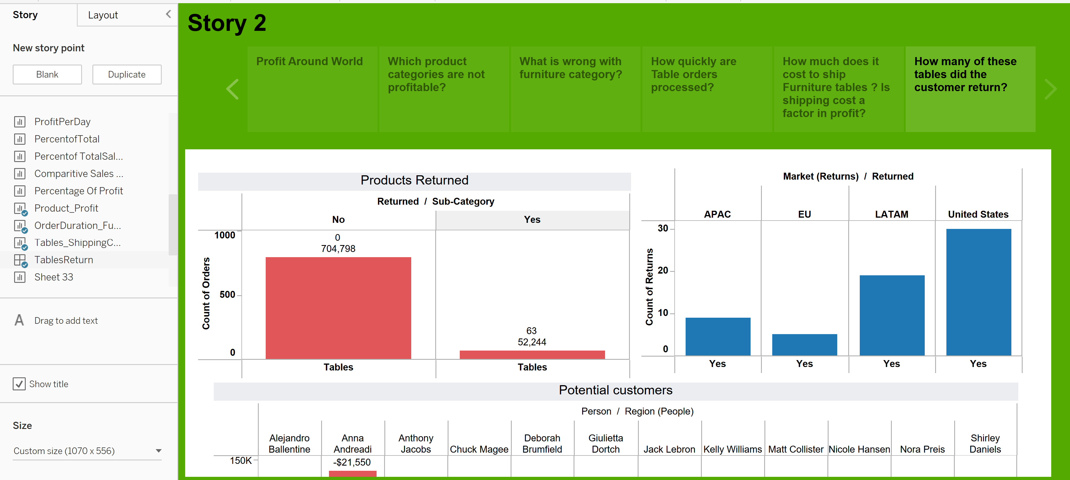

# Insights/Conclusions

**Sales vs Profit:**

After visualizing the Sales vs Profit Trends in the past year , we could see that profit decreases as the Sales decreases .So Sales is an important metric for the Company. The company should focus more on increasing the Sales Figure to generate more Profits.

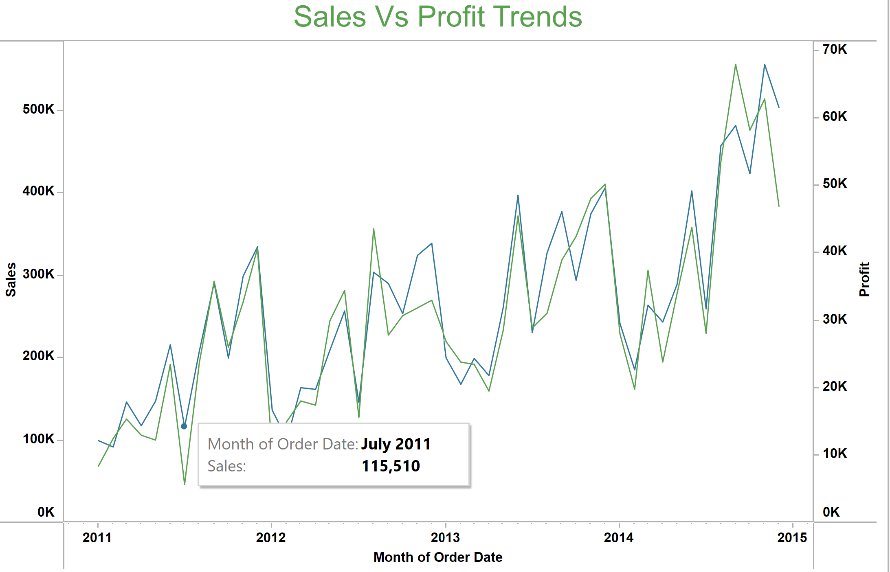

**Profit yielding Countries:**

Across the globe, United States dominates both in Sales and Profit metrics. It generates Profits approximately $2.8M. Followed by China, India, France and Australia

**Product Performance Analysis:**

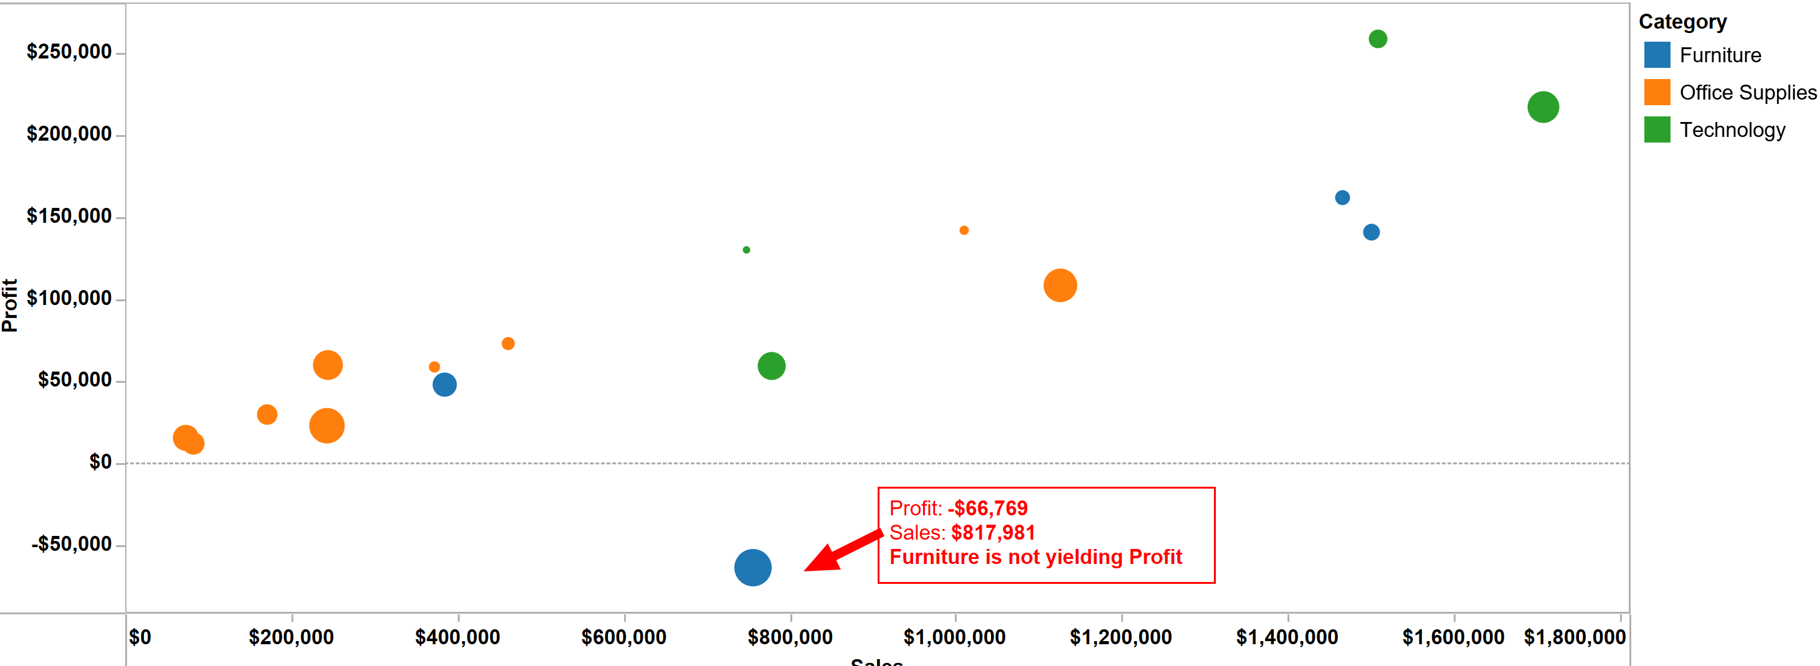From the above visualization , we can see that

* Technology category products are performing well.
* In Furniture Category , Tables is not yielding profit to the store

**Order Processing Duration:**

We have calculated Order Processing Duration for Tables Sub-category. The below Gantt chart represents the Order processing duration calculation for each of the orders for Tables.

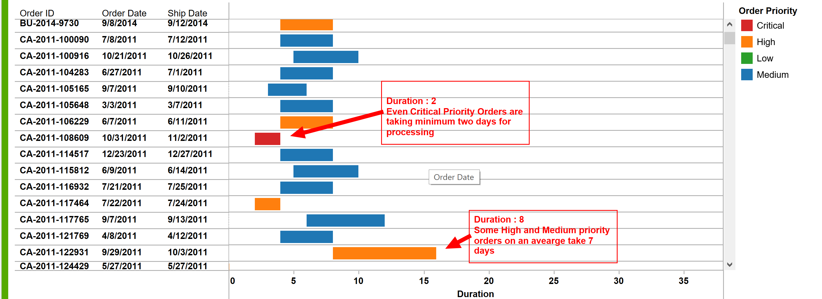

* Critical priority Orders are taking minimum two days for Processing
* Some High and Medium Priority orders take 7 days for processing

**Product Returns:**

We are visualizing the returns for Tables of the Furniture category in the below chart.

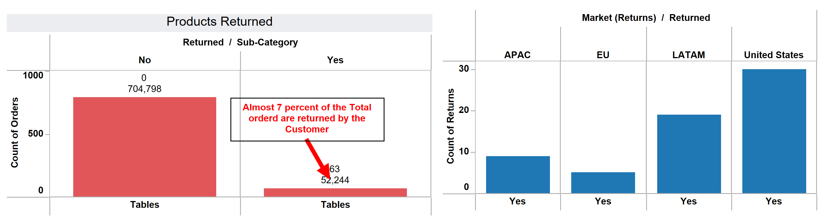

* We can see that 7 percent of the Products ordered are returned
* United States has the High return count among the other regions

# 1.10 Learning objectives Table with findings

|  |  |  |
| --- | --- | --- |
| **Learning Objectives** | **Activities/Tasks** | **Reader’s Learning Measure** |
| Determine the KPI’s | Explore the Visualization ,view the identified KPI’s for the Business | Employees of the company can see the KPI values and understand how their business performs now and in the past by following the Task. |
| Analyzing the sales and profitability of various product categories | Run an exploration , choose a particular Product category or Sub-Category, and see the top performing products | If the employee completes the tasks exactly, they will be able to name the Top product along with its sales and profit figures. |
| Proportional Brushing: Comparing each Product Profit to other product categories in order to make future investment decisions. | Run an exploration , choose a particular Product category or Sub-Category , compare the profit, and identify which is underperforming | If the Employee follows the exact tasks , they can name out the Product which yields negative profit to the company and how much is the Negative Profit Amount |
| Examining the Order Processing Duration for each order in relation to the Customer Priority. This will assist in achieving customer satisfaction. | By exploring the Order date and Shipment date ,they can calculate the order duration using the functions as shown in the chart | By following the tasks, they can identify minimum and maximum order processing duration for each order |
| Using the Sales/profit ratio, analyze product popularity across different market segments. | By using the profit Ratio ,Sales and Profit measures , they can compare the Popularity of the product | Employees can visualize the Popularity across different markets by seeing the graph and then can decide on marketing strategies. |